**EXERCISE 1:**

import java.util.Scanner;

public class Main {

public static void main(String[] args)

{

Scanner input = new Scanner (System.in);

System.out.print("Input your first name: ");

String fname = input.next();

System.out.print("Input your last name: ");

String lname = input.next();

System.out.println();

System.out.println("Hello \n"+fname+" "+lname);

}

}

**OUTPUT:**

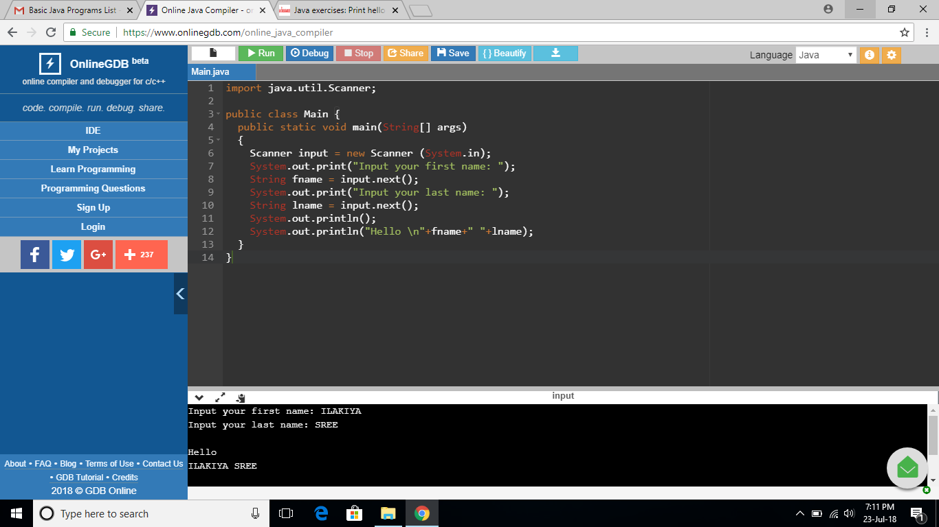

**EXERCISE 2:**

import java.util.Scanner;

public class Main {

public static void main(String[] args)

{

Scanner input = new Scanner (System.in);

System.out.print("Input the first number: ");

int num1 = input.nextInt();

System.out.print("Input the second number: ");

int num2 = input.nextInt();

int sum = num1 + num2;

System.out.println();

System.out.println("Sum: "+sum);

}

}

**OUTPUT:**

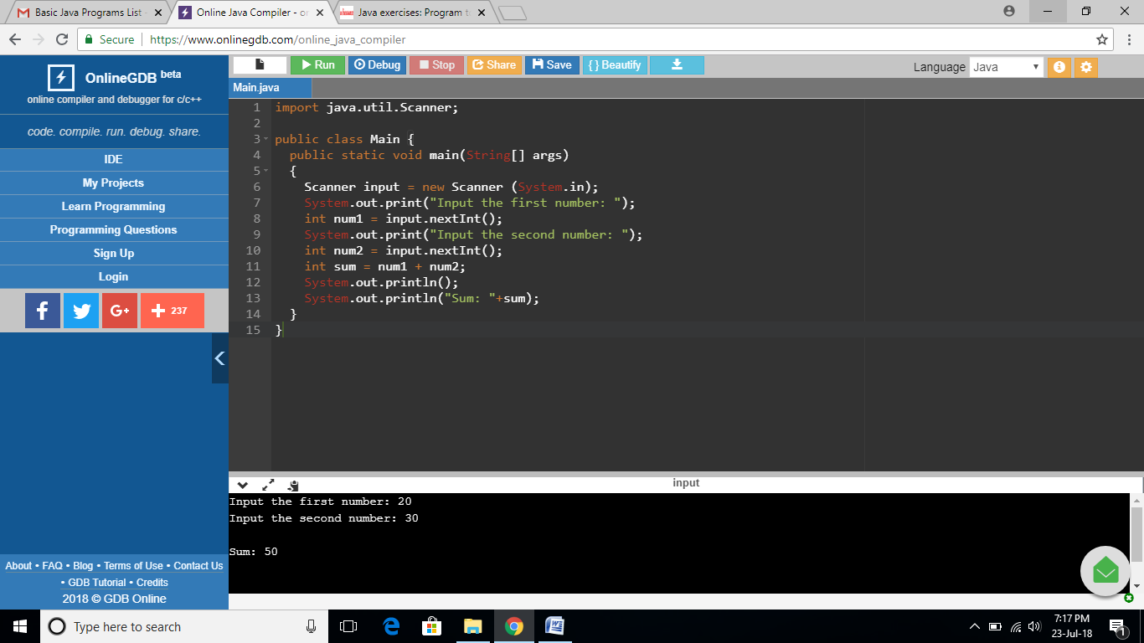

**EXERCISE 3:**

import java.util.Scanner;

public class Main {

public static void main(String[] args)

{

Scanner input = new Scanner (System.in);

System.out.print("Input the first number: ");

int a = input.nextInt();

System.out.print("Input the second number: ");

int b = input.nextInt();

int d = (a/b);

System.out.println();

System.out.println("The division of a and b is:" +d);

}

}

**OUTPUT:**

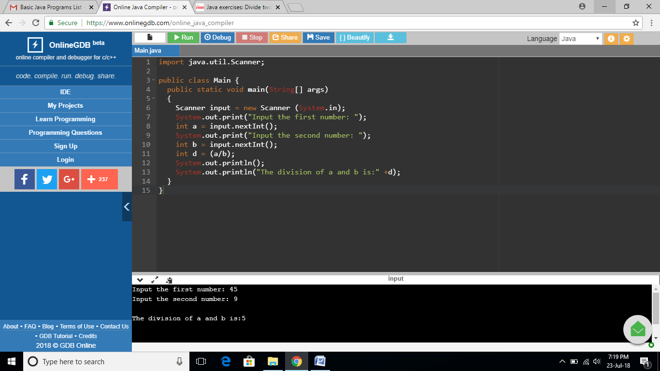

**EXERCISE 4:**

public class Main {

public static void main(String[] args) {

int w = -5 + 8 * 6;

int x = (55 + 9) % 9;

int y = 20 + (-3 * 5 / 8);

int z = 5 + 15 / 3 * 2 - 8 % 3;

System.out.print(w + "\n" + x + "\n" + y + "\n" + z);

}

}

**OUTPUT:**

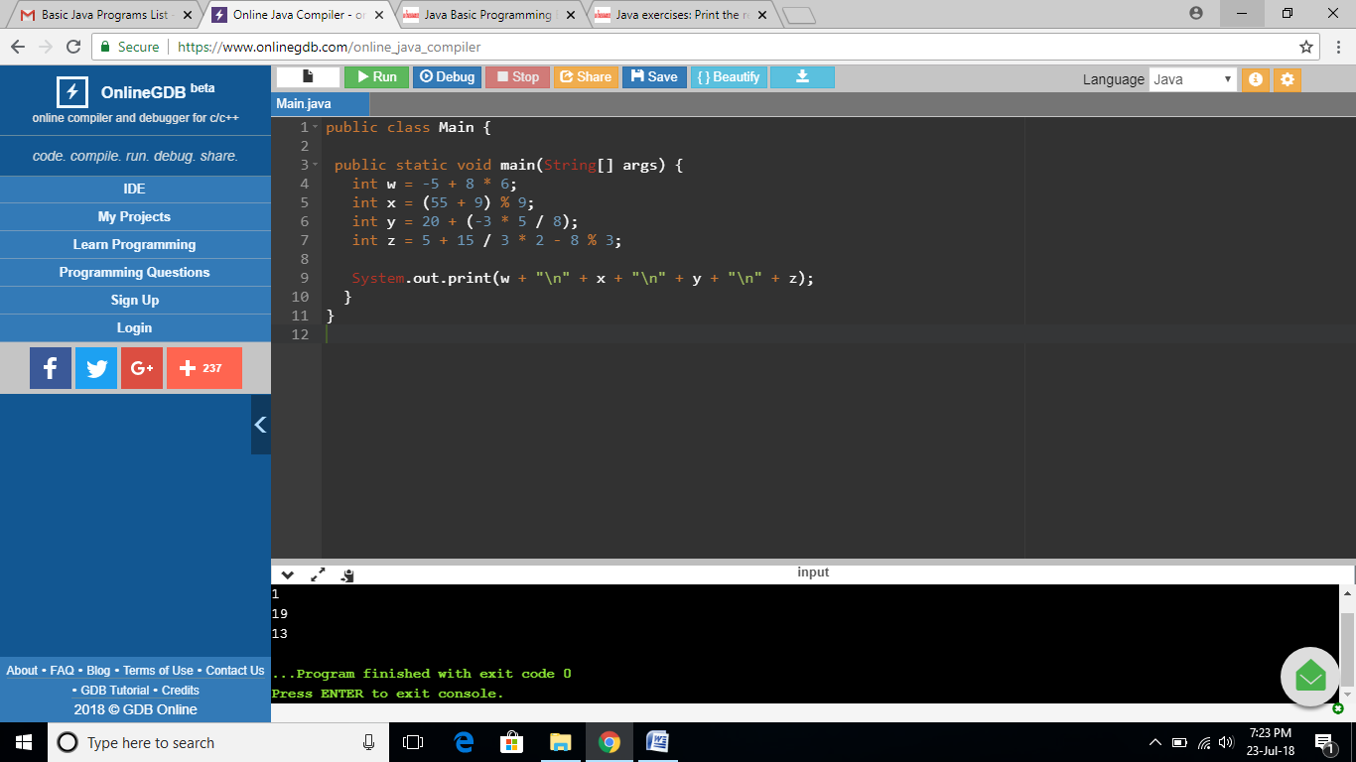

**EXERCISE 5:**

public class Main

{

static int x = 45;

static int y = 6;

public static void main(String[] args)

{

System.out.println(x*y);

}

}

**OUTPUT:**

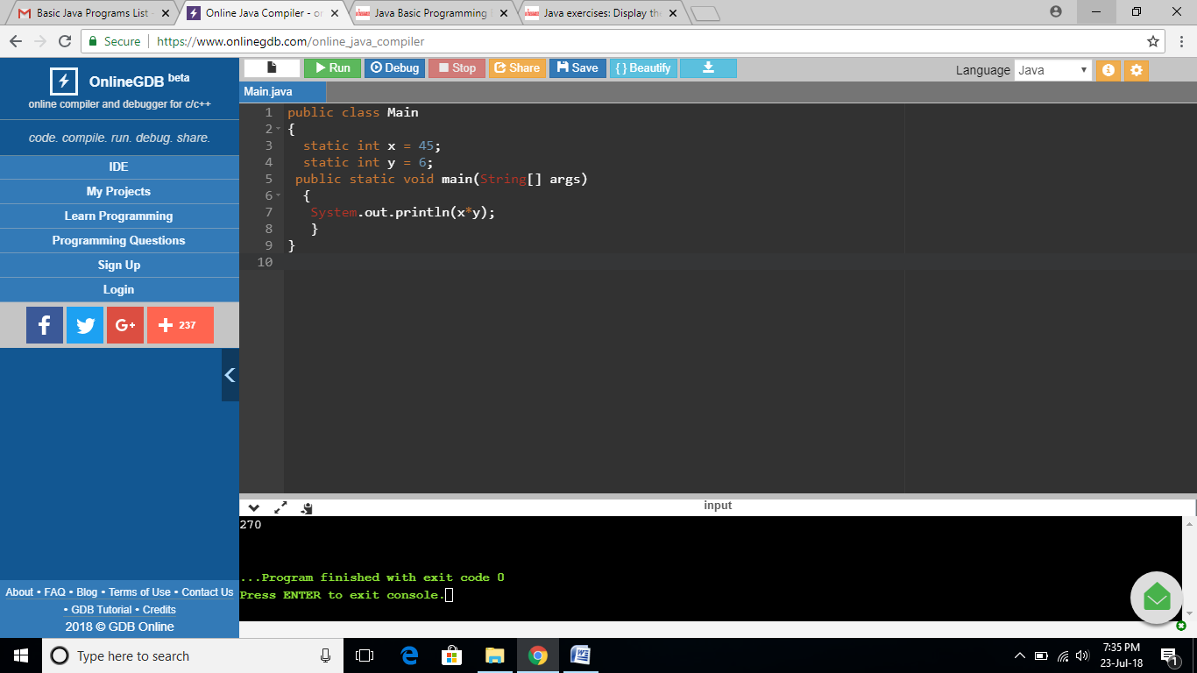

**EXERCISE 6:**

import java.util.Scanner;

public class Main {

public static void main(String[] args) {

Scanner scanner = new Scanner(System.in);

System.out.println("Input the first number: ");

int n1 = scanner.nextInt();

System.out.println("Input the second number: ");

int n2 = scanner.nextInt();

int sum = n1 + n2;

int minus = n1 - n2;

int multiply = n1 * n2;

int subtract = n1 + n2;

int divide = n1 / n2;

int rnums = n1 % n2;

System.out.printf("Sum = %d\nMinus = %d\nMultiply = %d\nSubtract = %d\nDivide = %d\nRemainderOf2Numbers = %d\n ", sum, minus, multiply, subtract, divide, rnums);

}

}

**OUTPUT:**

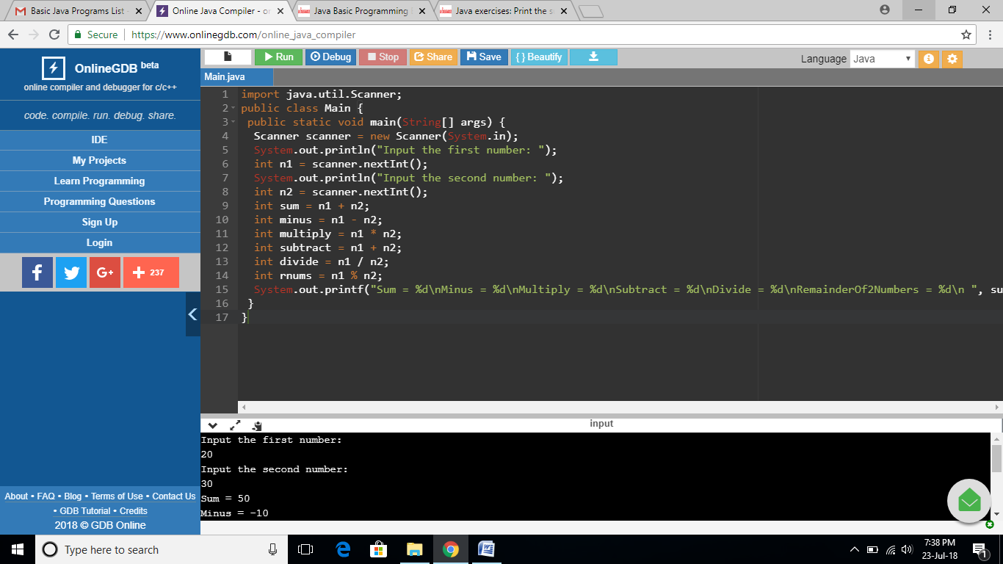

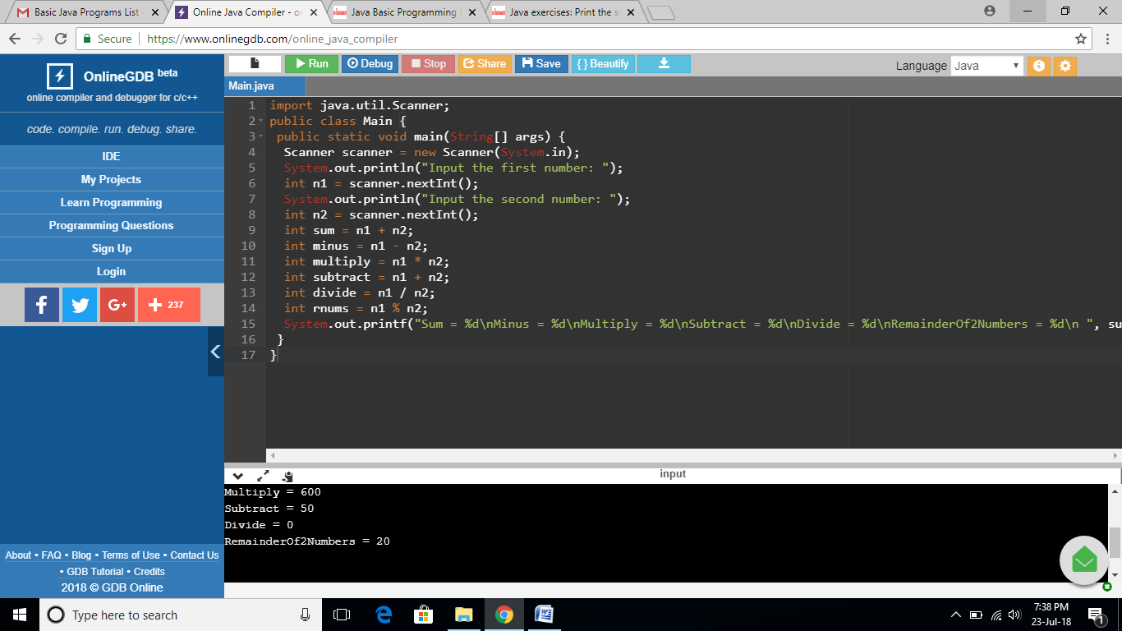

**EXERCISE 7:**

import java.util.Scanner;

public class Main {

public static void main(String[] args) {

Scanner in = new Scanner(System.in);

System.out.println("Input the Number: ");

int n = in .nextInt();

for (int i = 1; i <= 10; i++) {

System.out.println(n + "*" + i + " = " + (n * i));

}

}

}

**OUTPUT:**

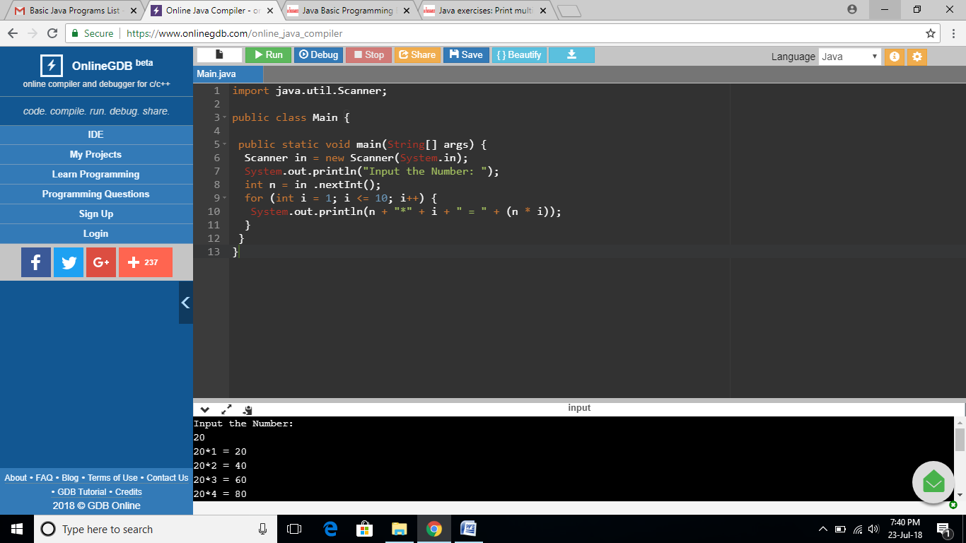

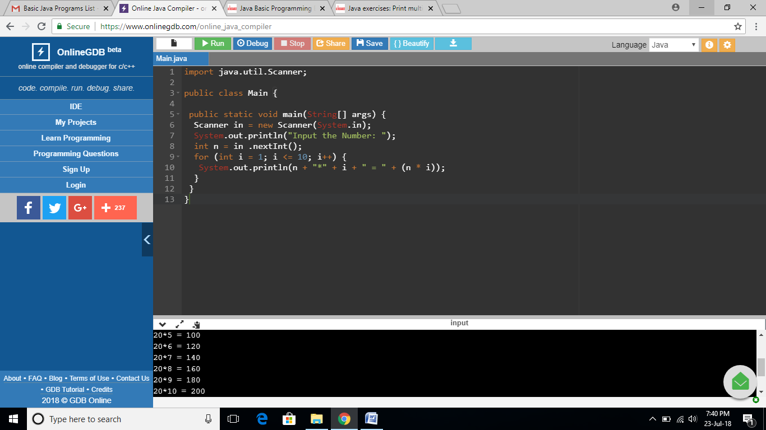

**EXERCISE 8:**

import java.util.Scanner;

public class Main {

public static void main(String[] args) {

Scanner in = new Scanner(System.in);

System.out.println(" J a v v a ");

System.out.println(" J a a v v a a");

System.out.println("J J aaaaa V V aaaaa");

System.out.println(" JJ a a V a a");

}

}

**OUTPUT:**

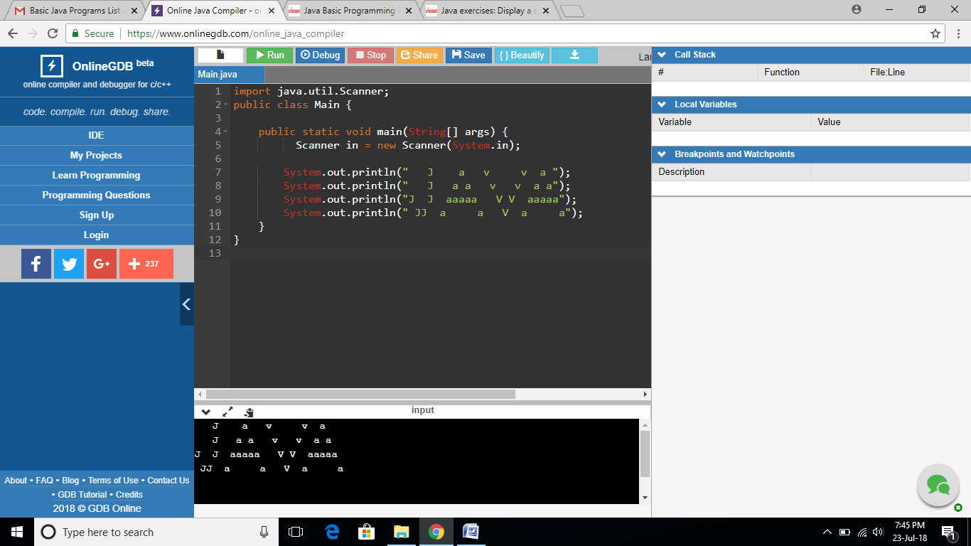

**EXERCISE 9:**

import java.util.Scanner;

public class Main {

public static void main(String[] args) {

Scanner in = new Scanner(System.in);

System.out.println((25.5 * 3.5 - 3.5 * 3.5) / (40.5 - 4.5));

}

}

**OUTPUT:**

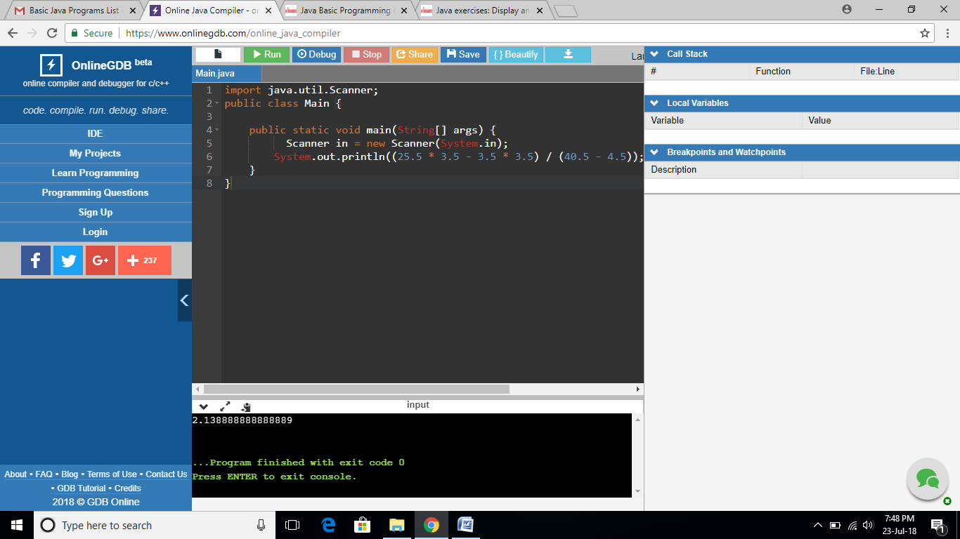

**EXERCISE 10:**

import java.util.Scanner;

public class Main {

public static void main(String[] args) {

double pi = 4.0 * (1 - (1.0/3) + (1.0/5) - (1.0/7) + (1.0/9) - (1.0/11));

System.out.println(pi); //

}

}

**OUTPUT:**

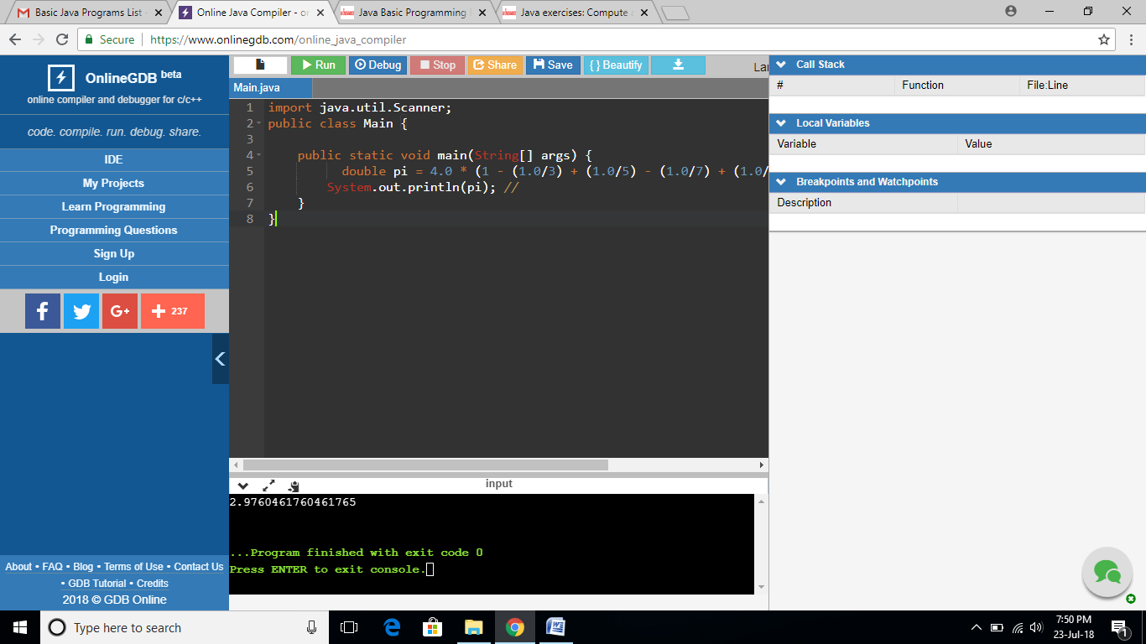

**EXERCISE 11:**

import java.util.Scanner;

public class Main {

private static final double radius = 8.5;

public static void main(String[] args) {

double perimeter = 2 * Math.PI * radius;

double area = Math.PI * radius * radius;

System.out.println("Perimeter is = " + perimeter);

System.out.println("Area is = " + area);

}

}

**OUTPUT:**

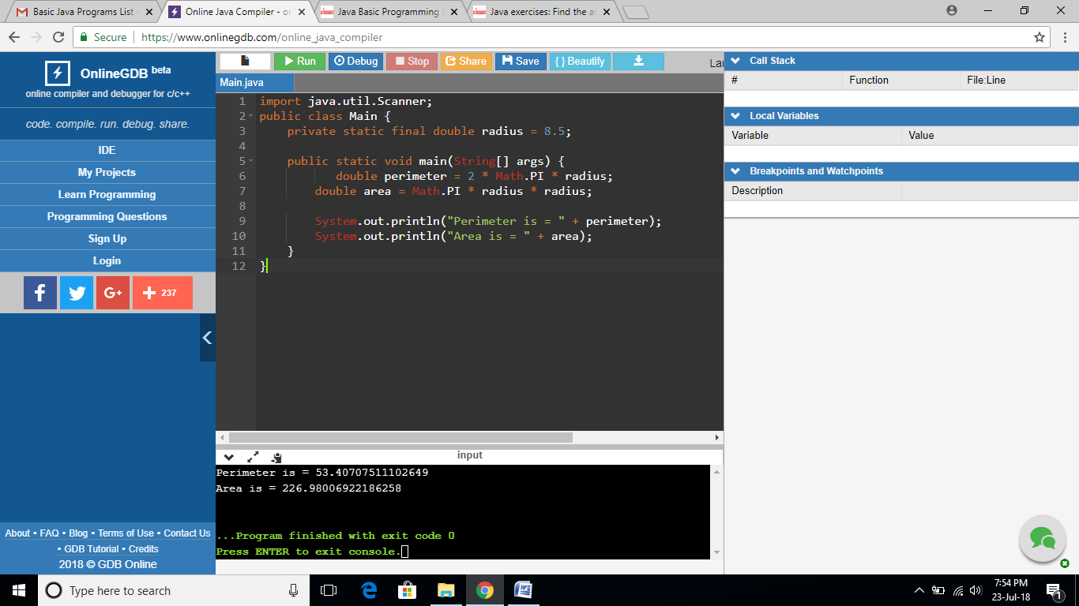

**EXERCISE 12:**

import java.util.Scanner;

public class Main {

public static void main(String[] args) {

Scanner in = new Scanner(System.in);

System.out.print("Input first number: ");

int num1 = in.nextInt();

System.out.print("Input second number: ");

int num2 = in.nextInt();

System.out.print("Input third number: ");

int num3 = in.nextInt();

System.out.print("Input fourth number: ");

int num4 = in.nextInt();

System.out.print("Enter fifth number: ");

int num5 = in.nextInt();

System.out.println("Average of five numbers is: " +

(num1 + num2 + num3 + num4 + num5) / 5);

}

}

**OUTPUT:**

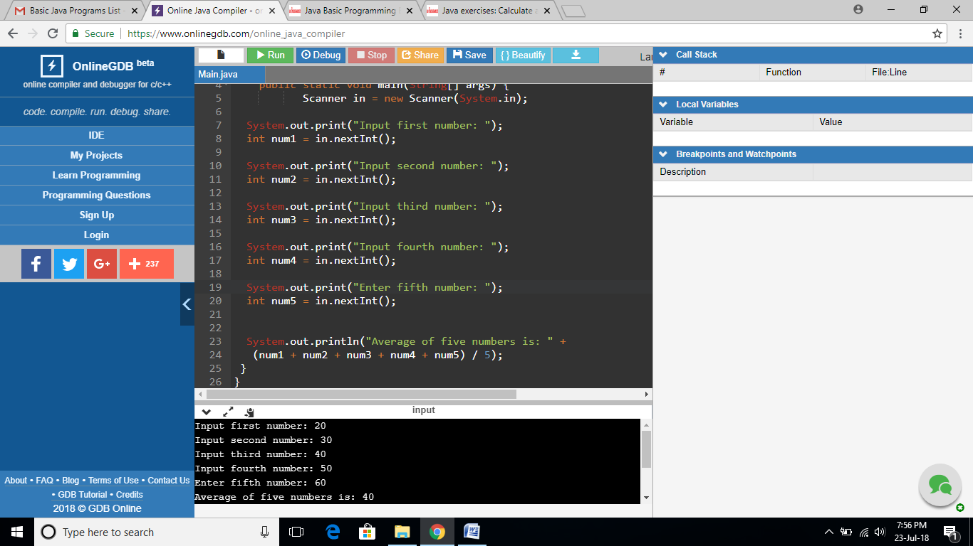

**EXERCISE 13:**

import java.util.Scanner;

public class Main {

public static void main(String[] args) {

Scanner in = new Scanner(System.in);

final double width = 5.6;

final double height = 8.5;

double perimeter = 2*(height + width);

double area = width * height;

System.out.printf("Perimeter is 2*(%.1f + %.1f) = %.2f \n", height, width, perimeter);

System.out.printf("Area is %.1f * %.1f = %.2f \n", height, width, area);

}

}

**OUTPUT:**

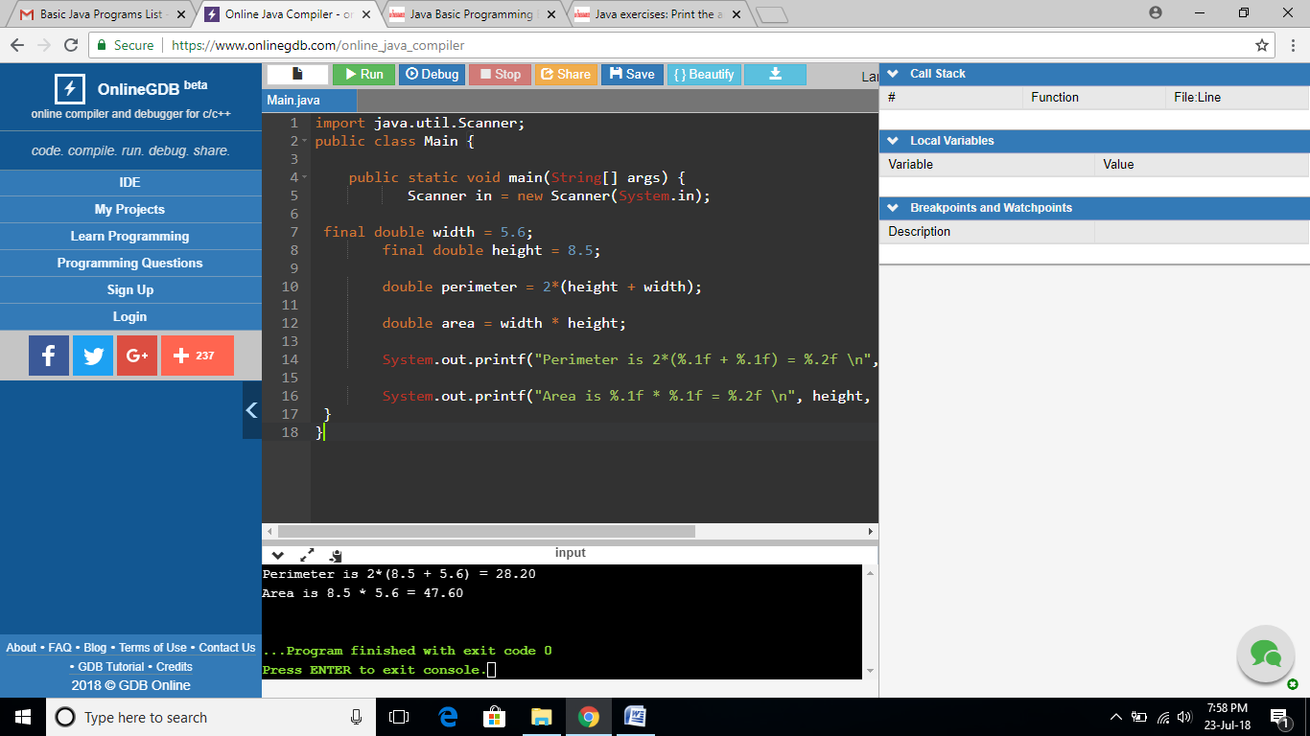

**EXERCISE 14:**

import java.util.Scanner;

public class Main {

public static void main(String[] args) {

Scanner in = new Scanner(System.in);

System.out.println("* * * * * * ==================================");

System.out.println(" * * * * * ==================================");

System.out.println("* * * * * * ==================================");

System.out.println(" * * * * * ==================================");

System.out.println("* * * * * * ==================================");

System.out.println(" * * * * * ==================================");

System.out.println("* * * * * * ==================================");

System.out.println(" * * * * * ==================================");

System.out.println("* * * * * * ==================================");

System.out.println("==============================================");

System.out.println("==============================================");

System.out.println("==============================================");

System.out.println("==============================================");

System.out.println("==============================================");

System.out.println("==============================================");

}

}

**OUTPUT:**

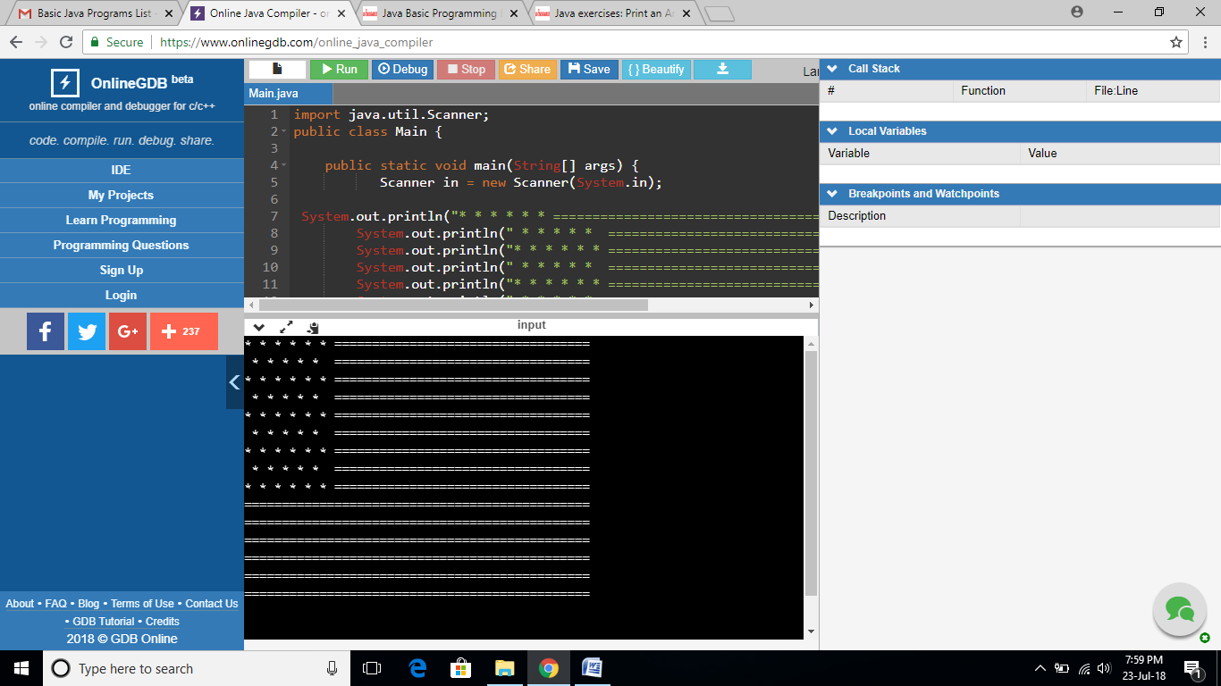

**EXERCISE 15:**

import java.util.Scanner;

public class Main {

public static void main(String[] args) {

Scanner in = new Scanner(System.in);

int a, b, temp;

a = 22;

b = 43;

System.out.println("Before swapping : a, b = "+a+", "+ + b);

temp = a;

a = b;

b = temp;

System.out.println("After swapping : a, b = "+a+", "+ + b);

}

}

**OUTPUT:**

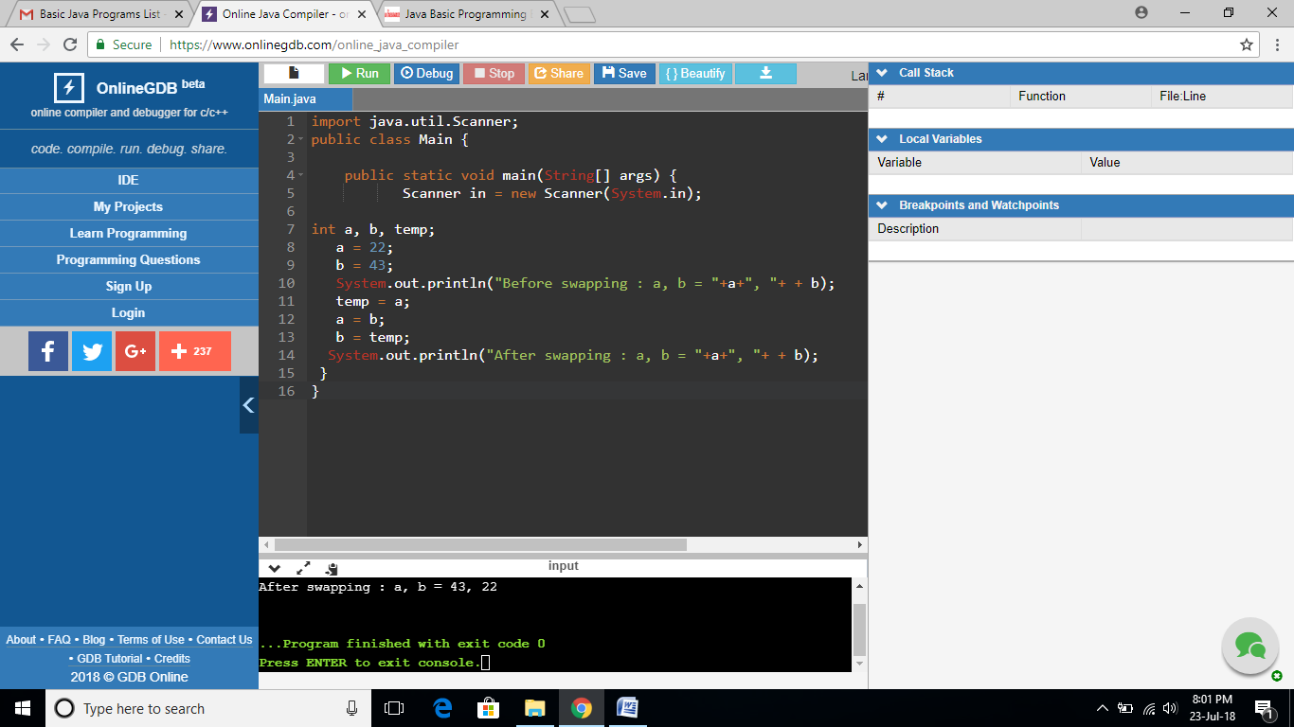

**EXERCISE 16:**

import java.util.Scanner;

public class Main {

public static void main(String[] args) {

Scanner in = new Scanner(System.in)

System.out.println(" +\"\"\"\"\"+ ");

System.out.println("[| o o |]");

System.out.println(" | ^ | ");

System.out.println(" | '-' | ");

System.out.println(" +-----+ ");

}

}

**OUTPUT:**

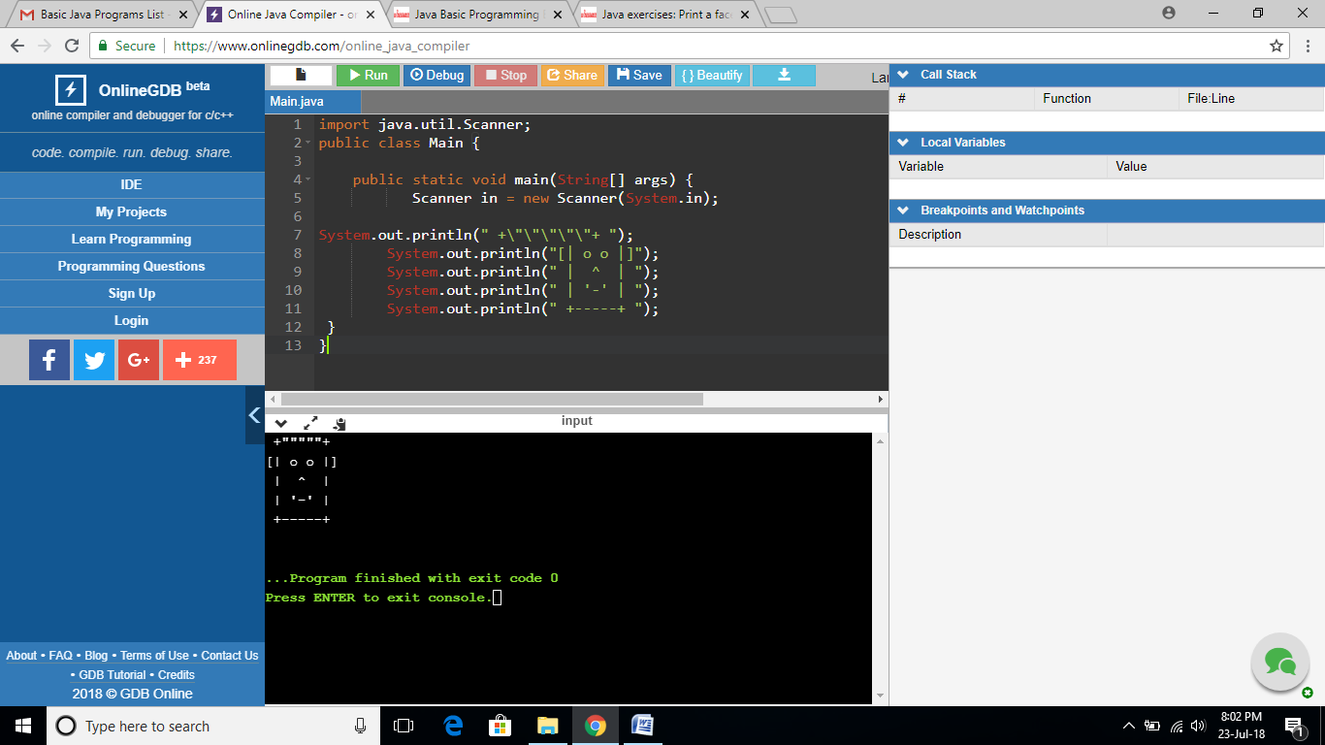

**EXERCISE 17:**

import java.util.Scanner;

public class Main {

public static void main(String[] args) {

long binary1, binary2;

int i = 0, remainder = 0;

int[] sum = new int[20];

Scanner in = new Scanner(System.in);

System.out.print("Input first binary number: ");

binary1 = in.nextLong();

System.out.print("Input second binary number: ");

binary2 = in.nextLong();

while (binary1 != 0 || binary2 != 0)

{

sum[i++] = (int)((binary1 % 10 + binary2 % 10 + remainder) % 2);

remainder = (int)((binary1 % 10 + binary2 % 10 + remainder) / 2);

binary1 = binary1 / 10;

binary2 = binary2 / 10;

}

if (remainder != 0) {

sum[i++] = remainder;

}

--i;

System.out.print("Sum of two binary numbers: ");

while (i >= 0) {

System.out.print(sum[i--]);

}

System.out.print("\n");

}

}

**OUTPUT:**

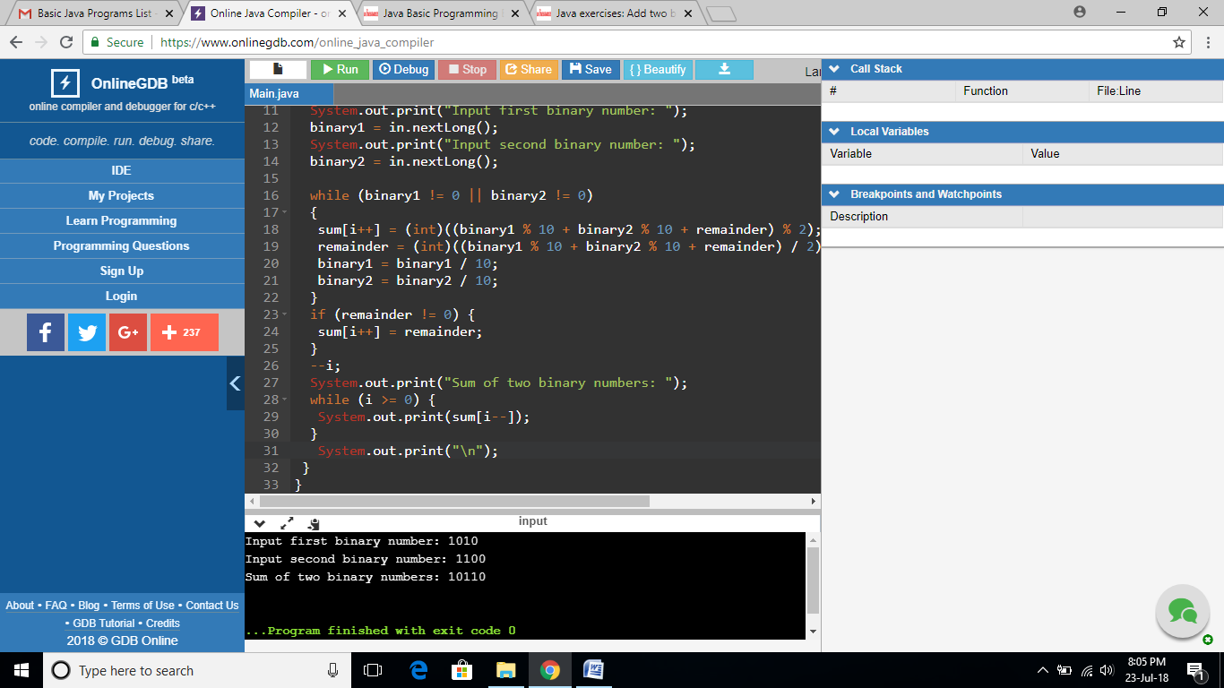

**EXERCISE 18:**

import java.util.Scanner;

public class Main {

public static void main(String[] args) {

long binary1, binary2, multiply = 0;

int digit, factor = 1;

Scanner in = new Scanner(System.in);

System.out.print("Input the first binary number: ");

binary1 = in.nextLong();

System.out.print("Input the second binary number: ");

binary2 = in.nextLong();

while (binary2 != 0)

{

digit = (int)(binary2 % 10);

if (digit == 1)

{

binary1 = binary1 * factor;

multiply = binaryproduct((int) binary1, (int) multiply);

}

else

{

binary1 = binary1 * factor;

}

binary2 = binary2 / 10;

factor = 10;

}

System.out.print("Product of two binary numbers: " + multiply+"\n");

}

static int binaryproduct(int binary1, int binary2)

{

int i = 0, remainder = 0;

int[] sum = new int[20];

int binary_prod_result = 0;

while (binary1 != 0 || binary2 != 0)

{

sum[i++] = (binary1 % 10 + binary2 % 10 + remainder) % 2;

remainder = (binary1 % 10 + binary2 % 10 + remainder) / 2;

binary1 = binary1 / 10;

binary2 = binary2 / 10;

}

if (remainder != 0)

{

sum[i++] = remainder;

}

--i;

while (i >= 0)

{

binary_prod_result = binary_prod_result * 10 + sum[i--];

}

return binary_prod_result;

}

}

**OUTPUT:**

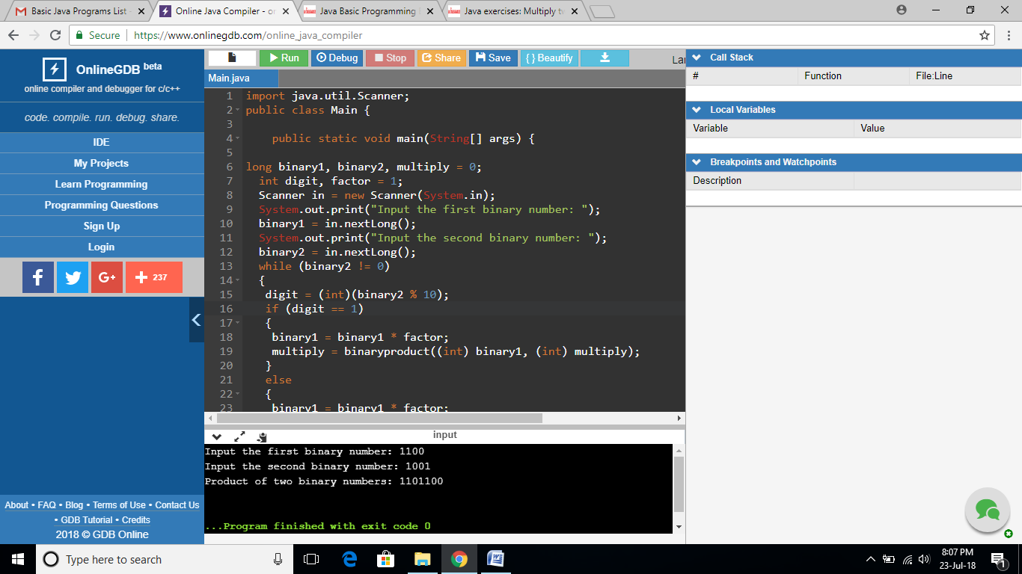

**EXERCISE 19:**

import java.util.Scanner;

public class Main {

public static void main(String[] args) {

int dec_num, rem, quot, i=1, j;

int bin_num[] = new int[100];

Scanner scan = new Scanner(System.in);

System.out.print("Input a Decimal Number : ");

dec_num = scan.nextInt();

quot = dec_num;

while(quot != 0)

{

bin_num[i++] = quot%2;

quot = quot/2;

}

System.out.print("Binary number is: ");

for(j=i-1; j>0; j--)

{

System.out.print(bin_num[j]);

}

System.out.print("\n");

}

}

**OUTPUT:**

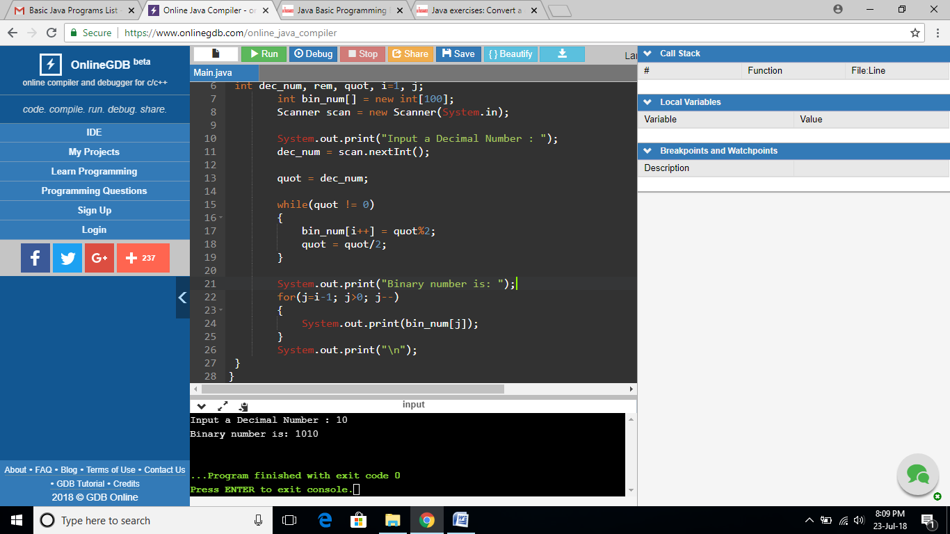

**EXERCISE 20:**

import java.util.Scanner;

public class Main {

public static void main(String[] args) {

int dec_num, rem;

String hexdec_num="";

/* hexadecimal number digits */

char hex[]={'0','1','2','3','4','5','6','7','8','9','A','B','C','D','E','F'};

Scanner in = new Scanner(System.in);

System.out.print("Input a decimal number: ");

dec_num = in.nextInt();

while(dec_num>0)

{

rem = dec_num%16;

hexdec_num = hex[rem] + hexdec_num;

dec_num = dec_num/16;

}

System.out.print("Hexadecimal number is : "+hexdec_num+"\n");

}

}

**OUTPUT:**

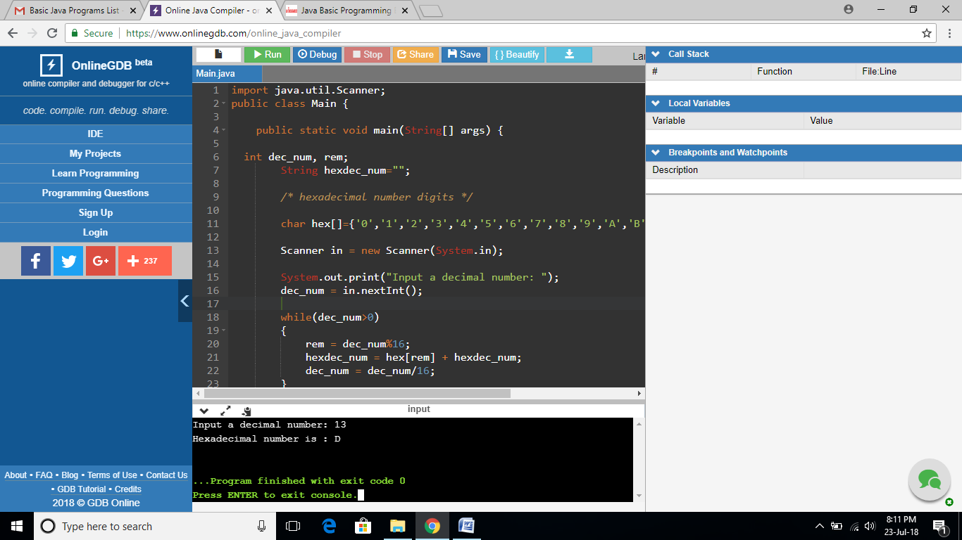

**EXERCISE 21:**

import java.util.Scanner;

public class Main {

public static void main(String[] args) {

int dec_num, rem, quot, i=1, j;

int oct_num[] = new int[100];

Scanner scan = new Scanner(System.in);

System.out.print("Input a Decimal Number: ");

dec_num = scan.nextInt();

quot = dec_num;

while(quot != 0)

{

oct_num[i++] = quot%8;

quot = quot/8;

}

System.out.print("Octal number is: ");

for(j=i-1; j>0; j--)

{

System.out.print(oct_num[j]);

}

System.out.print("\n");

}

}

**OUTPUT:**

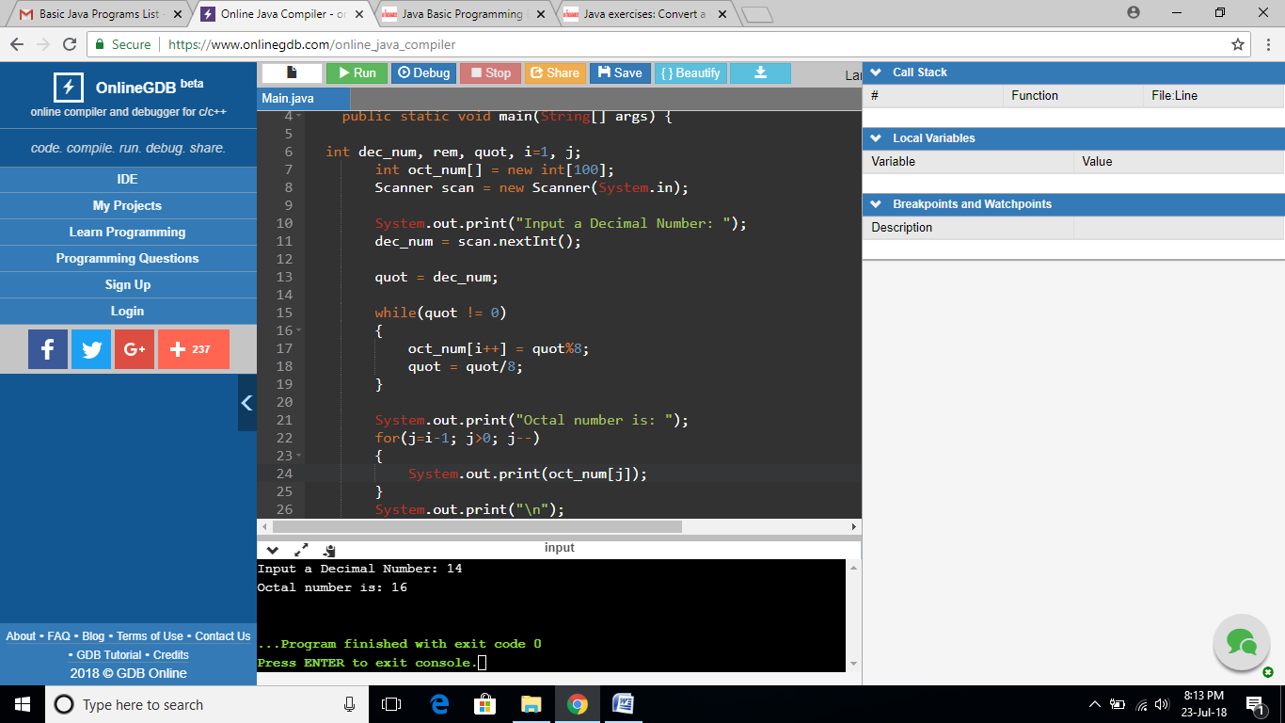

**EXERCISE 22:**

import java.util.Scanner;

public class Main {

public static void main(String[] args) {

Scanner sc = new Scanner(System.in);

long binaryNumber, decimalNumber = 0, j = 1, remainder;

System.out.print("Input a binary number: ");

binaryNumber = sc.nextLong();

while (binaryNumber != 0)

{

remainder = binaryNumber % 10;

decimalNumber = decimalNumber + remainder * j;

j = j * 2;

binaryNumber = binaryNumber / 10;

}

System.out.println("Decimal Number: " + decimalNumber);

}

}

**OUTPUT:**

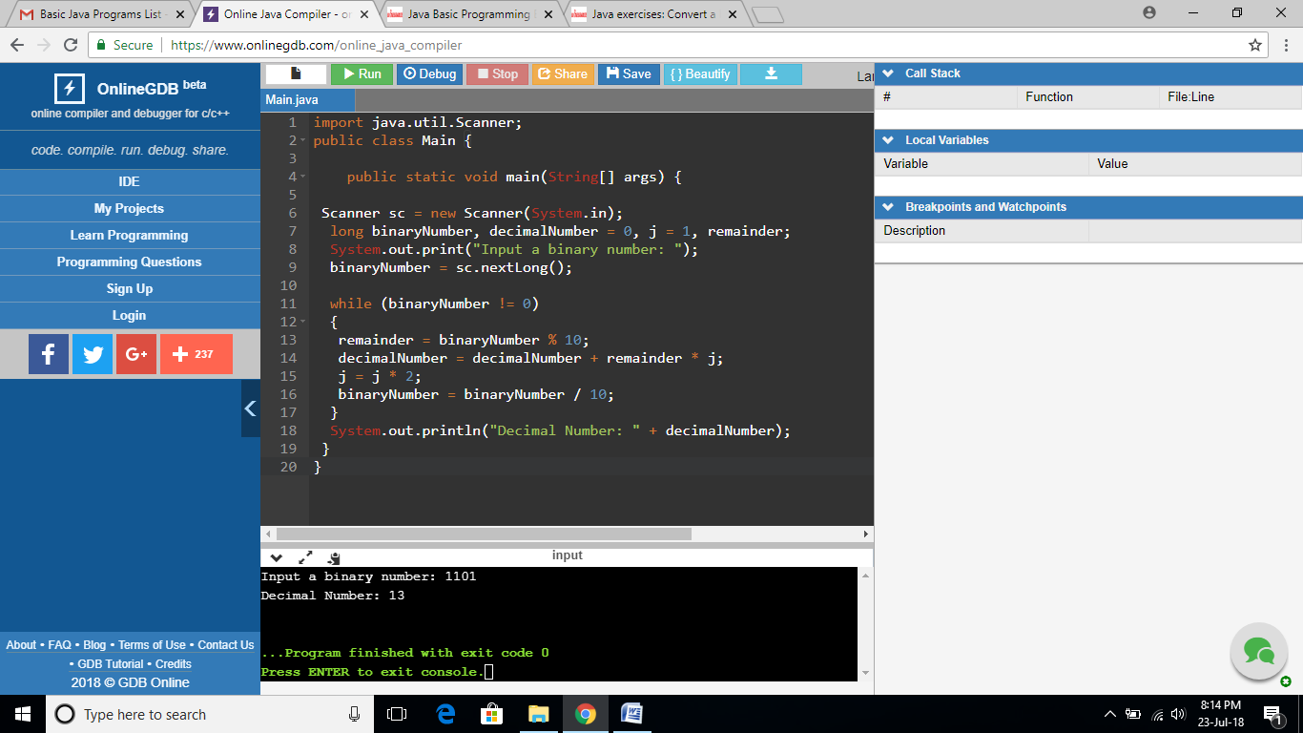

**EXERCISE 23:**

import java.util.Scanner;

public class Main {

public static void main(String[] args) {

int[] hex = new int[1000];

int i = 1, j = 0, rem, dec = 0, bin;

Scanner in = new Scanner(System.in);

System.out.print("Input a Binary Number: ");

bin = in.nextInt();

while (bin > 0) {

rem = bin % 2;

dec = dec + rem * i;

i = i * 2;

bin = bin / 10;

}

i = 0;

while (dec != 0) {

hex[i] = dec % 16;

dec = dec / 16;

i++;

}

System.out.print("HexaDecimal value: ");

for (j = i - 1; j >= 0; j--)

{

if (hex[j] > 9)

{

System.out.print((char)(hex[j] + 55)+"\n");

} else

{

System.out.print(hex[j]+"\n");

}

}

}

}

**OUTPUT:**

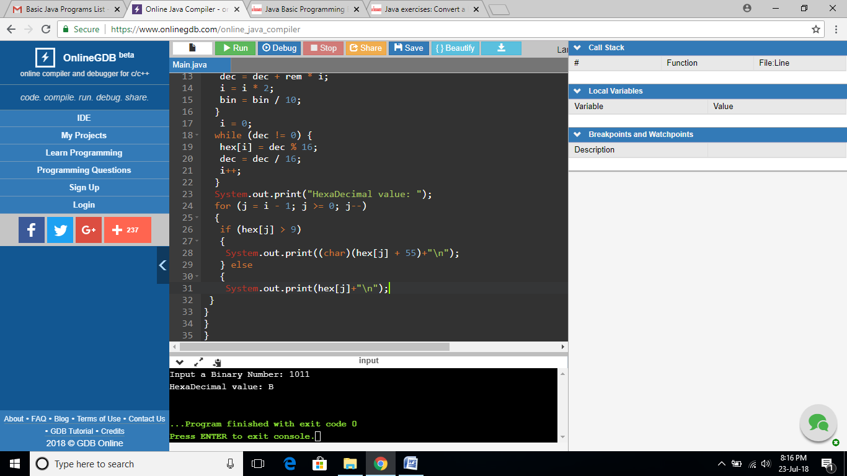

**EXERCISE 24:**

import java.util.Scanner;

public class Main {

public static void main(String[] args) {

int binnum, binnum1,rem, decnum=0, quot, i=1, j;

int octnum[] = new int[100];

Scanner scan = new Scanner(System.in);

System.out.print("Input a Binary Number : ");

binnum = scan.nextInt();

binnum1=binnum;

while(binnum > 0)

{

rem = binnum % 10;

decnum = decnum + rem*i;

//System.out.println(rem);

i = i*2;

binnum = binnum/10;

}

i=1;

quot = decnum;

while(quot > 0)

{

octnum[i++] = quot % 8;

quot = quot / 8;

}

System.out.print("Equivalent Octal Value of " +binnum1+ " is :");

for(j=i-1; j>0; j--)

{

System.out.print(octnum[j]);

}

System.out.print("\n");

}

}

**OUTPUT:**

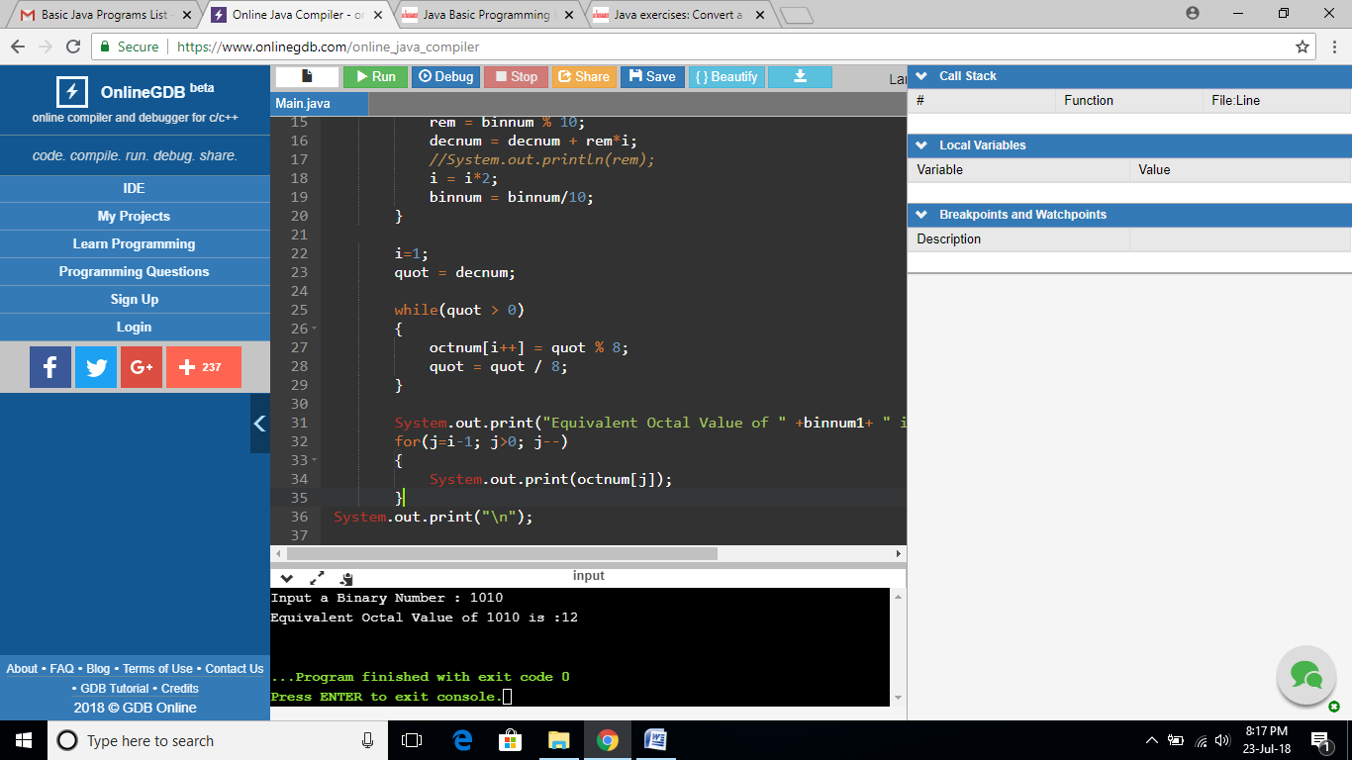

**EXERCISE 25:**

import java.util.Scanner;

public class Main {

public static void main(String[] args) {

Scanner in = new Scanner(System.in);

long octal_num, decimal_num = 0;

int i = 0;

System.out.print("Input any octal number: ");

octal_num = in.nextLong();

while (octal_num != 0)

{

decimal_num = (long)(decimal_num + (octal_num % 10) * Math.pow(8, i++));

octal_num = octal_num / 10;

}

System.out.print("Equivalent decimal number: " + decimal_num+"\n");

}

}

**OUTPUT:**

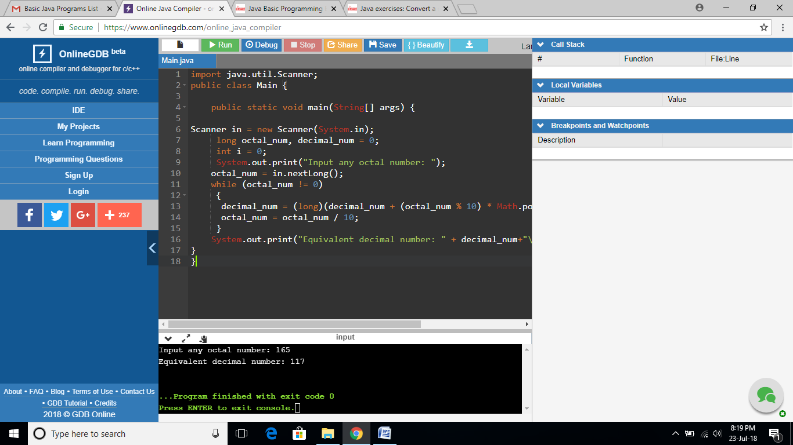

**EXERCISE 26:**

import java.util.Scanner;

public class Main {

public static void main(String[] args) {

Scanner in = new Scanner(System.in);

int[] octal_numvalues = {0, 1, 10, 11, 100, 101, 110, 111};

long octal_num, tempoctal_num, binary_num, place;

int rem;

System.out.print("Input any octal number: ");

octal_num = in.nextLong();

tempoctal_num = octal_num;

binary_num = 0;

place = 1;

while (tempoctal_num != 0)

{

rem = (int)(tempoctal_num % 10);

binary_num = octal_numvalues[rem] * place + binary_num;

tempoctal_num /= 10;

place *= 1000;

}

System.out.print("Equivalent binary number: " + binary_num+"\n");

}

}

**OUTPUT:**

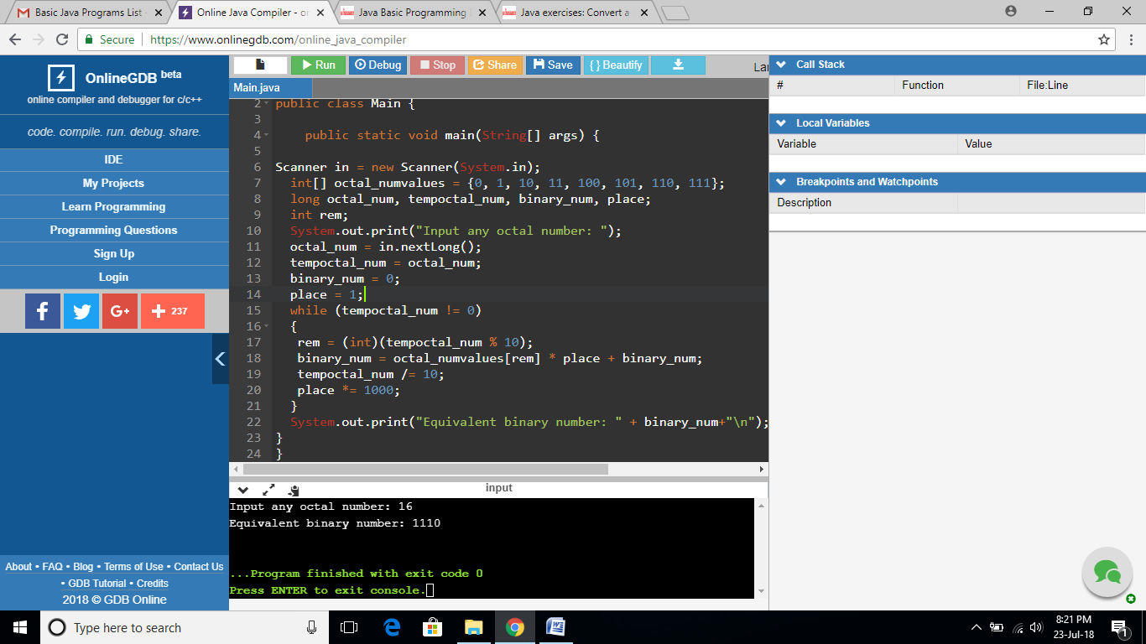

**EXERCISE2 7:**

import java.util.Scanner;

public class Main {

public static void main(String[] args) {

String octal_num, hex_num;

int decnum;

Scanner in = new Scanner(System.in);

System.out.print("Input a octal number : ");

octal_num = in.nextLine();

decnum = Integer.parseInt(octal_num, 8);

hex_num = Integer.toHexString(decnum);

System.out.print("Equivalent hexadecimal number: "+ hex_num+"\n");

}

}

**OUTPUT:**

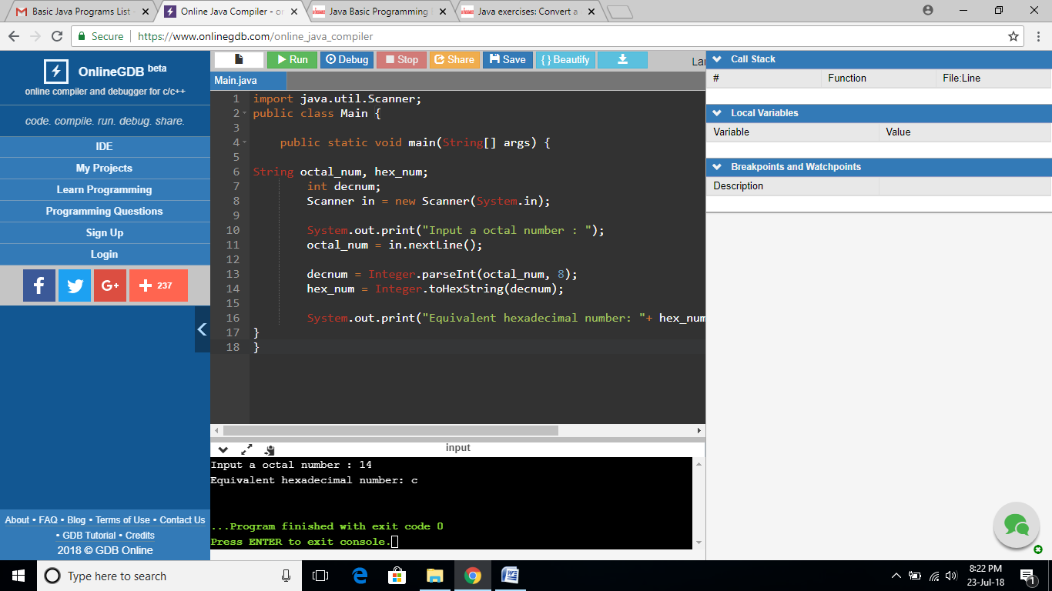

**EXERCISE28:**

import java.util.Scanner;

public class Main {

public static int hex_to_decimal(String s){

String digits = "0123456789ABCDEF";

s = s.toUpperCase();

int val = 0;

for (int i = 0; i < s.length(); i++)

{

char c = s.charAt(i);

int d = digits.indexOf(c);

val = 16*val + d;

}

return val;

}

public static void main(String args[])

{

String hexdec_num;

int dec_num;

Scanner scan = new Scanner(System.in);

System.out.print("Input a hexadecimal number: ");

hexdec_num = scan.nextLine();

dec_num = hex_to_decimal(hexdec_num);

System.out.print("Equivalent decimal number is: " + dec_num+"\n");

}

}

**OUTPUT:**

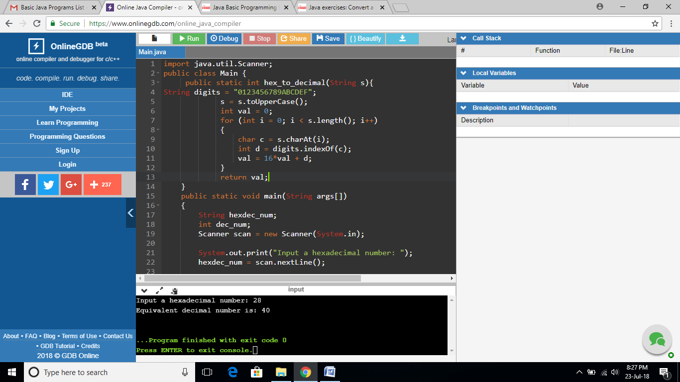

**EXERCISE 29:**

import java.util.Scanner;

public class Main {

public static int hex_to_decimal(String s){

String digits = "0123456789ABCDEF";

s = s.toUpperCase();

int val = 0;

for (int i = 0; i < s.length(); i++)

{

char c = s.charAt(i);

int d = digits.indexOf(c);

val = 16*val + d;

}

return val;

}

public static void main(String args[])

{

String hexdec_num;

int dec_num, i=1, j;

int bin_num[] = new int[100];

Scanner scan = new Scanner(System.in);

System.out.print("Enter Hexadecimal Number : ");

hexdec_num = scan.nextLine();

/* convert hexadecimal to decimal */

dec_num = hex_to_decimal(hexdec_num);

/* convert decimal to binary */

while(dec_num != 0)

{

bin_num[i++] = dec_num%2;

dec_num = dec_num/2;

}

System.out.print("Equivalent Binary Number is: ");

for(j=i-1; j>0; j--)

{

System.out.print(bin_num[j]);

}

System.out.print("\n");

}

}

**OUTPUT:**

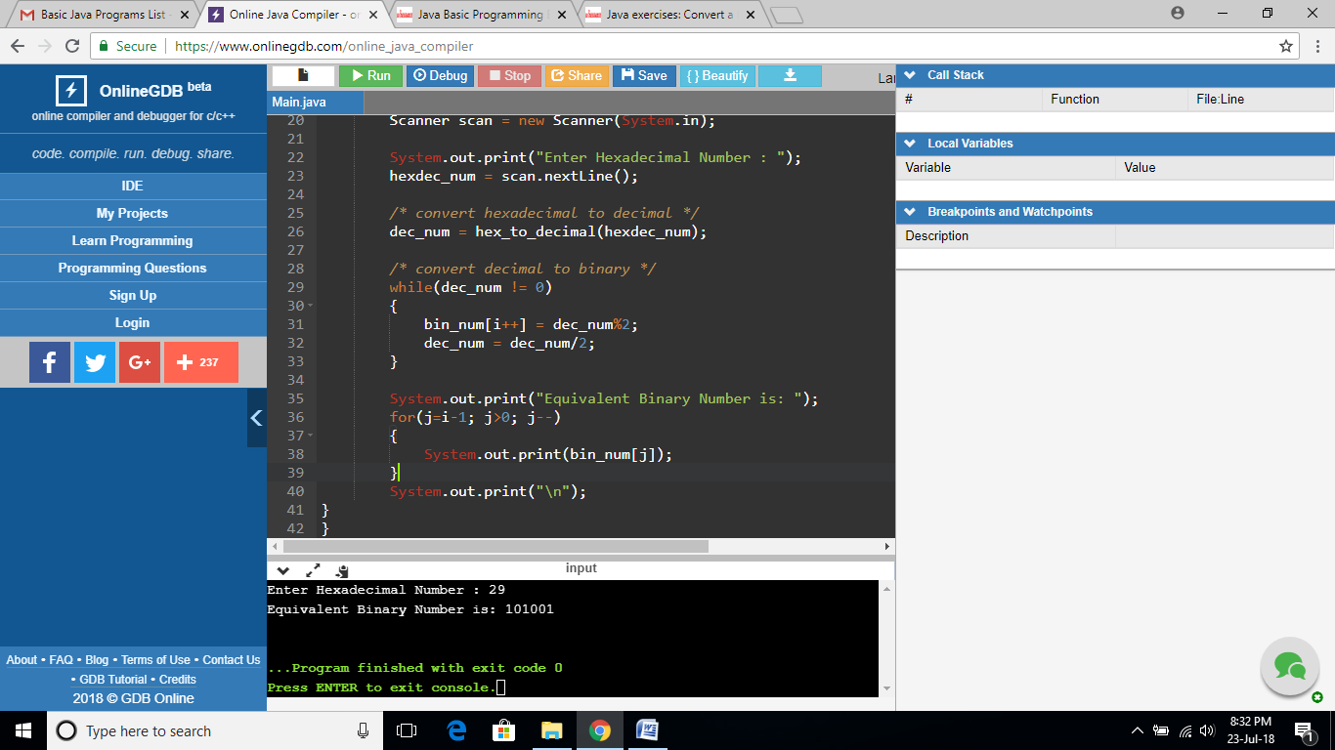

**EXERCISE 30:**

import java.util.Scanner;

public class Main {

public static int hex_to_decimal(String s){

String digits = "0123456789ABCDEF";

s = s.toUpperCase();

int val = 0;

for (int i = 0; i < s.length(); i++)

{

char c = s.charAt(i);

int d = digits.indexOf(c);

val = 16*val + d;

}

return val;

}

public static void main(String args[])

{

String hexdec_num;

int dec_num, i=1, j;

int octal_num[] = new int[100];

Scanner in = new Scanner(System.in);

System.out.print("Input a hexadecimal number: ");

hexdec_num = in.nextLine();

// Convert hexadecimal to decimal

dec_num = hex_to_decimal(hexdec_num);

//Convert decimal to octal

while(dec_num != 0)

{

octal_num[i++] = dec_num%8;

dec_num = dec_num/8;

}

System.out.print("Equivalent of octal number is: ");

for(j=i-1; j>0; j--)

{

System.out.print(octal_num[j]);

}

System.out.print("\n");

}

}

**OUTPUT:**

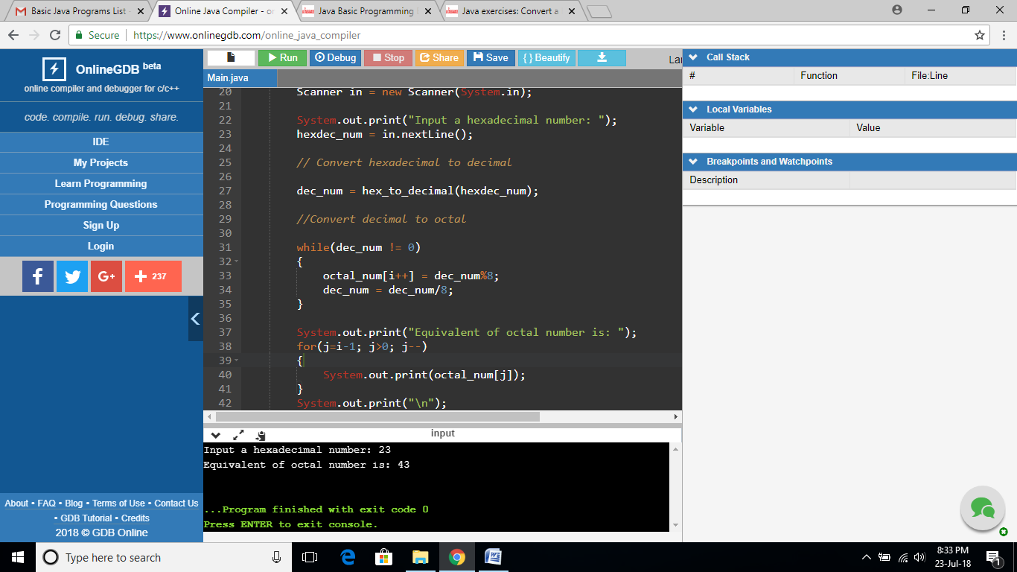

**EXERCISE 31:**

import java.util.Scanner;

public class Main {

public static void main(String[] args) {

System.out.println("\nJava Version: "+System.getProperty("java.version"));

System.out.println("Java Runtime Version: "+System.getProperty("java.runtime.version"));

System.out.println("Java Home: "+System.getProperty("java.home"));

System.out.println("Java Vendor: "+System.getProperty("java.vendor"));

System.out.println("Java Vendor URL: "+System.getProperty("java.vendor.url"));

System.out.println("Java Class Path: "+System.getProperty("java.class.path")+"\n");

}

}

**OUTPUT:**

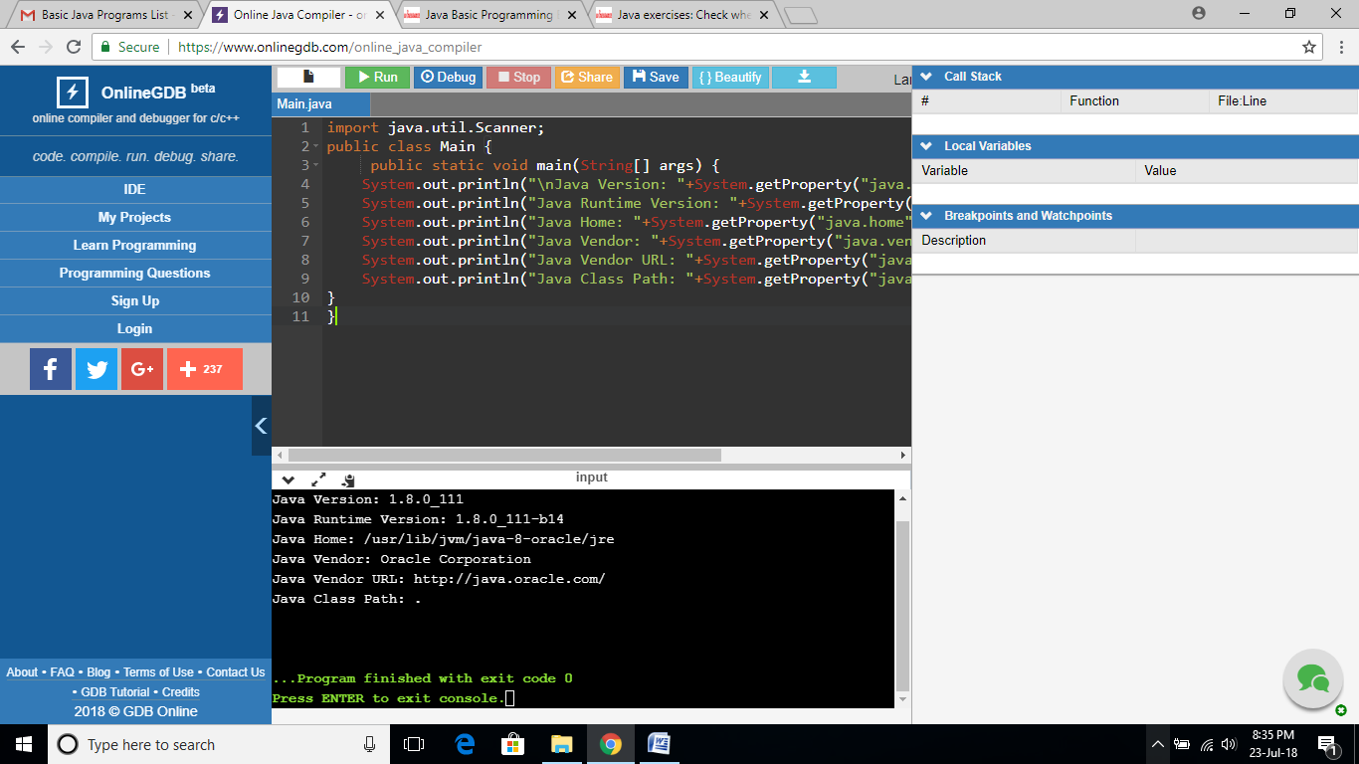

**EXERCISE 32:**

import java.util.Scanner;

public class Main {

public static void main(String[] args) {

// create Scanner to obtain input from command window

Scanner input = new Scanner(System.in);

int number1; // first number to compare

int number2; // second number to compare

System.out.print( "Input first integer: " ); // prompt

number1 = input.nextInt(); // read first number from user

System.out.print( "Input second integer: " ); // prompt

number2 = input.nextInt(); // read second number from user

if ( number1 == number2 )

System.out.printf( "%d == %d\n", number1, number2 );

if ( number1 != number2 )

System.out.printf( "%d != %d\n", number1, number2 );

if ( number1 < number2 )

System.out.printf( "%d < %d\n", number1, number2 );

if ( number1 > number2 )

System.out.printf( "%d > %d\n", number1, number2 );

if ( number1 <= number2 )

System.out.printf( "%d <= %d\n", number1, number2 );

if ( number1 >= number2 )

System.out.printf( "%d >= %d\n", number1, number2 );

}

}

**OUTPUT:**

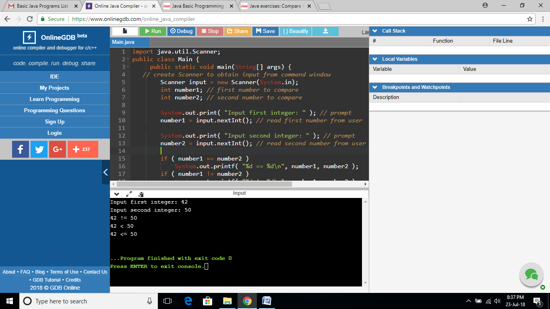

**EXERCISE 33:**

import java.util.Scanner;

public class Main {

public static void main(String[] args) {

Scanner input = new Scanner(System.in);

System.out.print("Input an integer: ");

long n = input.nextLong();

System.out.println("The sum of the digits is: " + sumDigits(n));

}

public static int sumDigits(long n) {

int sum = 0;

while (n != 0) {

sum += n % 10;

n /= 10;

}

return sum;

}

}

**OUTPUT:**

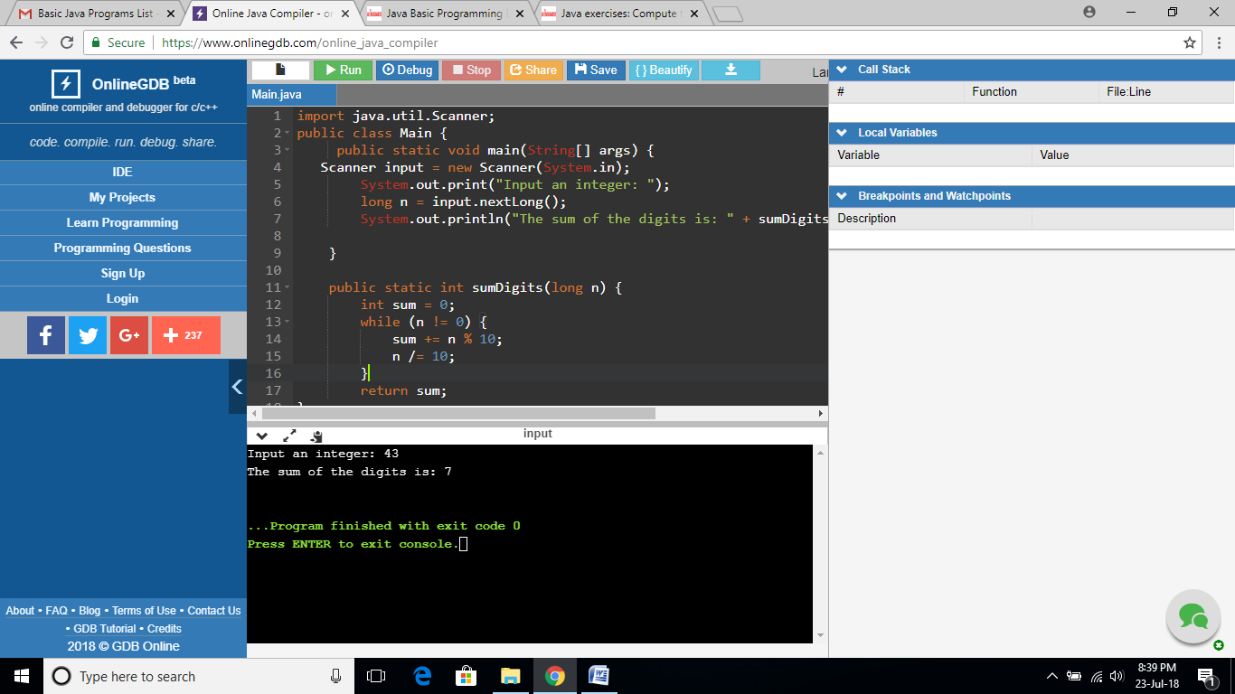

**EXERCISE 34:**

import java.util.Scanner;

public class Main {

public static void main(String[] args) {

Scanner input = new Scanner(System.in);

System.out.print("Input the length of a side of the hexagon: ");

double s = input.nextDouble();

System.out.print("The area of the hexagon is: " + hexagonArea(s)+"\n");

}

public static double hexagonArea(double s) {

return (6*(s*s))/(4*Math.tan(Math.PI/6));

}

}

**OUTPUT:**

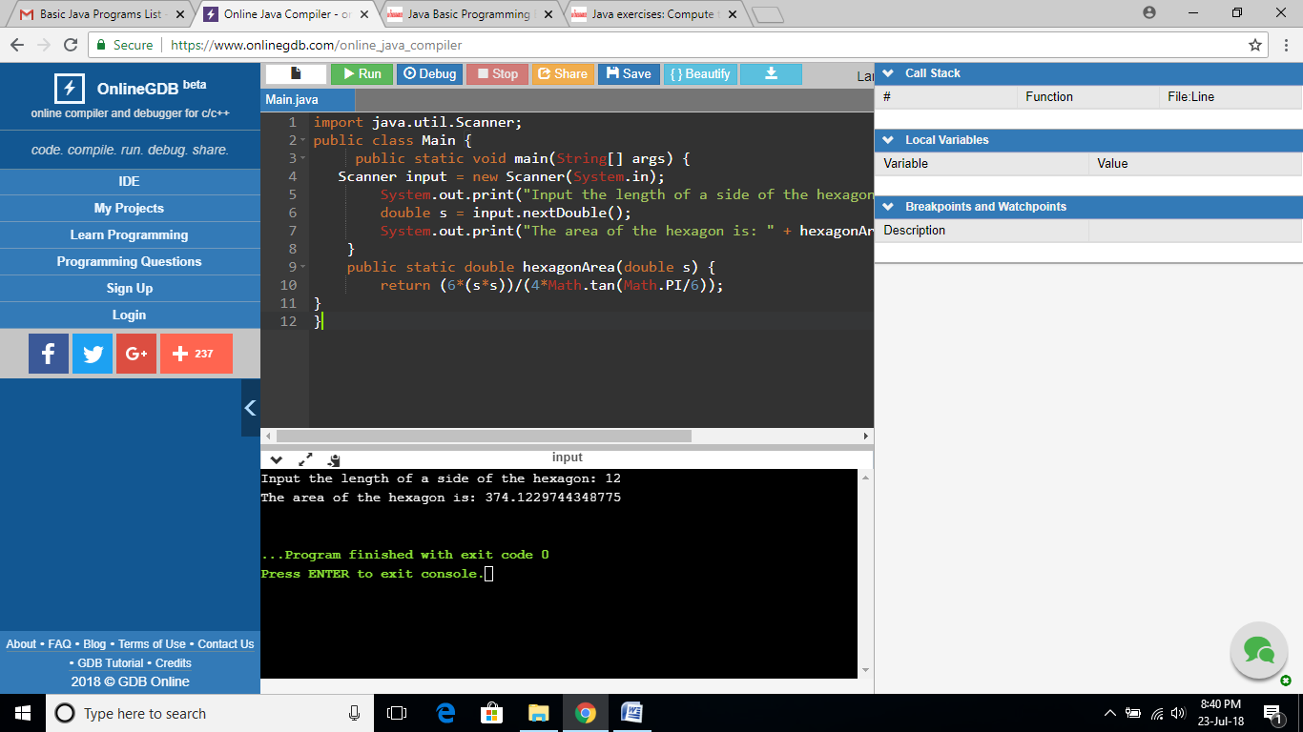

**EXERCISE 35:**

import java.util.Scanner;

public class Main {

public static void main(String[] args) {

Scanner input = new Scanner(System.in);

System.out.print("Input the number of sides on the polygon: ");

int ns = input.nextInt();

System.out.print("Input the length of one of the sides: ");

double side = input.nextDouble();

System.out.print("The area is: " + polygonArea(ns, side)+"\n");

}

public static double polygonArea(int ns, double side) {

return (ns * (side * side)) / (4.0 * Math.tan((Math.PI / ns)));

}

}

**OUTPUT:**

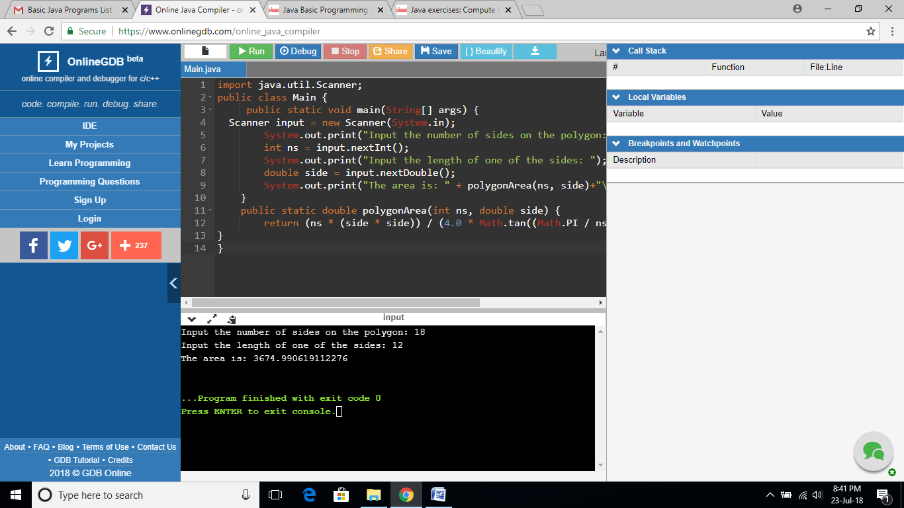

**EXERCISE 36:**

import java.util.Scanner;

public class Main {

public static void main(String[] args) {

Scanner input = new Scanner(System.in);

System.out.print("Input the latitude of coordinate 1: ");

double lat1 = input.nextDouble();

System.out.print("Input the longitude of coordinate 1: ");

double lon1 = input.nextDouble();

System.out.print("Input the latitude of coordinate 2: ");

double lat2 = input.nextDouble();

System.out.print("Input the longitude of coordinate 2: ");

double lon2 = input.nextDouble();

System.out.print("The distance between those points is: " + distance_Between_LatLong(lat1, lon1, lat2, lon2) + " km\n");

}

// Points will be converted to radians before calculation

public static double distance_Between_LatLong(double lat1, double lon1, double lat2, double lon2) {

lat1 = Math.toRadians(lat1);

lon1 = Math.toRadians(lon1);

lat2 = Math.toRadians(lat2);

lon2 = Math.toRadians(lon2);

double earthRadius = 6371.01; //Kilometers

return earthRadius * Math.acos(Math.sin(lat1)*Math.sin(lat2) + Math.cos(lat1)*Math.cos(lat2)*Math.cos(lon1 - lon2));

}

}

**OUTPUT:**

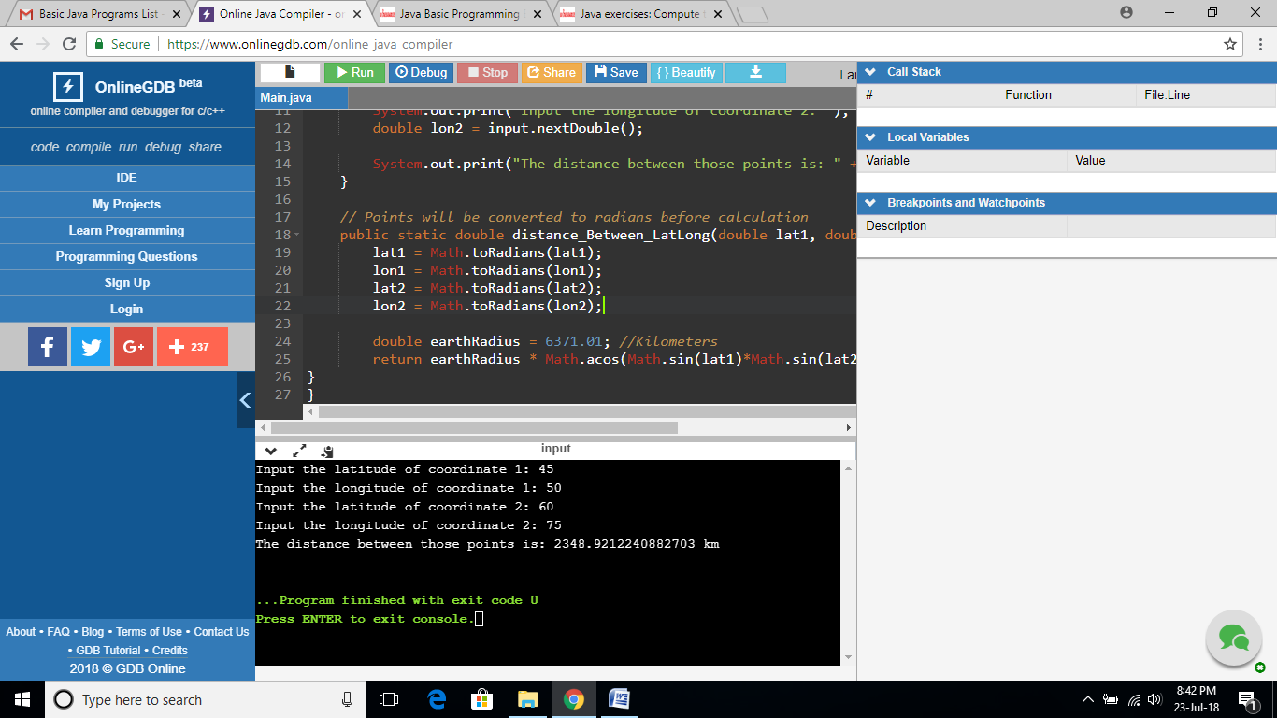

**EXERCISE 37:**

import java.util.Scanner;

public class Main {

public static void main(String[] args) {

Scanner scanner = new Scanner(System.in);

System.out.print("Input a string: ");

char[] letters = scanner.nextLine().toCharArray();

System.out.print("Reverse string: ");

for (int i = letters.length - 1; i >= 0; i--) {

System.out.print(letters[i]);

}

System.out.print("\n");

}

}

**OUTPUT:**

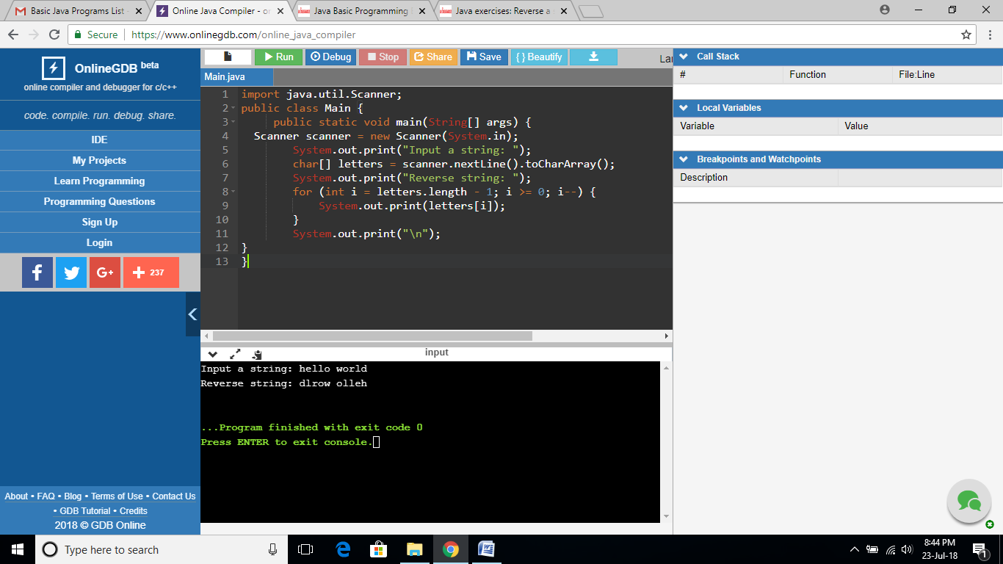

**EXERCISE 38:**

import java.util.Scanner;

public class Main {

public static void main(String[] args) {

String test = "Hello Kirubu, I am Ilakiyasree. how are yoy?? 44.56";

count(test);

}

public static void count(String x){

char[] ch = x.toCharArray();

int letter = 0;

int space = 0;

int num = 0;

int other = 0;

for(int i = 0; i < x.length(); i++){

if(Character.isLetter(ch[i])){

letter ++ ;

}

else if(Character.isDigit(ch[i])){

num ++ ;

}

else if(Character.isSpaceChar(ch[i])){

space ++ ;

}

else{

other ++;

}

}

System.out.println("The string is : Hello Kirubu, I am Ilakiyasree. how are yoy?? 44.56");

System.out.println("letter: " + letter);

System.out.println("space: " + space);

System.out.println("number: " + num);

System.out.println("other: " + other);

}

}

**OUTPUT:**

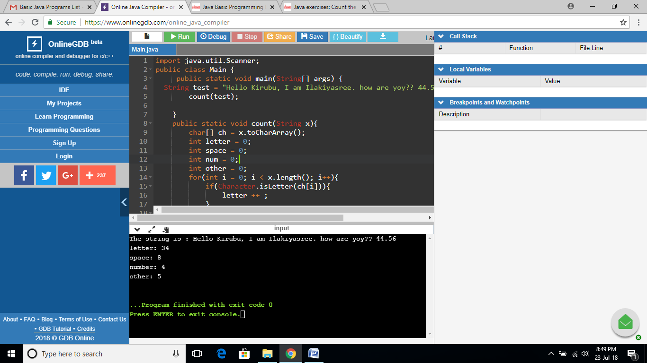

**EXERCISE 39:**

import java.util.Scanner;

public class Main {

public static void main(String[] args) {

int amount = 0;

for(int i = 1; i <= 4; i++){

for(int j = 1; j <= 4; j++){

for(int k = 1; k <= 4; k++){

if(k != i && k != j && i != j){

amount++;

System.out.println(i + "" + j + "" + k);

}

}

}

}

System.out.println("Total number of the three-digit-number is " + amount);

}

}

**OUTPUT:**

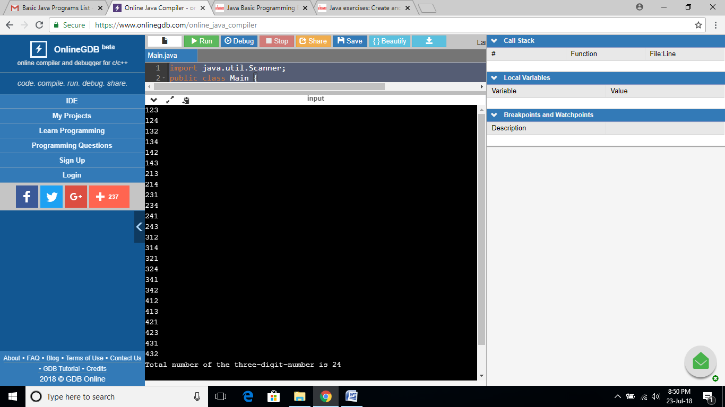

**EXERCISE 40:**

import java.nio.charset.Charset;

public class Main {

public static void main(String[] args) {

System.out.println("List of available character sets: ");

for (String str : Charset.availableCharsets().keySet()) {

System.out.println(str);

}

}

}

**OUTPUT:**

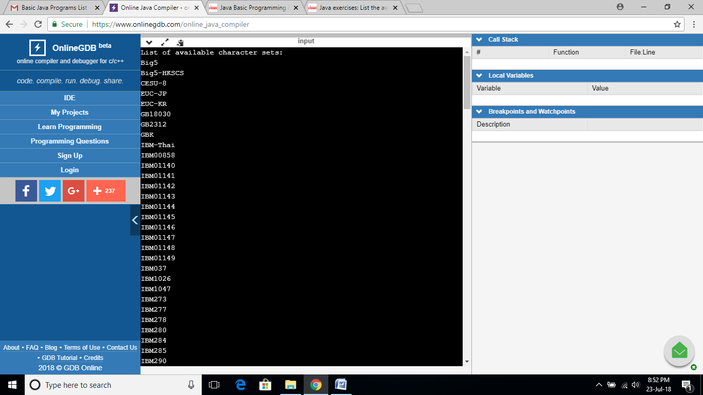

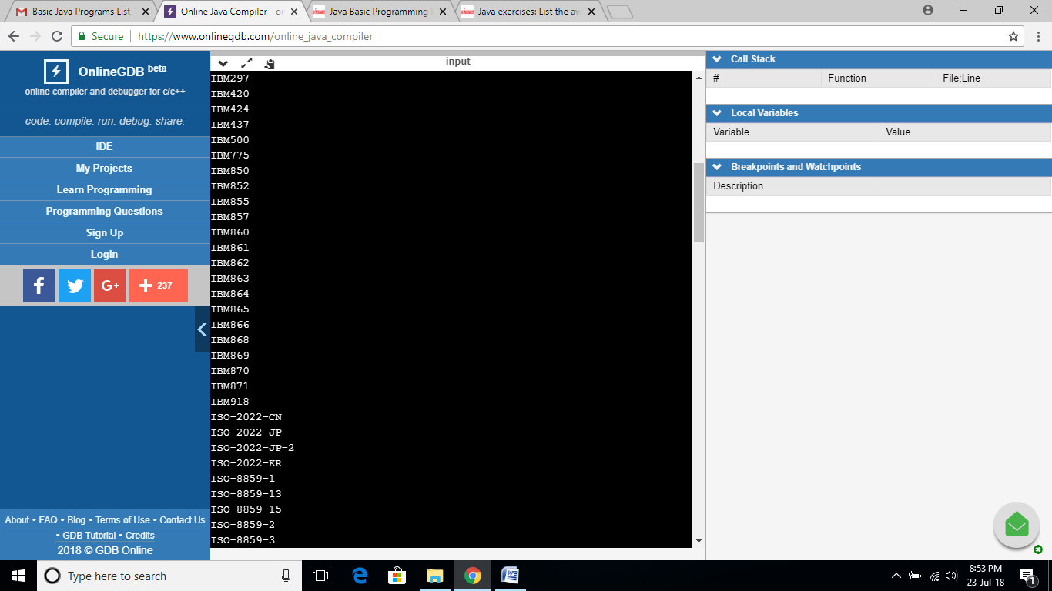

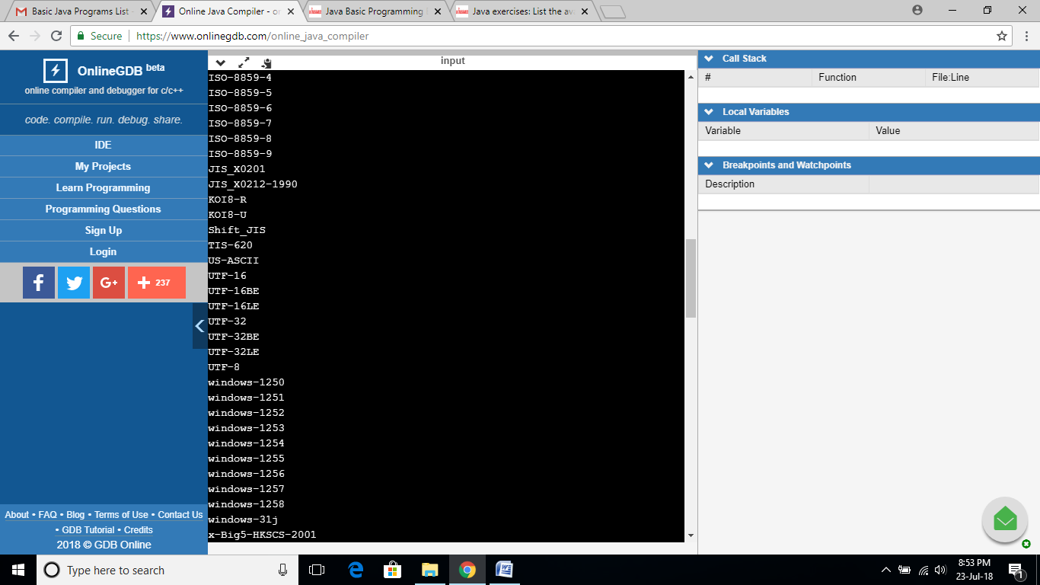

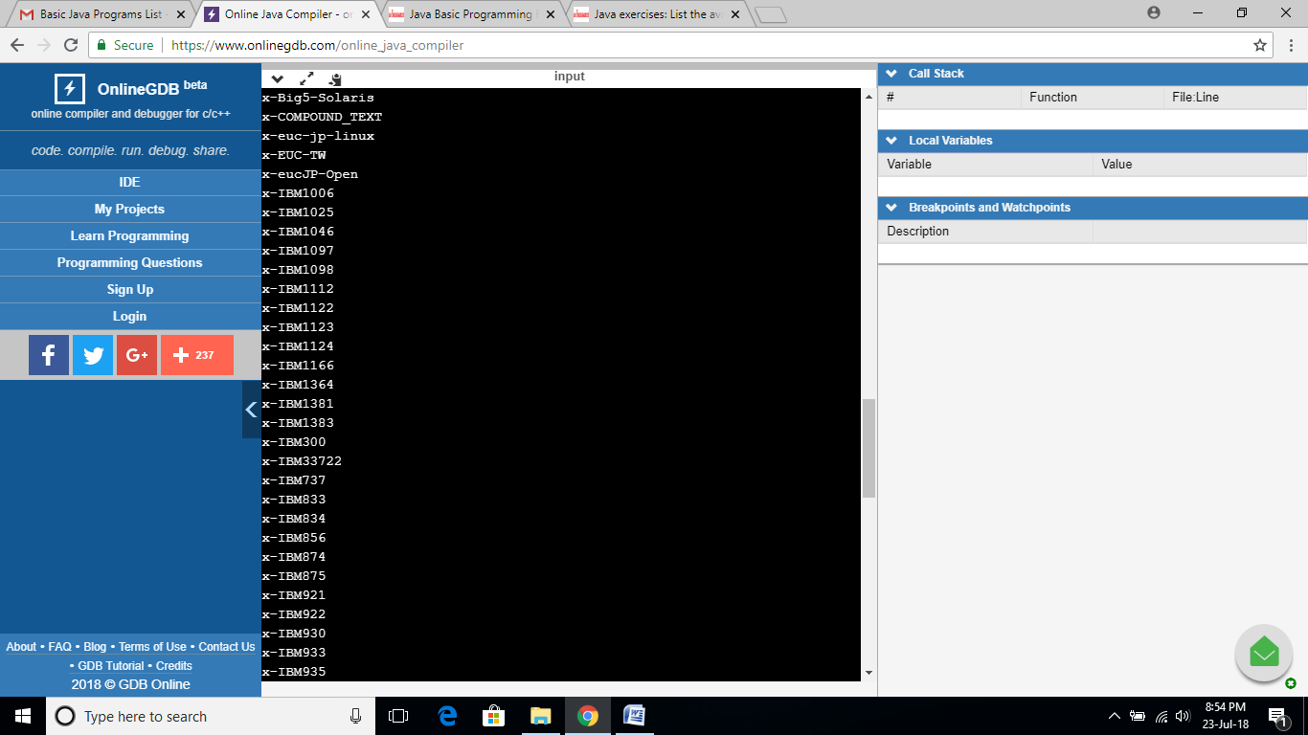

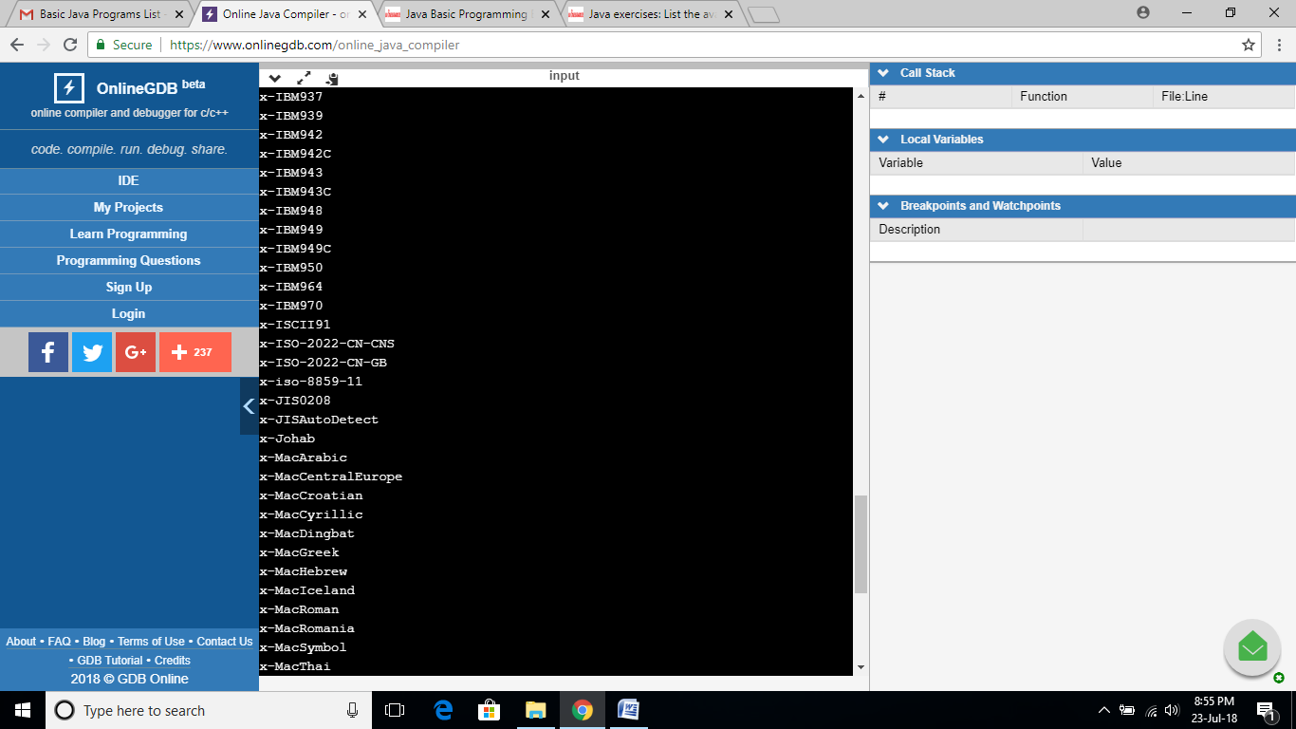

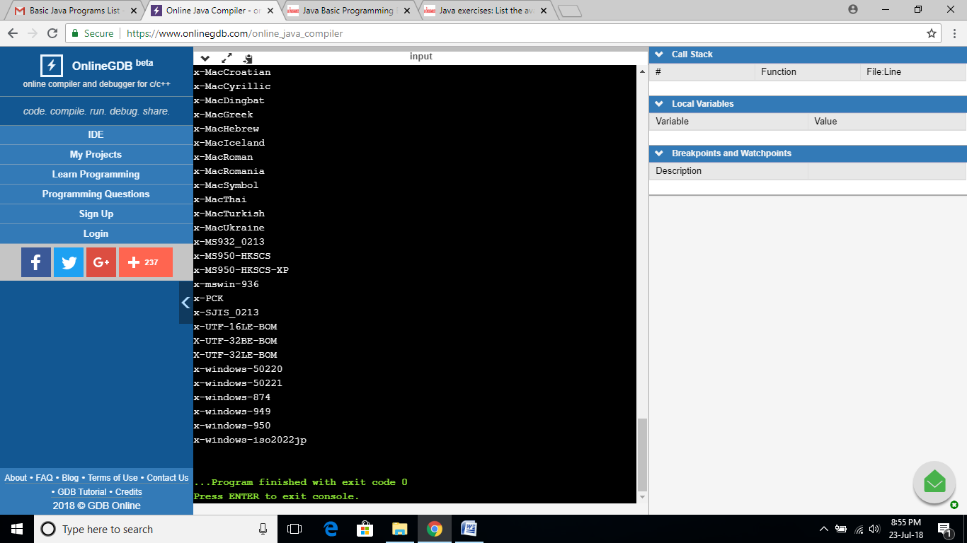

**EXERCISE 41:**

public class Main

{

public static void main(String[] args) {

int chr = 'Z';

System.out.println("The ASCII value of Z is :"+chr);

}

}

**OUTPUT:**

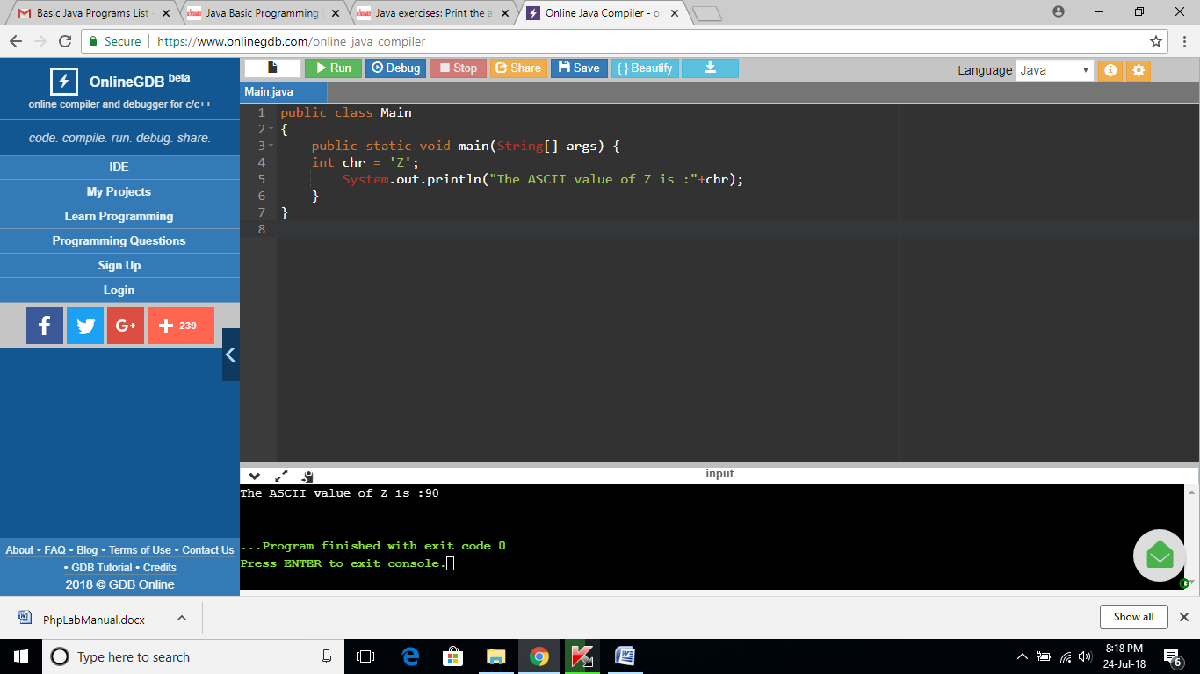

**EXERCISE 42:**

import java.io.Console;

public class Main

{

public static void main(String[] args) {

Console cons;

if ((cons = System.console()) != null) {

char[] pass_ward = null;

try {

pass_ward = cons.readPassword("Input your Password:");

System.out.println("Your password was: " + new String(pass_ward));

} finally {

if (pass_ward != null) {

java.util.Arrays.fill(pass_ward, ' ');

}

}

} else {

throw new RuntimeException("Can't get password...No console");

}

}

}

**OUTPUT:**

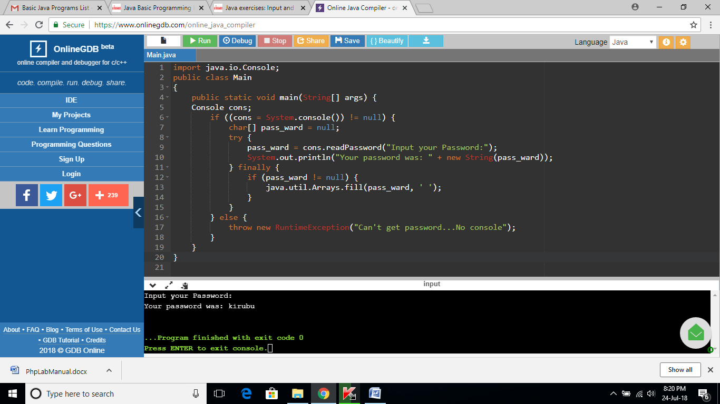

**EXERCISE 43:**

public class Main

{

public static void main(String[] args) {

System.out.println("\nTwinkle, twinkle, little star, \n\tHow I wonder what you are! \n\t\tUp above the world so high, \n\t\tLike a diamond in the sky. \nTwinkle, twinkle, little star, \n\tHow I wonder what you are!\n\n");

}

}

**OUTPUT:**

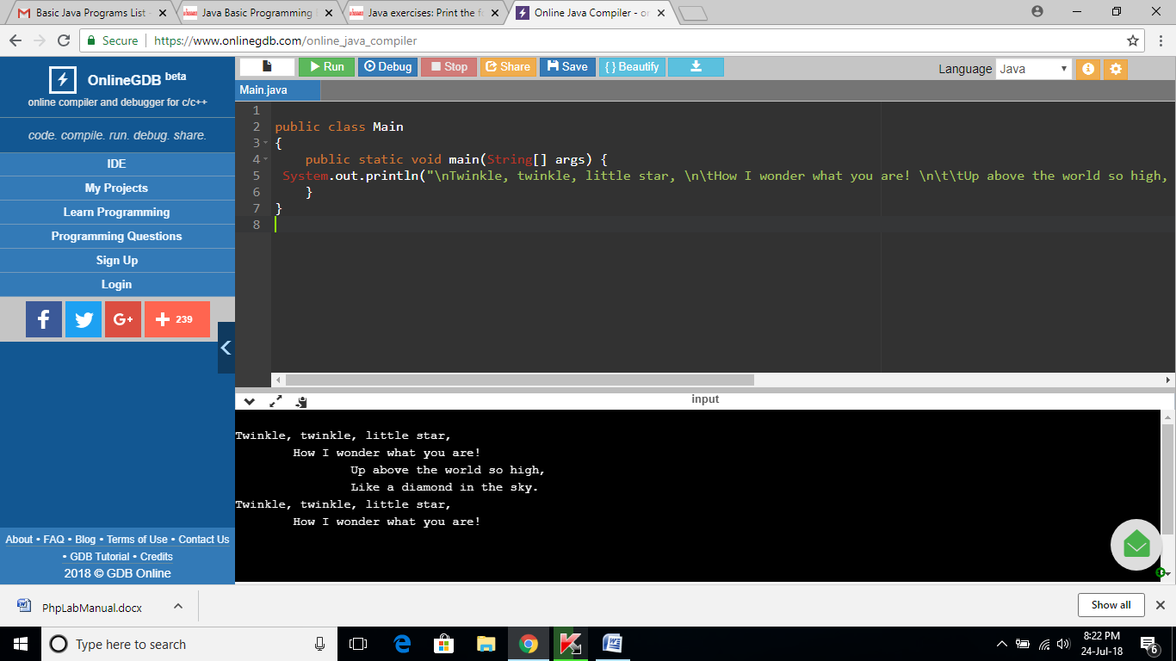

**EXERCISE 44:**

import java.util.Scanner;

public class Main

{

public static void main(String[] args) {

int n;

char s1, s2, s3;

Scanner in = new Scanner(System.in);

System.out.print("Input number: ");

n = in .nextInt();

System.out.printf("%d + %d%d + %d%d%d\n", n, n, n, n, n, n);

}

}

**OUTPUT:**

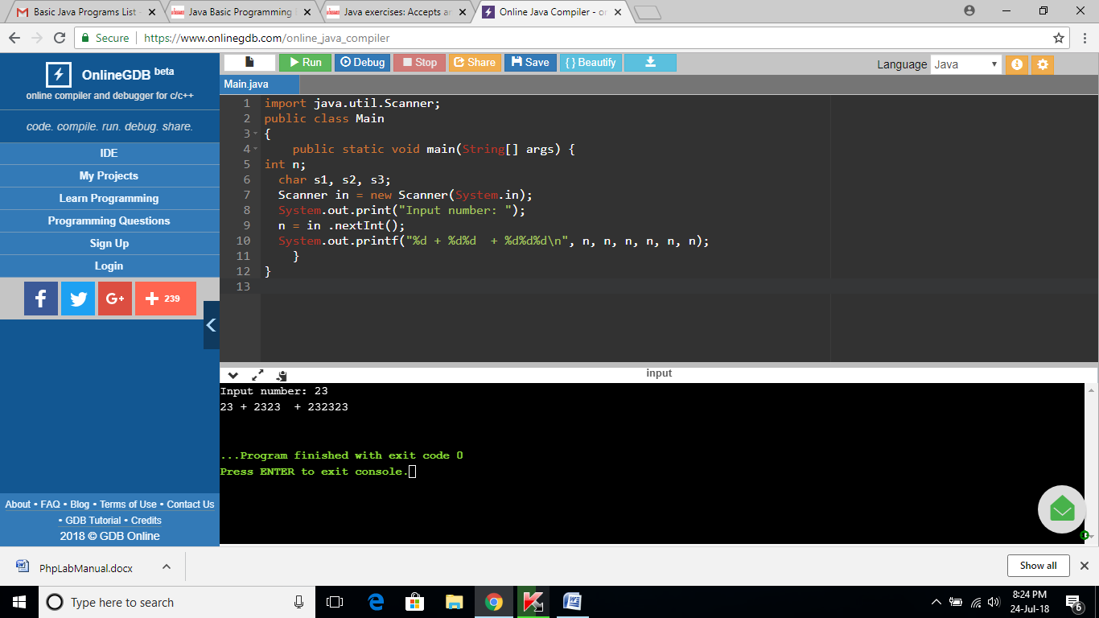

**EXERCISE 45:**

import java.util.Scanner;

import java.io.File;

public class Main

{

public static void main(String[] args) {

System.out.println("/home/students/abc.txt : " + new File("abc.txt").length() + " bytes");

System.out.println("/home/students/test.txt : " + new File("test.txt").length() + " bytes");

}

}

**OUTPUT:**

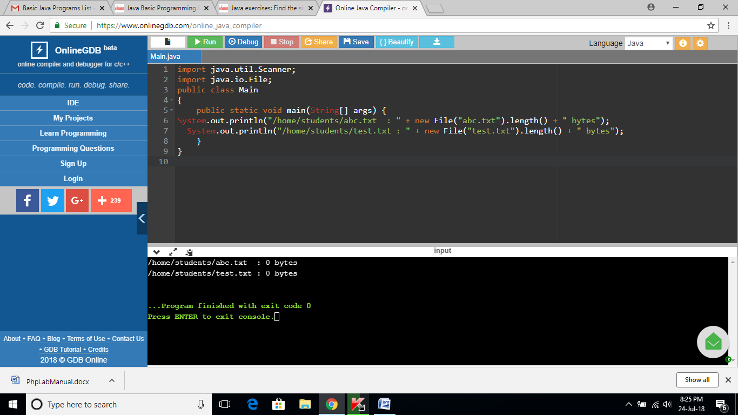

**EXERCISE 46:**

import java.util.Scanner;

public class Main

{

public static void main(String[] args) {

System.out.format("\nCurrent Date time: %tc%n\n", System.currentTimeMillis());

}

}

**OUTPUT:**

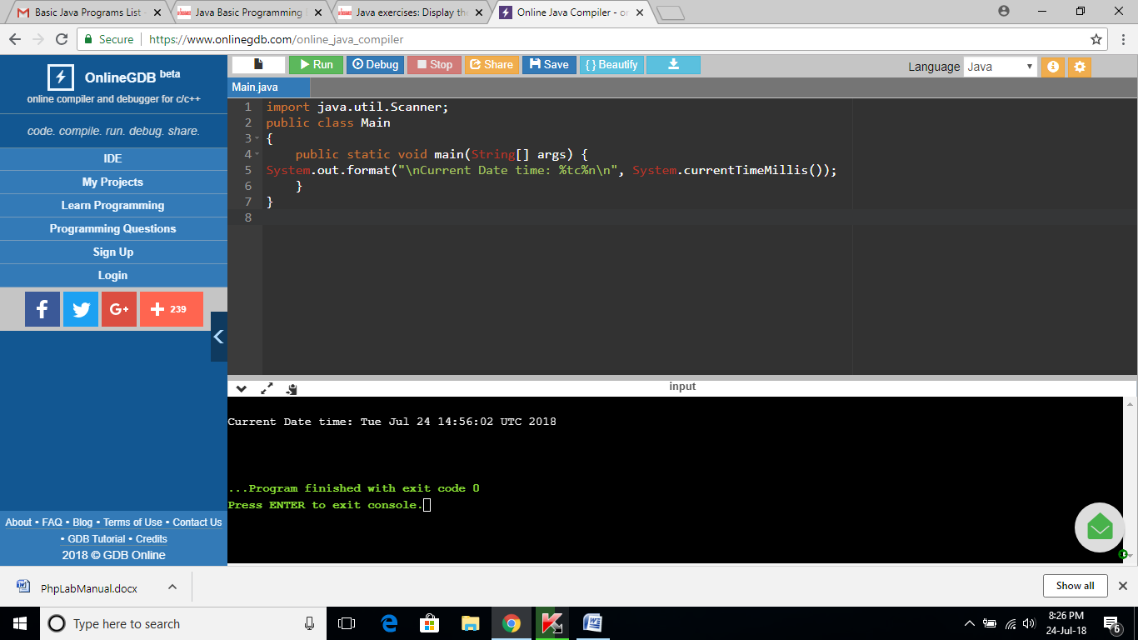

**EXERCISE4 7:**

import java.text.SimpleDateFormat;

import java.util.Calendar;

import java.util.TimeZone;

public class Main

{

public static void main(String[] args) {

SimpleDateFormat cdt = new SimpleDateFormat("yyyy/MM/dd HH:mm:ss.SSS");

cdt.setCalendar(Calendar.getInstance(TimeZone.getTimeZone("GMT")));

System.out.println("\nNow: "+cdt.format(System.currentTimeMillis()));

}

}

**OUTPUT:**

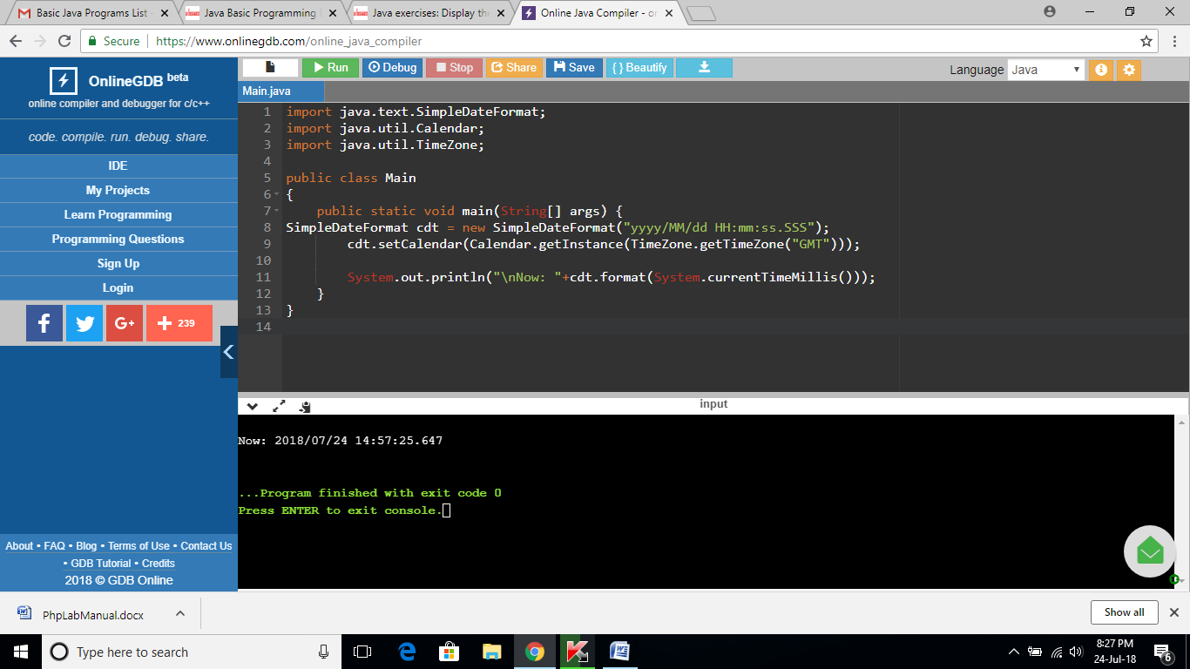

**EXERCISE 48:**

import java.util.*;

public class Main

{

public static void main(String[] args) {

for (int i = 1; i < 100; i++) {

if (i % 2 != 0) {

System.out.println(i);

}

}

}

}

**OUTPUT:**

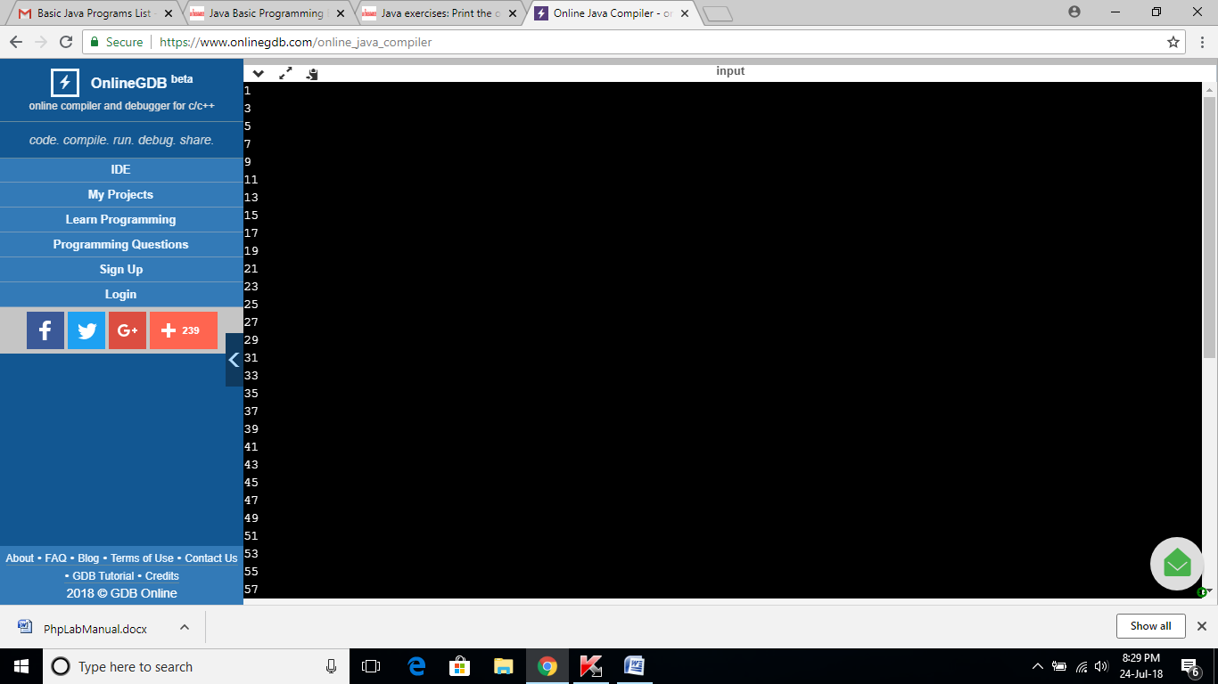

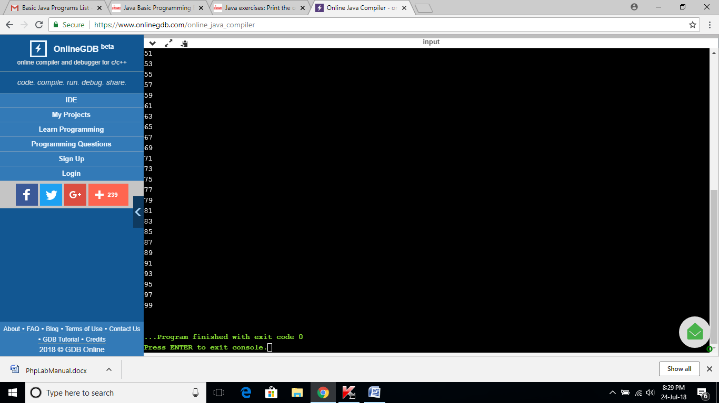

**EXERCISE 49:**

import java.util.*;

public class Main

{

public static void main(String[] args) {

Scanner in = new Scanner(System.in);

System.out.print("Input a number: ");

int n = in.nextInt();

if (n % 2 == 0) {

System.out.println(1);

}

else {

System.out.println(0);

}

}

}

**OUTPUT:**

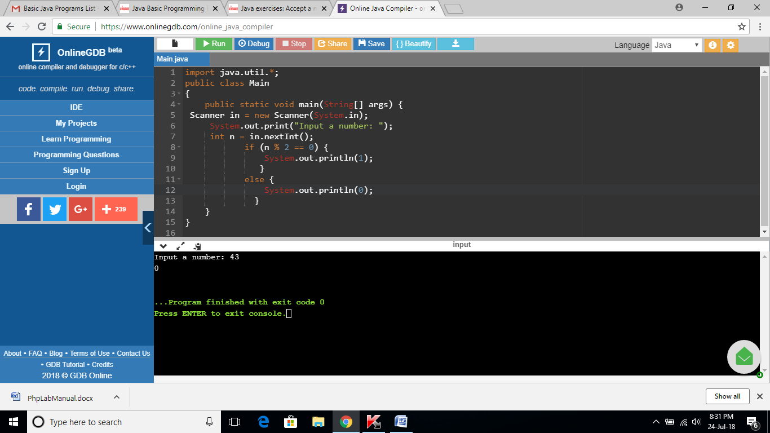

**EXERCISE 50:**

import java.util.*;

public class Main

{

public static void main(String[] args) {

System.out.println("\nDivided by 3: ");

for (int i=1; i<100; i++) {

if (i%3==0)

System.out.print(i +", ");

}

System.out.println("\n\nDivided by 5: ");

for (int i=1; i<100; i++) {

if (i%5==0) System.out.print(i +", ");

}

System.out.println("\n\nDivided by 3 & 5: ");

for (int i=1; i<100; i++) {

if (i%3==0 && i%5==0) System.out.print(i +", ");

}

System.out.println("\n");

}

}

**OUTPUT:**

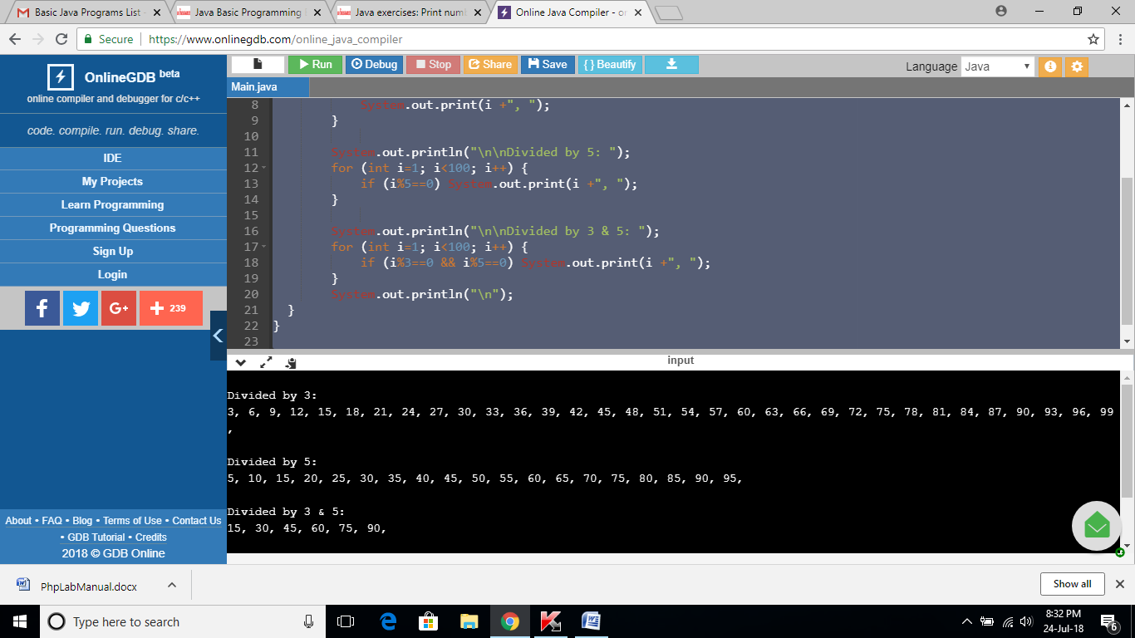

**EXERCISE 51:**

import java.util.*;

public class Main

{

public static void main(String[] args) {

Scanner in = new Scanner(System.in);

System.out.print("Input a number(string): ");

String str1 = in.nextLine();

int result = Integer.parseInt(str1);

System.out.printf("The integer value is: %d",result);

System.out.printf("\n");

}

}

**OUTPUT:**

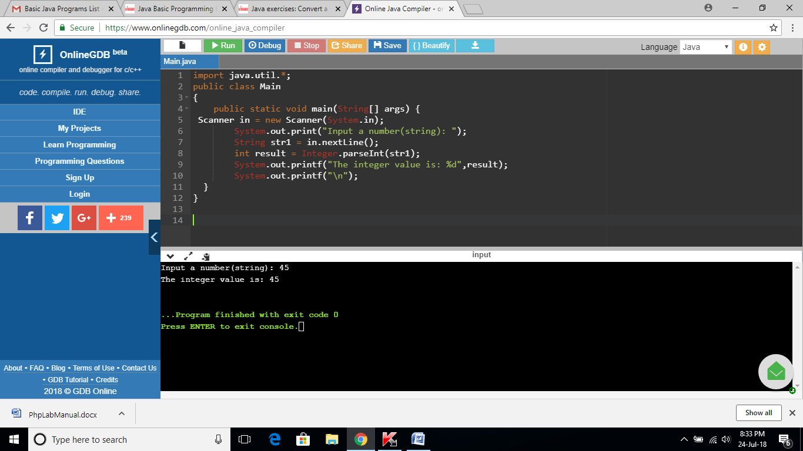

**EXERCISE 52:**

import java.util.*;

public class Main

{

public static void main(String[] args) {

Scanner in = new Scanner(System.in);

System.out.print("Input the first number : ");

int x = in.nextInt();

System.out.print("Input the second number: ");

int y = in.nextInt();

System.out.print("Input the third number : ");

int z = in.nextInt();

System.out.print("The result is: "+sumoftwo(x, y, z));

System.out.print("\n");

}

public static boolean sumoftwo(int p, int q, int r)

{

return ((p + q) == r || (q + r) == p || (r + p) == q);

}

}

**OUTPUT:**

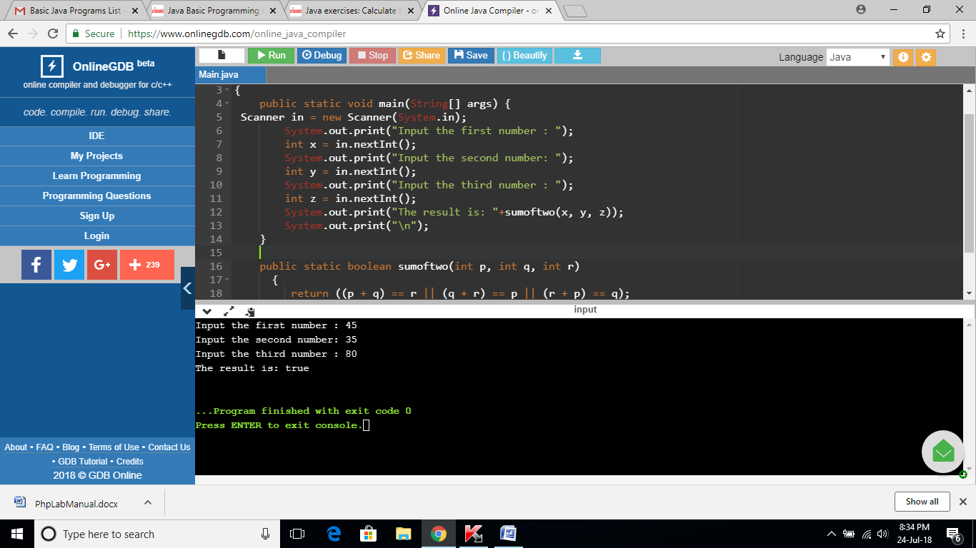

**EXERCISE 53:**

import java.util.*;

public class Main

{

public static void main(String[] args) {

Scanner in = new Scanner(System.in);

System.out.print("Input the first number : ");

int x = in.nextInt();

System.out.print("Input the second number: ");

int y = in.nextInt();

System.out.print("Input the third number : ");

int z = in.nextInt();

System.out.print("The result is: "+abc(x, y, z,true));

System.out.print("\n");

}

public static boolean abc(int p, int q, int r, boolean xyz)

{

if(xyz)

return (r > q);

return (q > p && r > q);

}

}

**OUTPUT:**

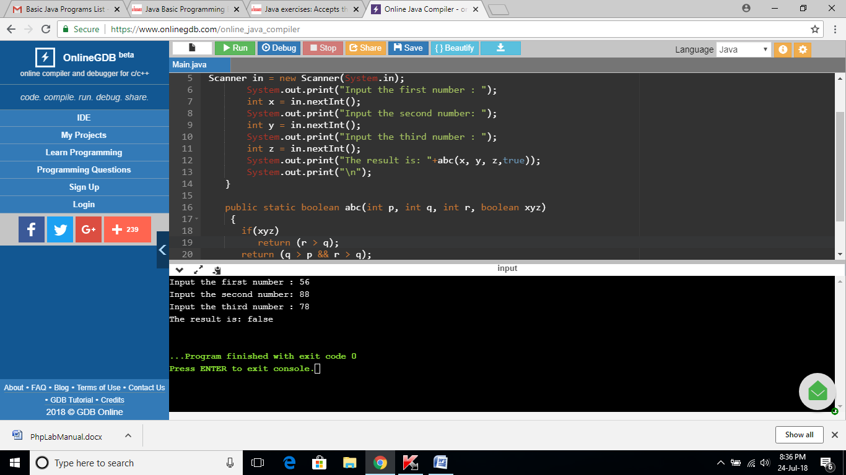

**EXERCISE 54:**

import java.util.*;

public class Main

{

public static void main(String[] args) {

Scanner in = new Scanner(System.in);

System.out.print("Input the first number : ");

int x = in.nextInt();

System.out.print("Input the second number: ");

int y = in.nextInt();

System.out.print("Input the third number : ");

int z = in.nextInt();

System.out.print("The result is: "+test_last_digit(x, y, z,true));

System.out.print("\n");

}

public static boolean test_last_digit(int p, int q, int r, boolean xyz)

{

return (p % 10 == q % 10) || (p % 10 == r % 10) || (q % 10 == r % 10);

}

}

**OUTPUT:**

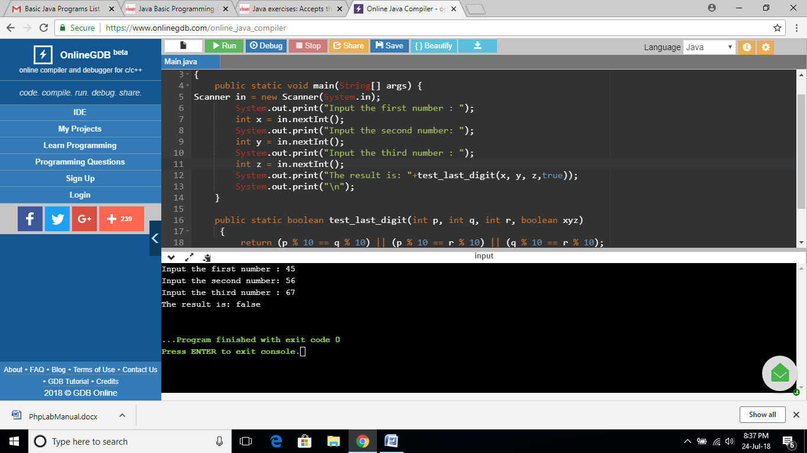

**EXERCISE 55:**

import java.util.*;

public class Main

{

public static void main(String[] args) {

Scanner in = new Scanner(System.in);

System.out.print("Input seconds: ");

int seconds = in.nextInt();

int p1 = seconds % 60;

int p2 = seconds / 60;

int p3 = p2 % 60;

p2 = p2 / 60;

System.out.print( p2 + ":" + p3 + ":" + p1);

System.out.print("\n");

}

}

**OUTPUT:**

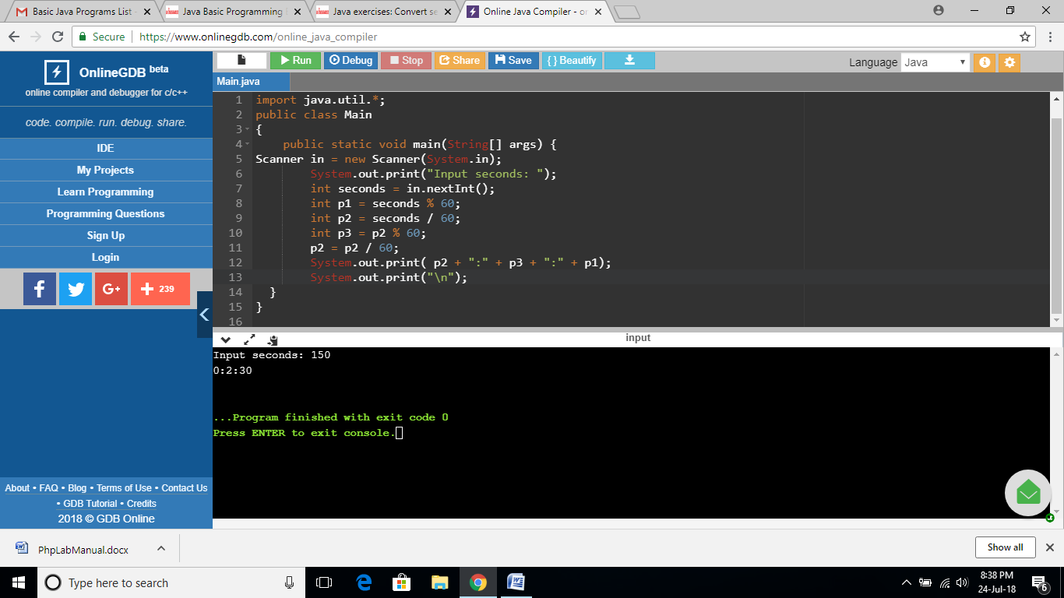

**EXERCISE 56:**

import java.util.*;

public class Main

{

public static void main(String[] args) {

int x = 5;

int y = 20;

int p = 3;

System.out.println(result(x,y,p));

}

public static int result(int x, int y, int p) {

if (x%p == 0)

return( y/p - x/p + 1);

return(y/p - x/p);

}

}

**OUTPUT:**

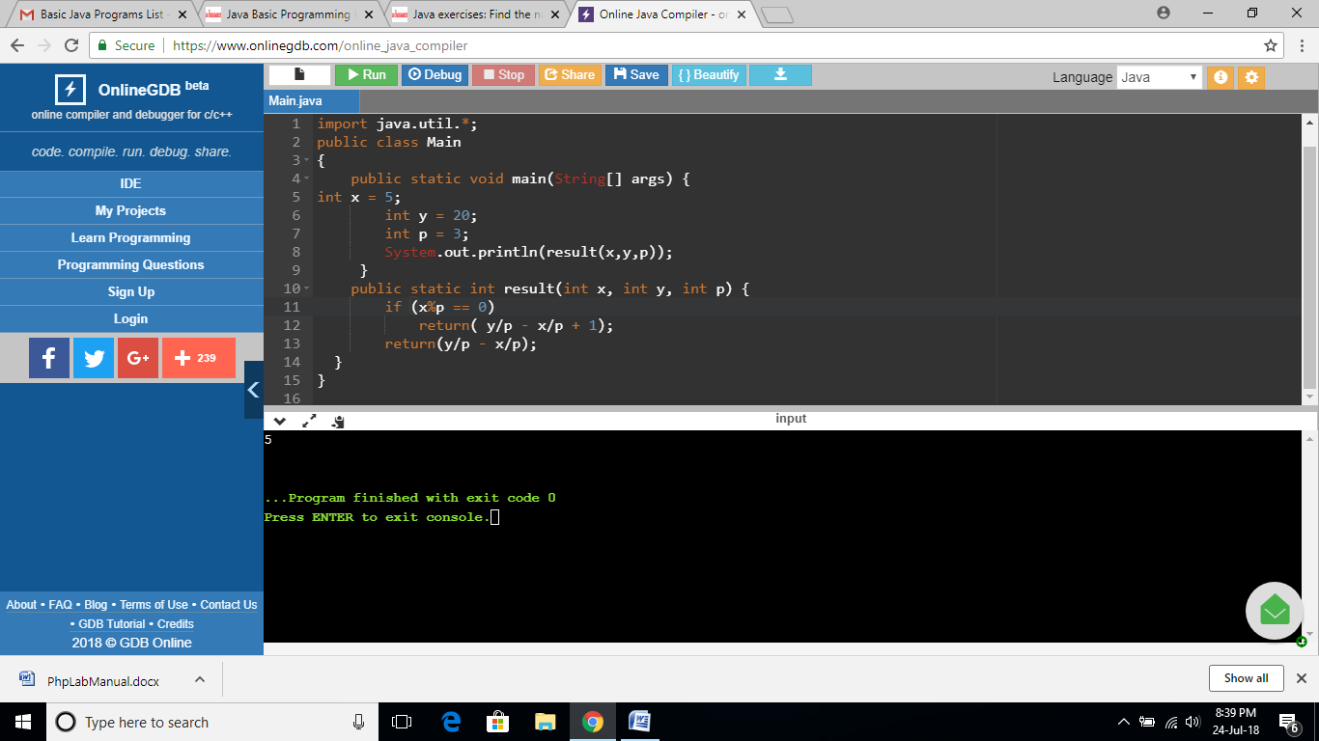

**EXERCISE 57:**

import java.util.*;

public class Main

{

public static void main(String[] args) {

Scanner in = new Scanner(System.in);

System.out.print("Input an integer: ");

int x = in.nextInt();

System.out.println(result(x));

}

public static int result(int num) {

int ctr = 0;

for(int i=1; i<=(int)Math.sqrt(num); i++) {

if(num%i==0 && i*i!=num) {

ctr+=2;

} else if (i*i==num) {

ctr++;

}

}

return ctr;

}

}

**OUTPUT:**

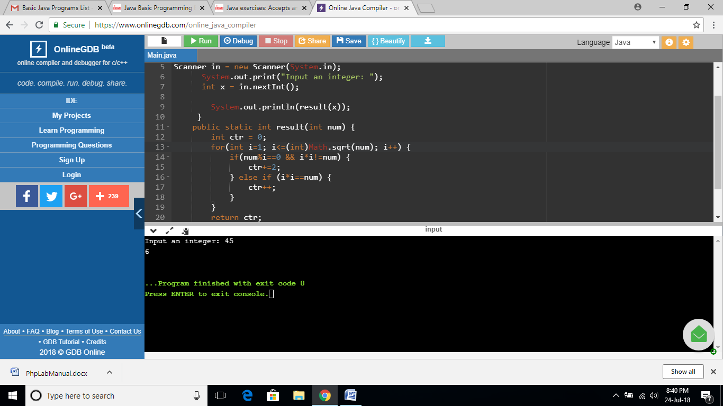

**EXERCISE 58:**

import java.util.*;

public class Main

{

public static void main(String[] args) {

Scanner in = new Scanner(System.in);

System.out.print("Input a Sentence: ");

String line = in.nextLine();

String upper_case_line = "";

Scanner lineScan = new Scanner(line);

while(lineScan.hasNext()) {

String word = lineScan.next();

upper_case_line += Character.toUpperCase(word.charAt(0)) + word.substring(1) + " ";

}

System.out.println(upper_case_line.trim());

}

}

**OUTPUT:**

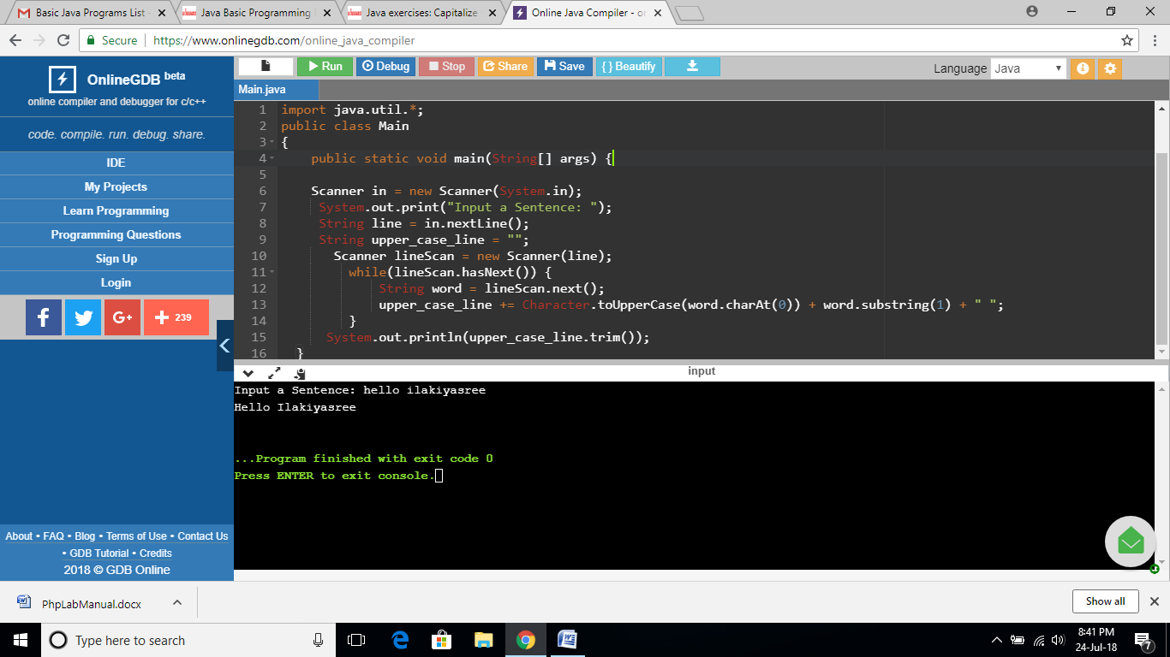

**EXERCISE 59:**

import java.util.*;

public class Main

{

public static void main(String[] args) {

Scanner in = new Scanner(System.in);

System.out.print("Input a String: ");

String line = in.nextLine();

line = line.toLowerCase();

System.out.println(line);

}

}

**OUTPUT:**

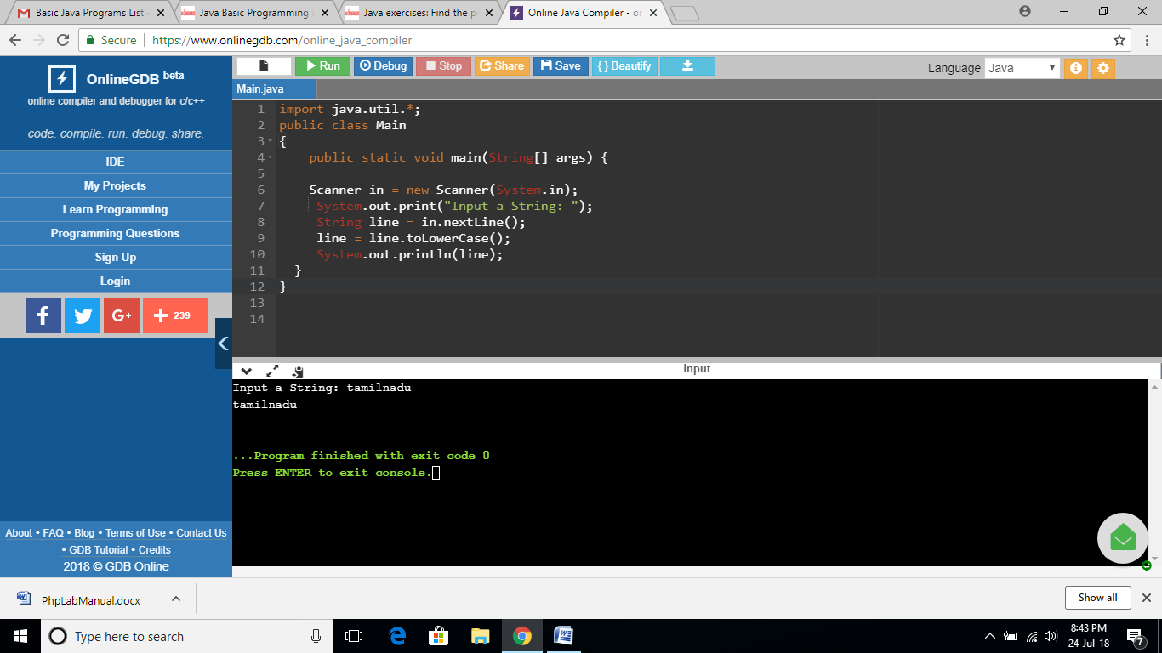

**EXERCISE 60:**

import java.util.*;

public class Main

{

public static void main(String[] args) {

Scanner in = new Scanner(System.in);

System.out.print("Input a Sentence: ");

String line = in.nextLine();

String[] words = line.split("[ ]+");

System.out.println("Penultimate word: "+words[words.length - 2]);

}

}

**OUTPUT:**

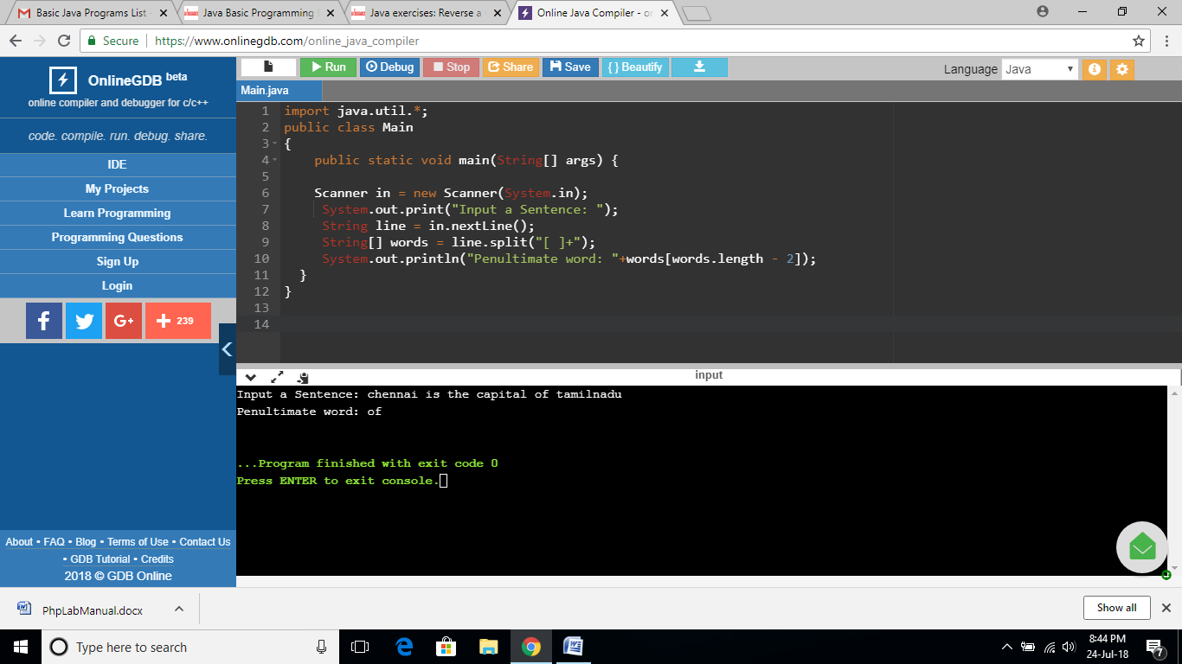

**EXERCISE 61:**

import java.util.*;

public class Main

{

public static void main(String[] args) {

Scanner in = new Scanner(System.in);

System.out.print("\nInput a word: ");

String word = in.nextLine();

word = word.trim();

String result = "";

char[] ch=word.toCharArray();

for (int i = ch.length - 1; i >= 0; i--) {

result += ch[i];

}

System.out.println("Reverse word: "+result.trim());

}

}

**OUTPUT:**

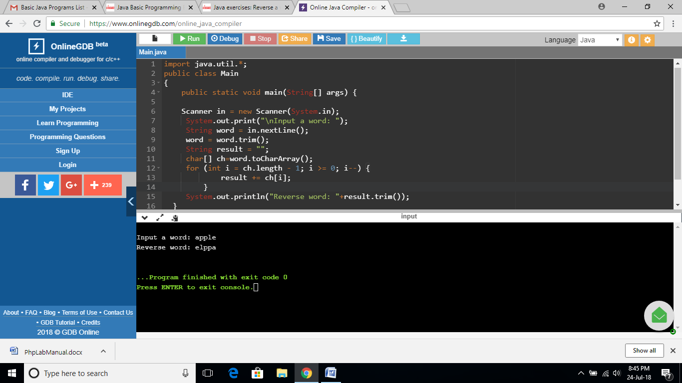

**EXERCISE 62:**

import java.util.*;

public class Main

{

public static void main(String[] args) {

Scanner in = new Scanner(System.in);

System.out.print("Input the first number : ");

int x = in.nextInt();

System.out.print("Input the second number: ");

int y = in.nextInt();

System.out.print("Input the third number : ");

int z = in.nextInt();

System.out.println((Math.abs(x - y) >= 20 || Math.abs(y - z) >= 20 || Math.abs(z - x) >= 20));

}

}

**OUTPUT:**

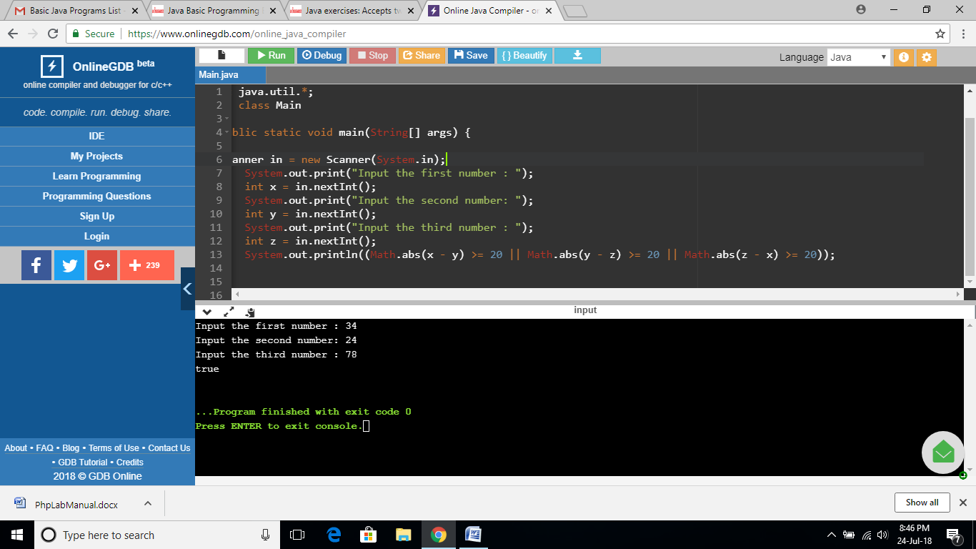

**EXERCISE 63:**

import java.util.*;

public class Main

{

public static void main(String[] args) {

Scanner in = new Scanner(System.in);

System.out.print("Input the first number : ");

int a = in.nextInt();

System.out.print("Input the second number: ");

int b = in.nextInt();

System.out.println("Result: "+result(a, b));

}

public static int result(int x, int y)

{

if(x == y)

return 0;

if(x % 6 == y % 6)

return (x < y) ? x : y;

return (x > y) ? x : y;

}

}

**OUTPUT:**

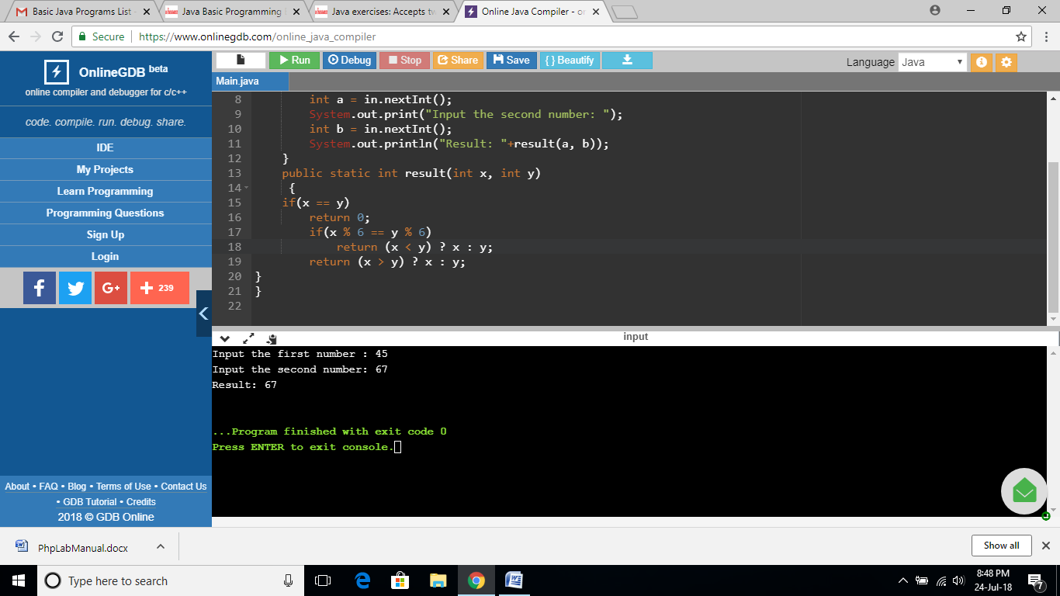

**EXERCISE 64:**

import java.util.*;

public class Main

{

public static void main(String[] args) {

Scanner in = new Scanner(System.in);

System.out.print("Input the first number : ");

int a = in.nextInt();

System.out.print("Input the second number: ");

int b = in.nextInt();

System.out.println("Result: "+common_digit(a, b));

}

public static boolean common_digit(int p, int q)

{

if (p<25 || q>75)

return false;

int x = p % 10;

int y = q % 10;

p /= 10;

q /= 10;

return (p == q || p == y || x == q || x == y);

}

}

**OUTPUT:**

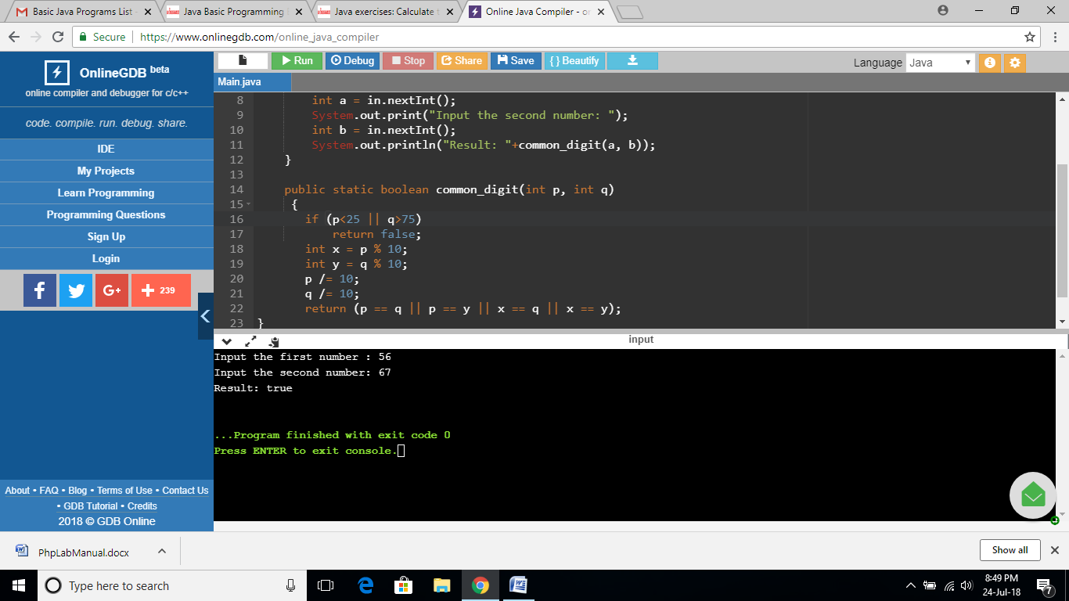

**EXERCISE 65:**

import java.util.*;

public class Main

{

public static void main(String[] args) {

Scanner in = new Scanner(System.in);

System.out.print("Input the first number : ");

int a = in.nextInt();

System.out.print("Input the second number: ");

int b = in.nextInt();

int divided = a / b;

int result = a - (divided * b);

System.out.println(result);

}

}

**OUTPUT:**

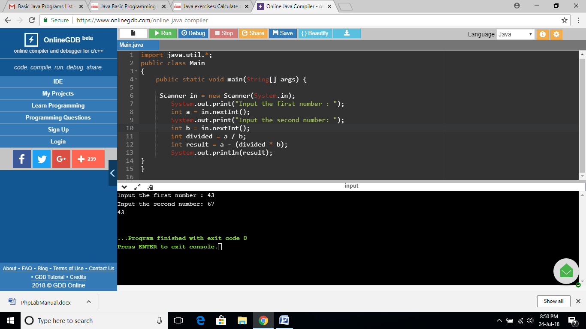

**EXERCISE 66:**

import java.util.*;

public class Main

{

public static void main(String[] args) {

int sum = 1;

int ctr = 0;

int n = 0;

while (ctr < 100) {

n++;

if (n % 2 != 0) {

// check if the number is even

if (is_Prime(n)) {

sum += n;

ctr++;

}

}

}

System.out.println("\nSum of the first 100 prime numbers: "+sum);

}

public static boolean is_Prime(int n) {

for (int i = 3; i * i <= n; i+= 2) {

if (n % i == 0) {

return false;

}

}

return true;

}

}

**OUTPUT:**

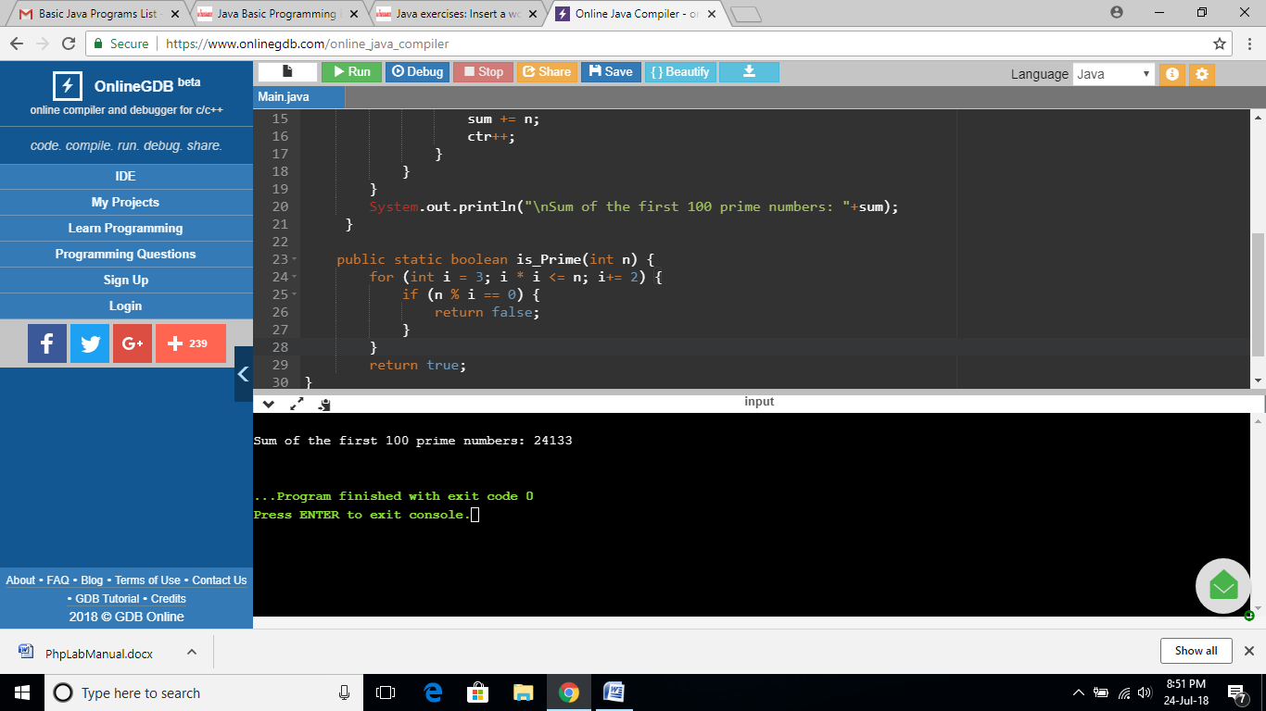

**EXERCISE 67:**

import java.util.*;

public class Main

{

public static void main(String[] args) {

String main_string = "Python 3.0";

String word = "Tutorial";

System.out.println(main_string.substring(0, 7) + word + main_string.substring(6));

}

}

**OUTPUT:**

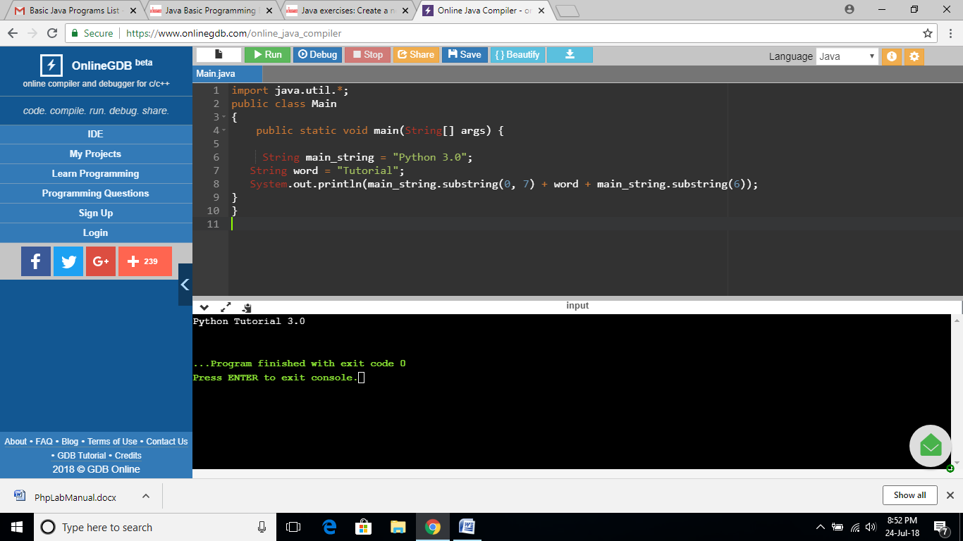

**EXERCISE 68:**

import java.util.*;

public class Main

{

public static void main(String[] args) {

String main_string = "Python 3.0";

String last_three_chars = main_string.substring(main_string.length() - 3);

System.out.println(last_three_chars + last_three_chars + last_three_chars + last_three_chars);

}

}

**OUTPUT:**

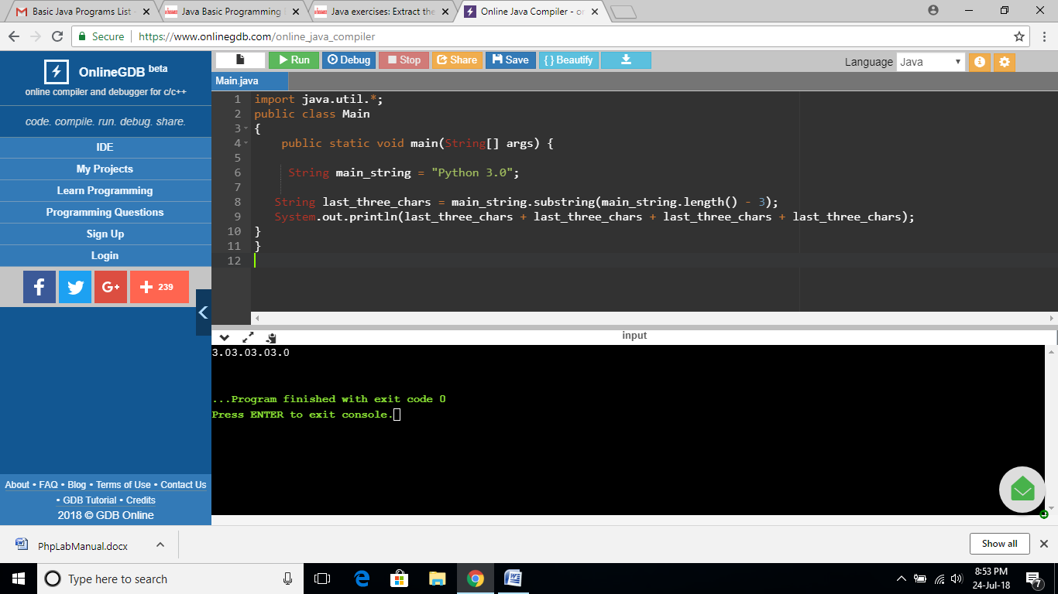

**EXERCISE 69:**

import java.util.*;

public class Main

{

public static void main(String[] args) {

String main_string = "Python";

System.out.println(main_string.substring(0, main_string.length()/2));

}

}

**OUTPUT:**

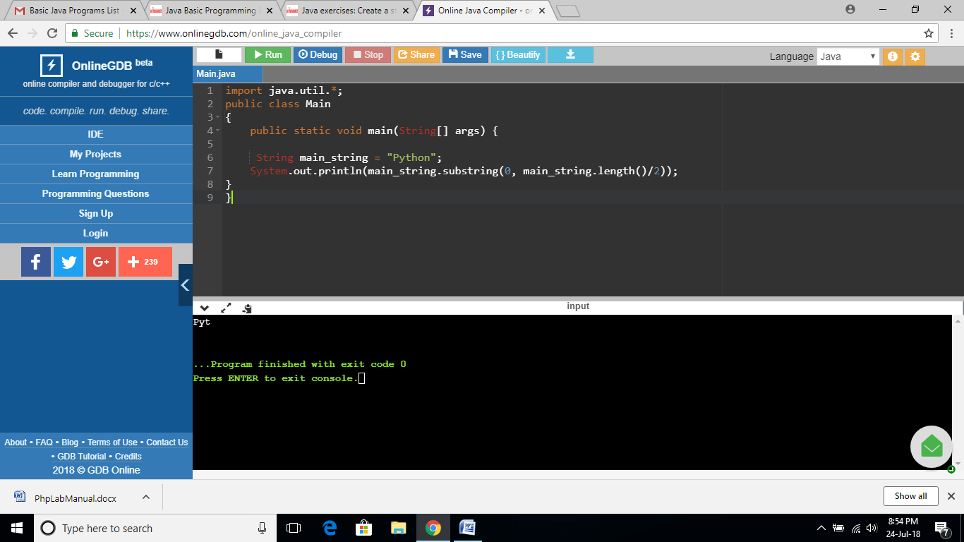

**EXERCISE 70:**

import java.util.*;

public class Main

{

public static void main(String[] args) {

String str1 = "Python";

String str2 = "Tutorial";

if(str1.length() >= str2.length())

System.out.println( str2+str1+str2);

else

System.out.println(str1+str2+str1);

}

}

**OUTPUT:**

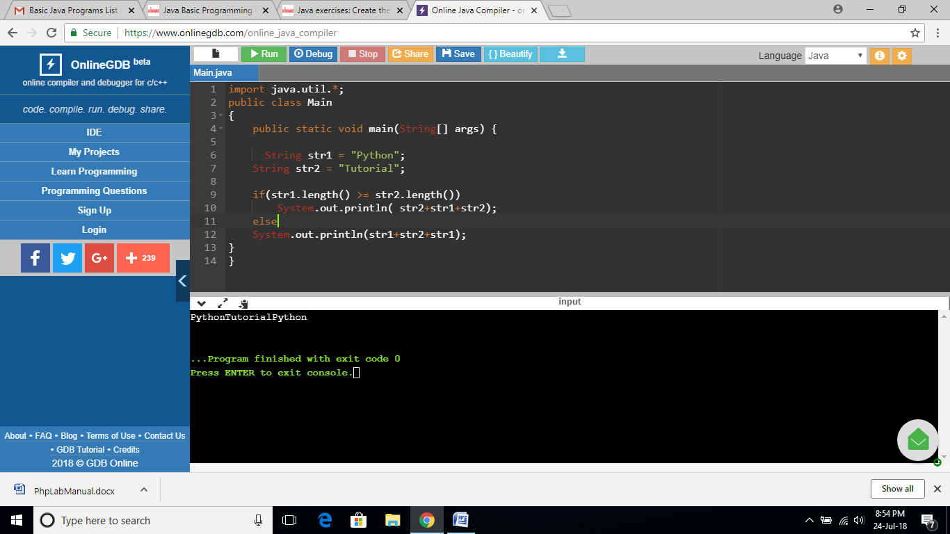

**EXERCISE 71:**

import java.util.*;

public class Main

{

public static void main(String[] args) {

String str1 = "Python";

String str2 = "Tutorial";

System.out.println(str1.substring(1) + str2.substring(1));

}

}

**OUTPUT:**

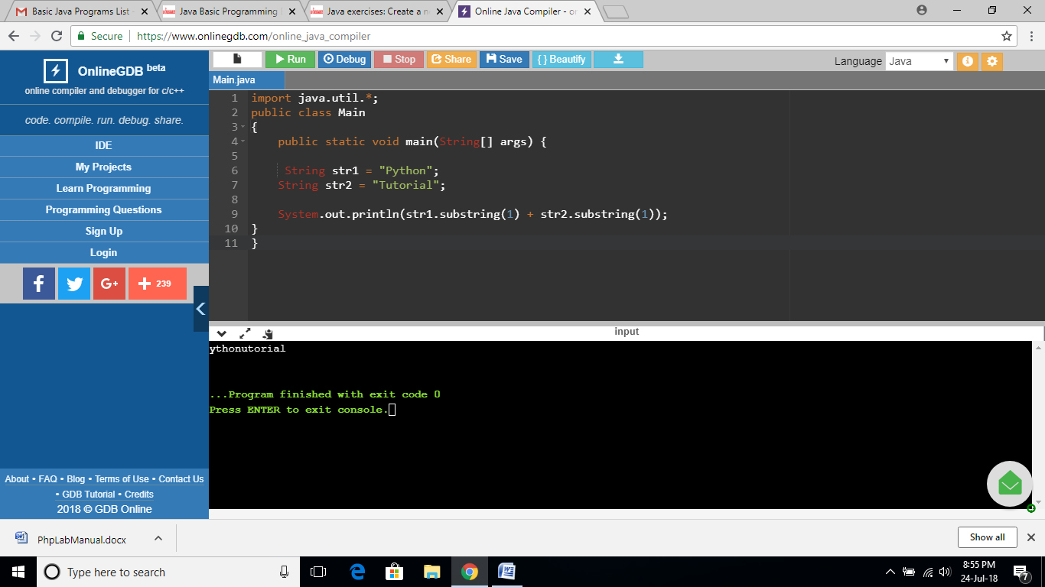

**EXERCISE 72:**

import java.util.*;

public class Main

{

public static void main(String[] args) {

String str1 = "";

int len = str1.length();

if(len >= 3)

System.out.println( str1.substring(0, 3));

else if(len == 1)

System.out.println( (str1.charAt(0)+"##"));

else

System.out.println("###");

}

}

**OUTPUT:**

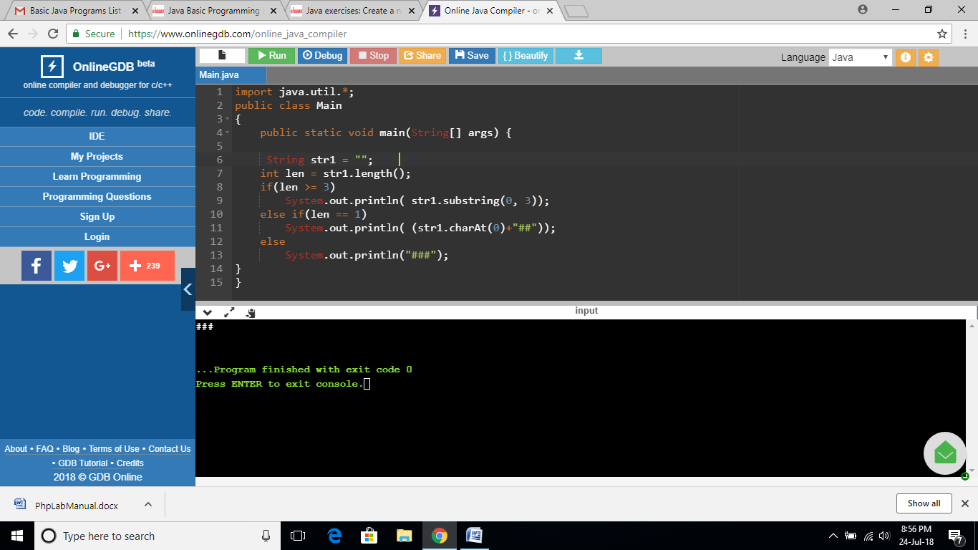

**EXERCISE 73:**

import java.util.*;

public class Main

{

public static void main(String[] args) {

String str1 = "Python";

String str2 = "";

int length2 = str2.length();

String result = "";

result += (str1.length() >= 1) ? str1.charAt(0) : '#';

result += (length2 >= 1) ? str2.charAt(length2-1) : '#';

System.out.println(result);

}

}

**OUTPUT:**

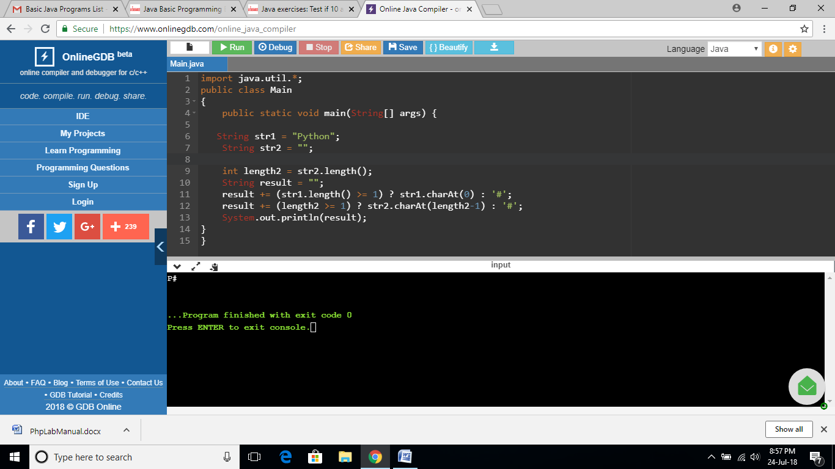

**EXERCISE 74:**

import java.util.*;

public class Main

{

public static void main(String[] args) {

int[] num_array = {10, -20, 0, 30, 40, 60, 10};

System.out.println((num_array[0] == 10 || num_array[num_array.length-1] == 10));

}

}

**OUTPUT:**

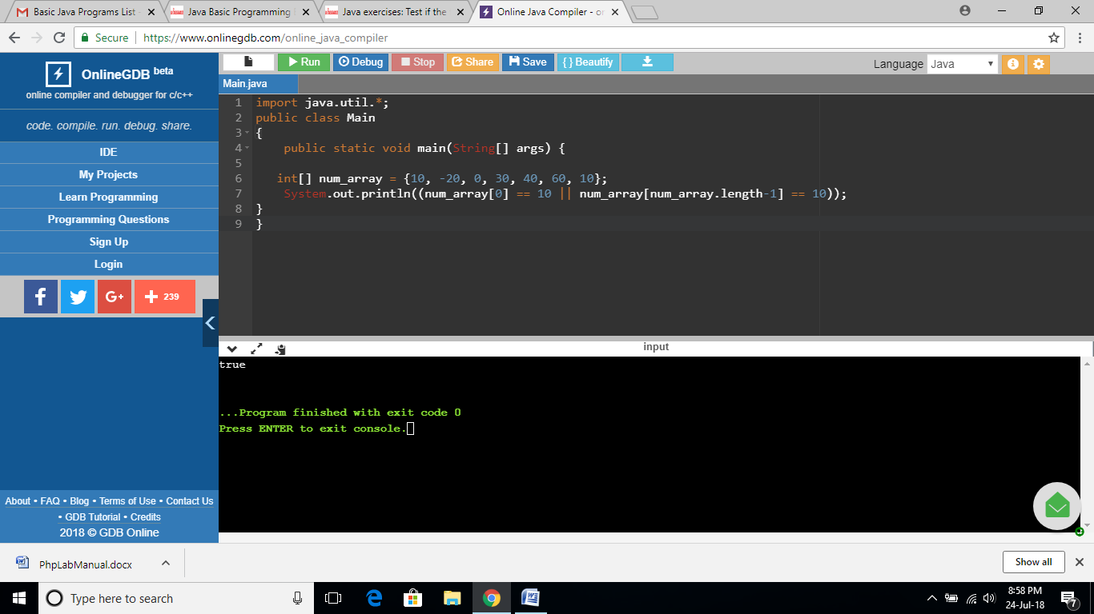

**EXERCISE 75:**

import java.util.*;

public class Main

{

public static void main(String[] args) {

int[] num_array = {50, -20, 0, 30, 40, 60, 10};

System.out.println (num_array.length >= 1 && num_array[0] == num_array[num_array.length-1]);

}

}

**OUTPUT:**

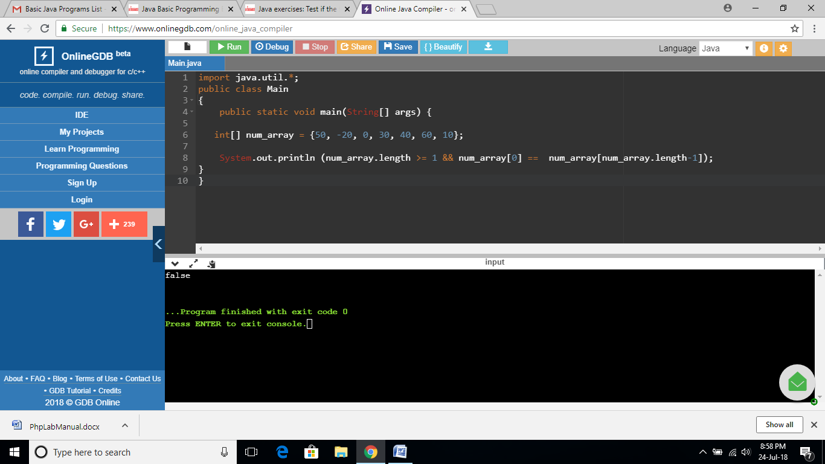

**EXERCISE 76:**

import java.util.*;

public class Main

{

public static void main(String[] args) {

int[] num_array1 = {50, -20, 0, 30, 40, 60, 12};

int[] num_array2 = {45, 20, 10, 20, 30, 50, 11};

System.out.println(num_array1[0] == num_array2[0] || num_array1[num_array1.length-1] == num_array2[num_array2.length-1]);

}

}

**OUTPUT:**

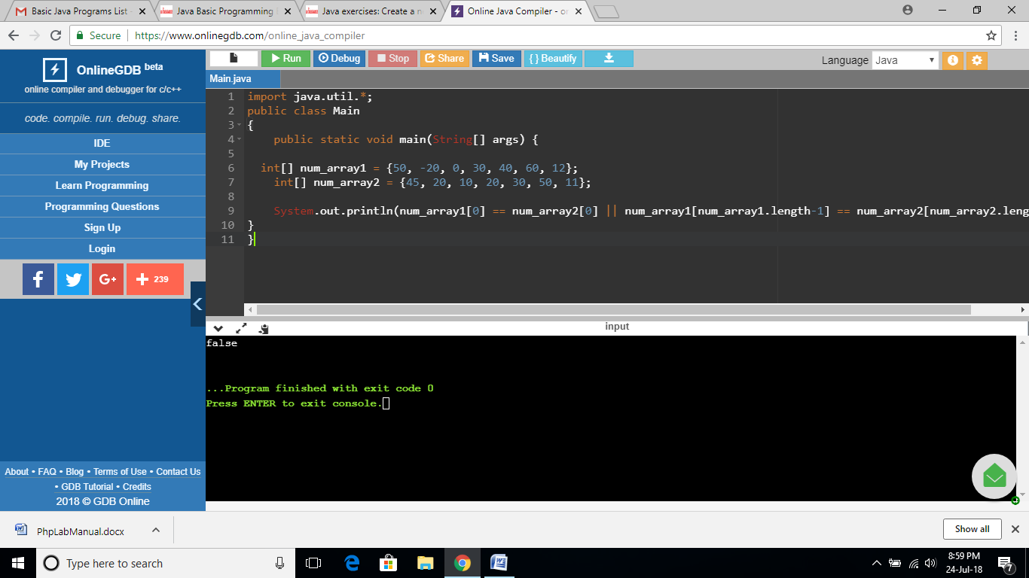

**EXERCISE 77:**

import java.util.*;

public class Main

{

public static void main(String[] args) {

int[] array1 = {50, -20, 0};

int[] array2 = {5, -50, 10};

System.out.println("Array1: "+Arrays.toString(array1));

System.out.println("Array2: "+Arrays.toString(array2));

int[] array_new = {array1[0], array2[2]};

System.out.println("New Array: "+Arrays.toString(array_new));

}

}

**OUTPUT:**

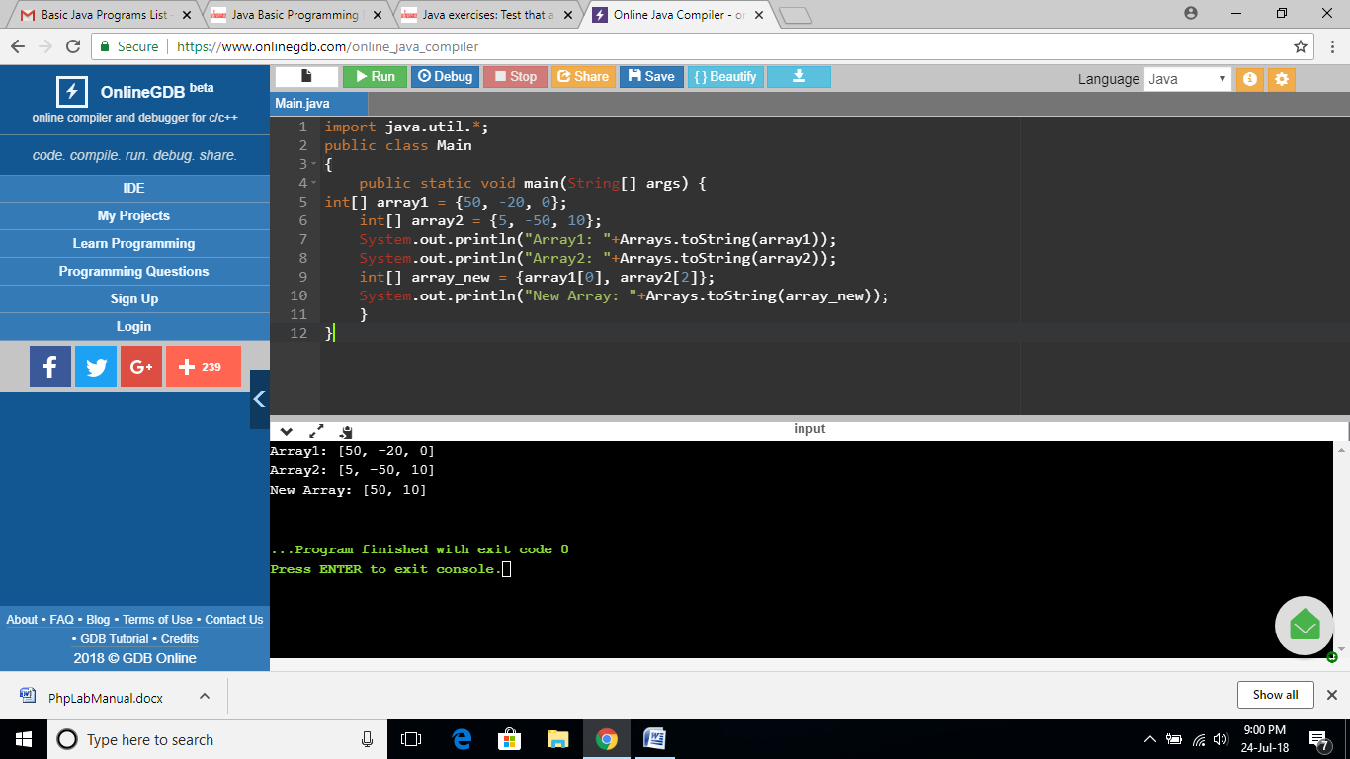

**EXERCISE 78:**

import java.util.*;

public class Main

{

public static void main(String[] args) {

int[] array_nums = {5, 7};

System.out.println("Original Array: "+Arrays.toString(array_nums));

if(array_nums[0] == 4 || array_nums[0] == 7)

System.out.println("True");

else

System.out.println(array_nums[1] == 4 || array_nums[1] == 7);

}

}

**OUTPUT:**

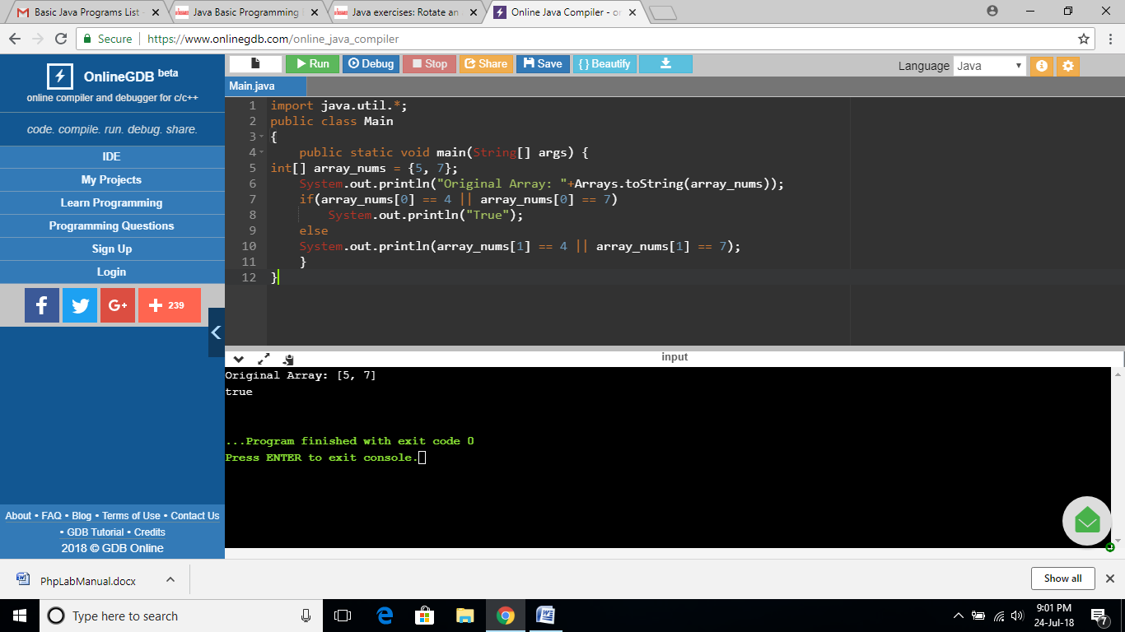

**EXERCISE 79:**

import java.util.*;

public class Main

{

public static void main(String[] args) {

int[] array_nums = {20, 30, 40};

System.out.println("Original Array: "+Arrays.toString(array_nums));

int[] new_array_nums = {array_nums[1], array_nums[2], array_nums[0]};

System.out.println("Rotated Array: "+Arrays.toString(new_array_nums));

}

}

**OUTPUT:**

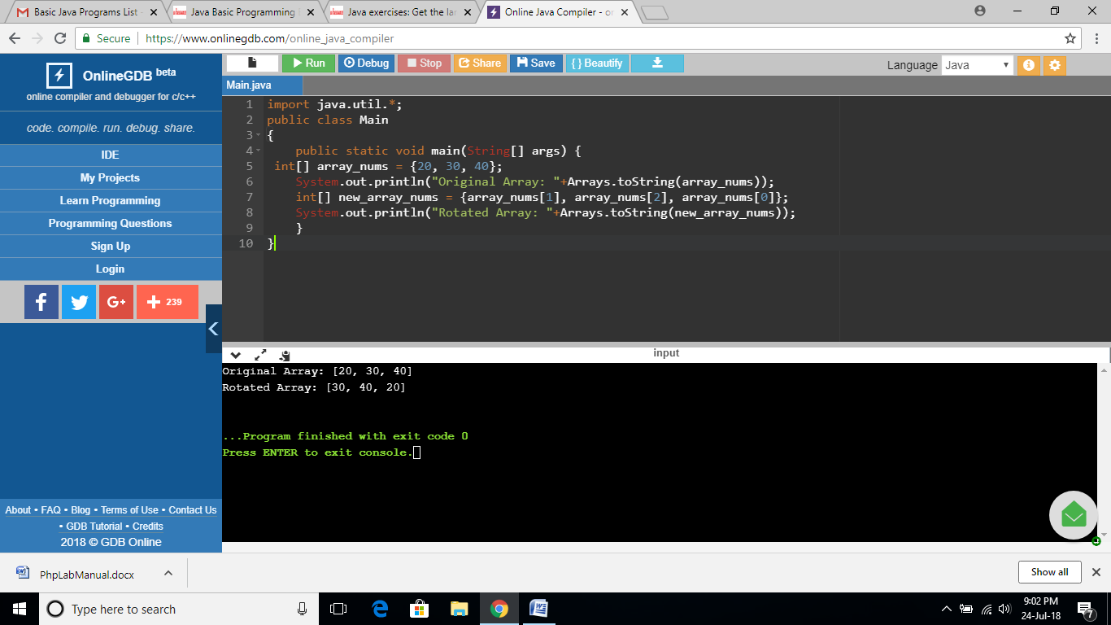

**EXERCISE 80:**

import java.util.*;

public class Main

{

public static void main(String[] args) {

int[] array_nums = {20, 30, 40};

System.out.println("Original Array: "+Arrays.toString(array_nums));

int max_val = array_nums[0];

if(array_nums[2] >= max_val)

max_val = array_nums[2];

System.out.println("Larger value between first and last element: "+max_val);

}

}

**OUTPUT:**

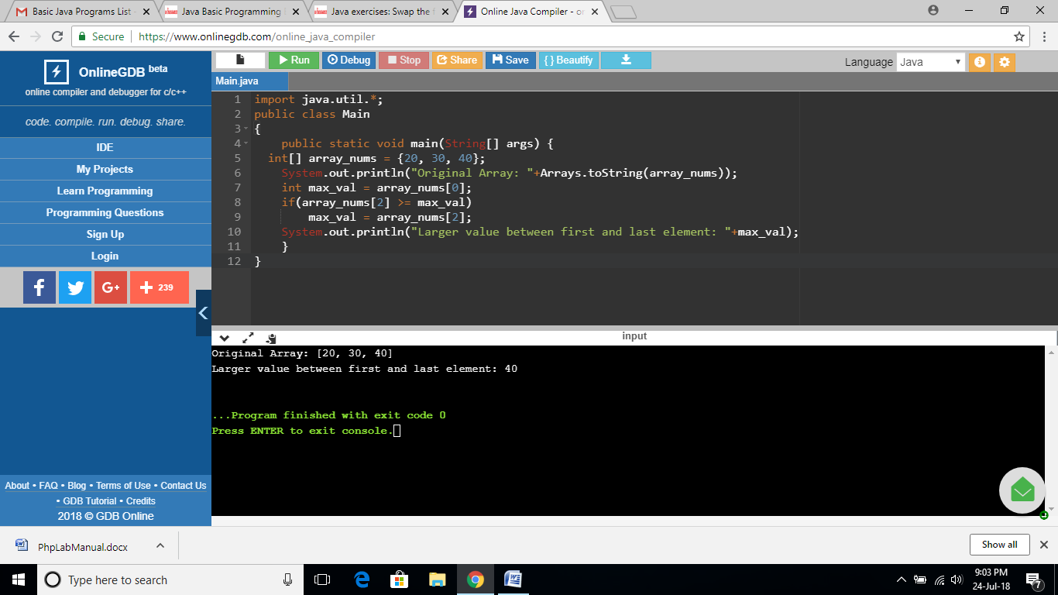

**EXERCISE 81:**

import java.util.*;

public class Main

{

public static void main(String[] args) {

int[] array_nums = {20, 30, 40};

System.out.println("Original Array: "+Arrays.toString(array_nums));

int x = array_nums[0];

array_nums[0] = array_nums[array_nums.length-1];

array_nums[array_nums.length-1] = x;

System.out.println("New array after swaping the first and last elements: "+Arrays.toString(array_nums));

}

}

**OUTPUT:**

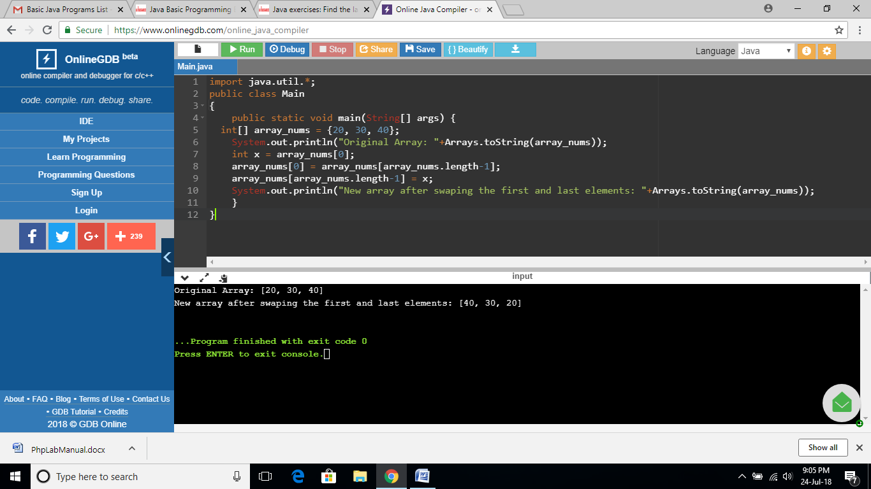

**EXERCISE 82:**

import java.util.*;

public class Main

{

public static void main(String[] args) {

int[] array_nums = {20, 30, 40, 50, 67};

System.out.println("Original Array: "+Arrays.toString(array_nums));

int max_val = array_nums[0];

if(max_val <= array_nums[array_nums.length-1])

max_val = array_nums[array_nums.length-1];

if(max_val <= array_nums[array_nums.length/2])

max_val = array_nums[array_nums.length/2];

System.out.println("Largest element between first, last, and middle values: "+max_val);

}

}

**OUTPUT:**

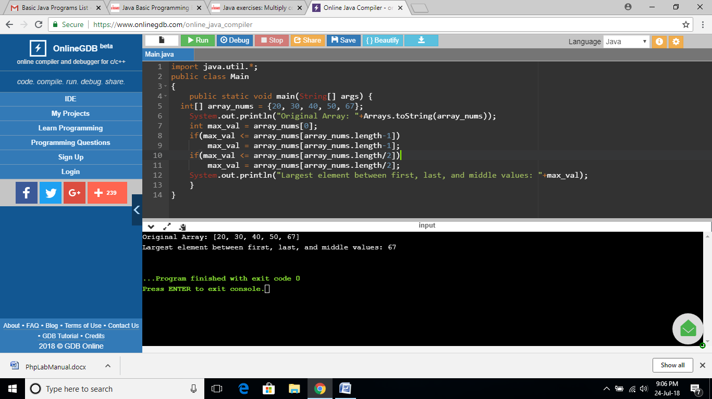

**EXERCISE 83:**

import java.util.*;

public class Main

{

public static void main(String[] args) {

String result = "";

int[] left_array = {1, 3, -5, 4};

int[] right_array = {1, 4, -5, -2};

System.out.println("\nArray1: "+Arrays.toString(left_array));

System.out.println("\nArray2: "+Arrays.toString(right_array));

for (int i = 0; i < left_array.length; i++) {

int num1 = left_array[i];

int num2 = right_array[i];

result += Integer.toString(num1 * num2) + " ";

}

System.out.println("\nResult: "+result);

}

}

**OUTPUT:**

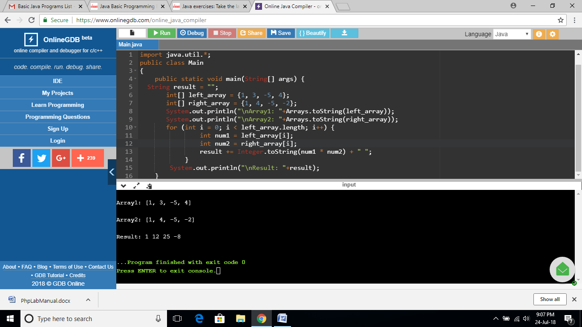

**EXERCISE 84:**

import java.util.*;

public class Main

{

public static void main(String[] args) {

String string1 = "Python";

int slength = 3;

if (slength > string1.length()) {

slength = string1.length();

}

String subpart = string1.substring(string1.length()-3);

System.out.println(subpart + string1 + subpart);

}

}

**OUTPUT:**

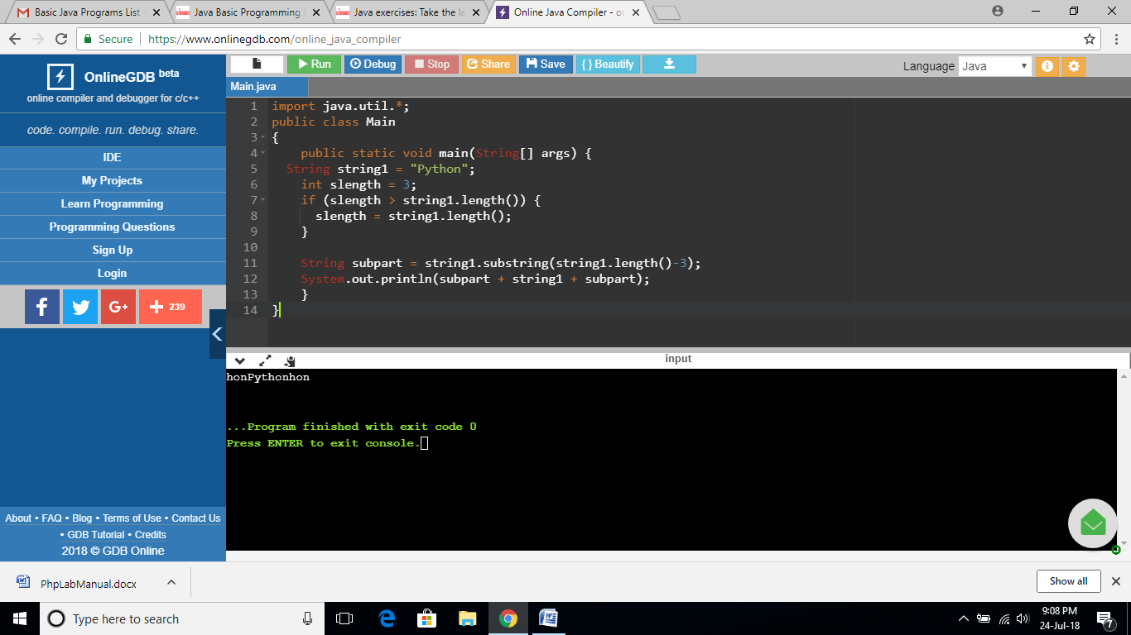

**EXERCISE 85:**

import java.util.*;

public class Main

{

public static void main(String[] args) {

String string1 = "Hello how are you?";

System.out.println(string1.startsWith("Hello"));

}

}

**OUTPUT:**

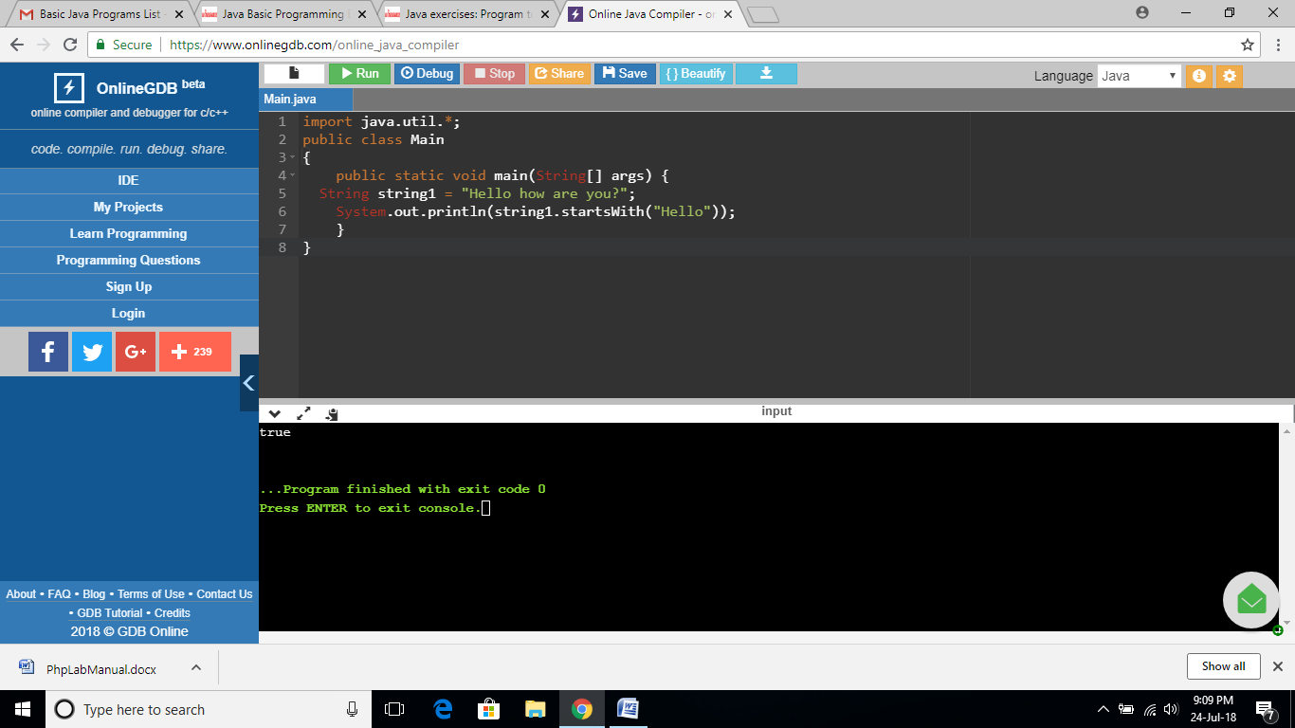

**EXERCISE 86:**

import java.util.*;

public class Main

{

public static void main(String[] args) {

int ctr = 0;

Scanner in = new Scanner(System.in);

int n = in.nextInt();

while (n != 1) {

System.out.println(n);

if (n % 2 == 0) {

n = n / 2;

ctr += 1;

}

else {

n = (3 * n + 1) / 2;

ctr += 1;

}

}

System.out.println(ctr);

in.close();

}

}

**OUTPUT:**

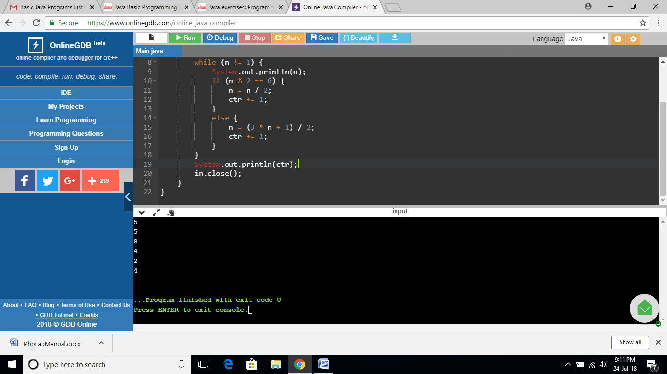

**EXERCISE 87:**

import java.io.*;

public class Main

{

public static void main(String[] args) {

BufferedReader br = new BufferedReader(new InputStreamReader(System.in));

try {

int sum = 0;

String str = br.readLine();

char[] numStr = str.toCharArray();

for (int i = 0; i < numStr.length; i ++) {

sum += numStr[i] - '0';

}

System.out.println("Original Number: "+str);

print_number(sum);

} catch (IOException e) {

e.printStackTrace();

}

}

public static void print_number(int n) {

int x; int y; int z;

String[] number = {"zero","one","two","three","four","five","six","seven","eight","nine"};

System.out.println("Sum of the digits of the said number: "+n);

if (n < 10) {

System.out.println(number[n]);

}

else if (n < 100) {

x = n / 10;

y = n - x *10;

System.out.println("In English: "+number[x] + " " + number[y]);

}

else {

x = n / 100;

y = (n - x * 100) / 10;

z = n - x * 100 - y * 10;

System.out.println("In English: "+number[x] + " " + number[y] + " " + number[z]);

}

}

}

**OUTPUT:**

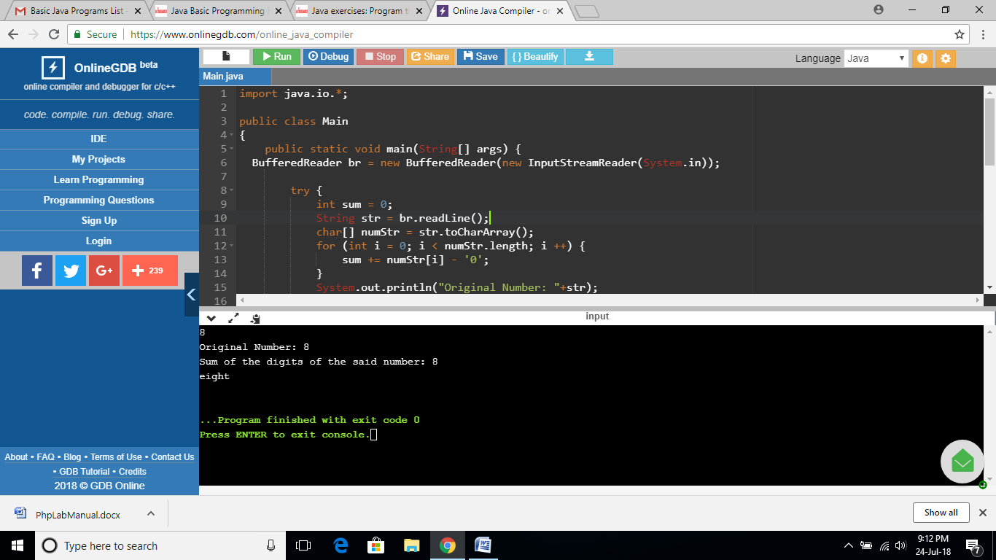

**EXERCISE 88:**

import java.lang.*;

public class Main

{

public static void main(String[] args) {

System.out.println("\nCurrent system environment:");

System.out.println(System.getenv());

System.out.println("\n\nCurrent system properties:");

System.out.println(System.getProperties());

}

}

**OUTPUT:**

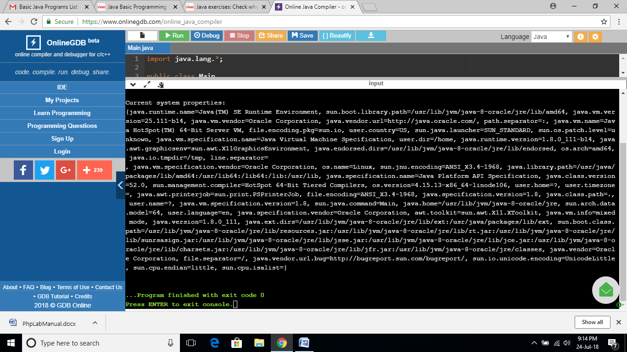

**EXERCISE 89:**

import java.lang.*;

public class Main

{

public static void main(String[] args) {

System.out.println("System security interface:");

System.out.println(System.getSecurityManager());

}

}

**OUTPUT:**

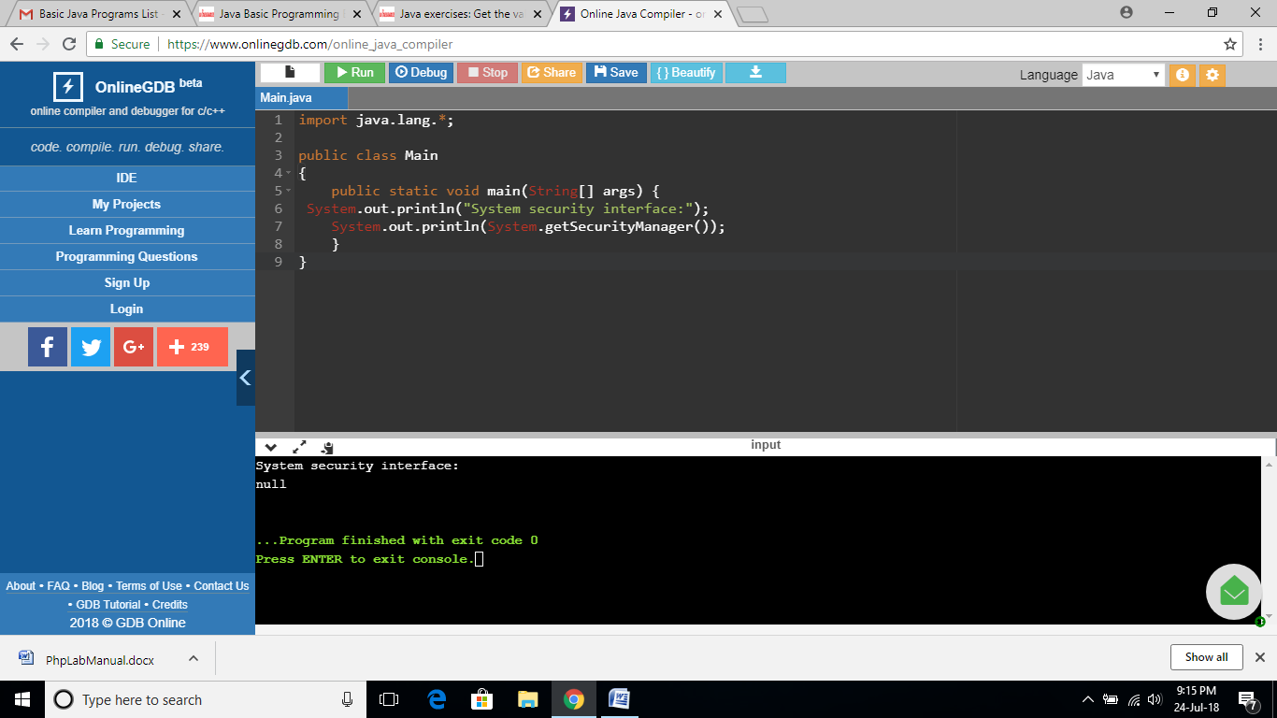

**EXERCISE 90:**

import java.lang.*;

public class Main

{

public static void main(String[] args) {

// gets the value of the specified environment variable "PATH"

System.out.println("\nEnvironment variable PATH: ");

System.out.println(System.getenv("PATH"));

// gets the value of the specified environment variable "TEMP"

System.out.println("\nEnvironment variable TEMP: ");

System.out.println(System.getenv("TEMP"));

// gets the value of the specified environment variable "USERNAME"

System.out.println("\nEnvironment variable USERNAME: ");

System.out.println(System.getenv("USERNAME"));

}

}

**OUTPUT:**

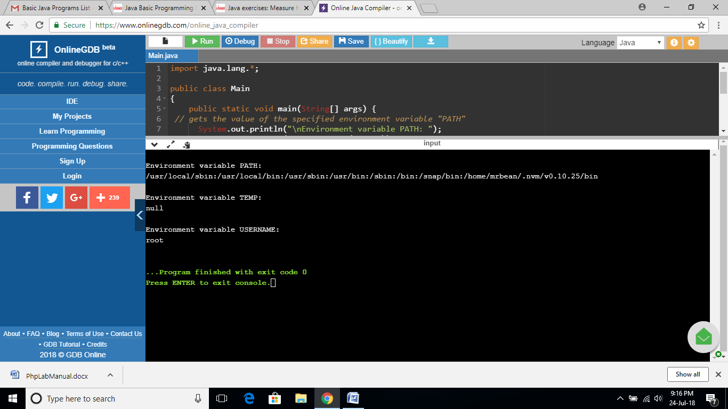

**EXERCISE 91:**

import java.lang.*;

public class Main

{

public static void main(String[] args) {

long startTime = System.nanoTime();

// Sample program

// Display the first 10 natural numbers.

int i;

System.out.println ("The first 10 natural numbers are:\n");

for (i=1;i<=10;i++)

{

System.out.println (i);

}

long estimatedTime = System.nanoTime() - startTime;

System.out.println("Estimated time (in nanoseconds) to get the first 10 natural numbers: "+estimatedTime);

}

}

**OUTPUT:**

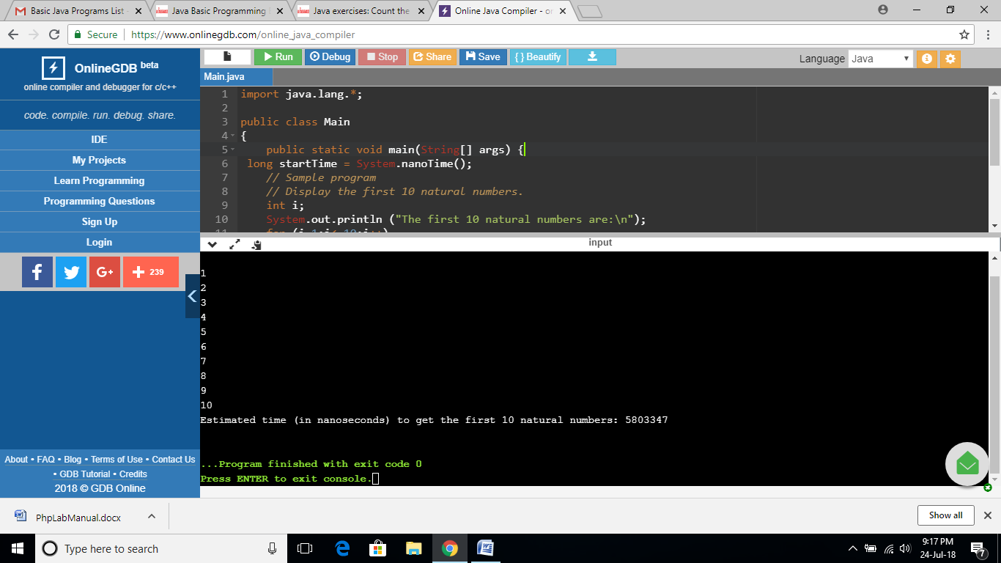

**EXERCISE 92:**

import java.util.*;

public class Main

{

public static void main(String[] args) {

int[] nums = {5, 7, 2, 4, 9};

int ctr_even = 0, ctr_odd = 0;

System.out.println("Original Array: "+Arrays.toString(nums));

for(int i = 0; i < nums.length; i++) {

if(nums[i] % 2 == 0)

{

ctr_even++;

}

else

ctr_odd++;

}

System.out.printf("\nNumber of even elements in the array: %d",ctr_even);

System.out.printf("\nNumber of odd elements in the array: %d",ctr_odd);

System.out.printf("\n");

}

}

**OUTPUT:**

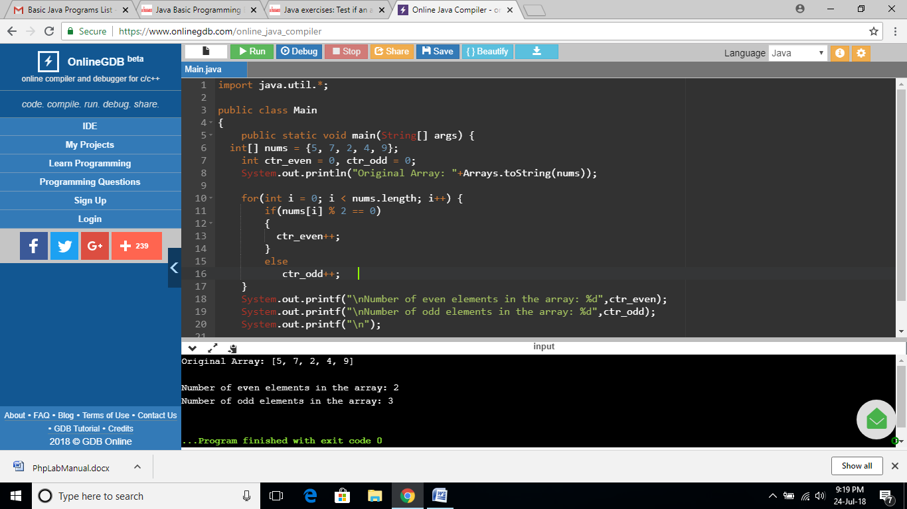

**EXERCISE 93:**

import java.util.*;

public class Main

{

public static void main(String[] args) {

//int[] nums = {10, 10, 2, 4, 9};

int[] nums = {10, 10, 2, 4, 20, 20};

int ctr_even = 0, ctr_odd = 0;

System.out.println("Original Array: "+Arrays.toString(nums));

boolean found1010 = false;

boolean found2020 = false;

for(int i = 0; i < nums.length - 1; i++) {

if(nums[i] == 10 && nums[i+1] == 10)

found1010 = true;

if(nums[i] == 20 && nums[i+1] == 20)

found2020 = true;

}

System.out.printf( String.valueOf(found1010 != found2020));

System.out.printf("\n");

}

}

**OUTPUT:**

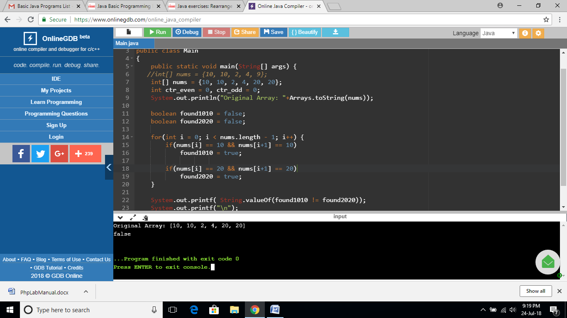

**EXERCISE 94:**

import java.util.*;

import java.io.*;

public class Main

{

public static void main(String[] args) {

int[] array_nums = {1, 7, 8, 5, 7, 13, 0, 2, 4, 9};

int i = 0;

System.out.println("Original Array: "+Arrays.toString(array_nums));

while(i < array_nums.length && array_nums[i] % 2 == 0)

i++;

for(int j = i + 1; j < array_nums.length; j++) {

if(array_nums[j] % 2 != 0) {

int temp = array_nums[i];

array_nums[i] = array_nums[j];

array_nums[j] = temp;

i++;

}

}

System.out.println("New Array: "+Arrays.toString(array_nums));

}

}

**OUTPUT:**

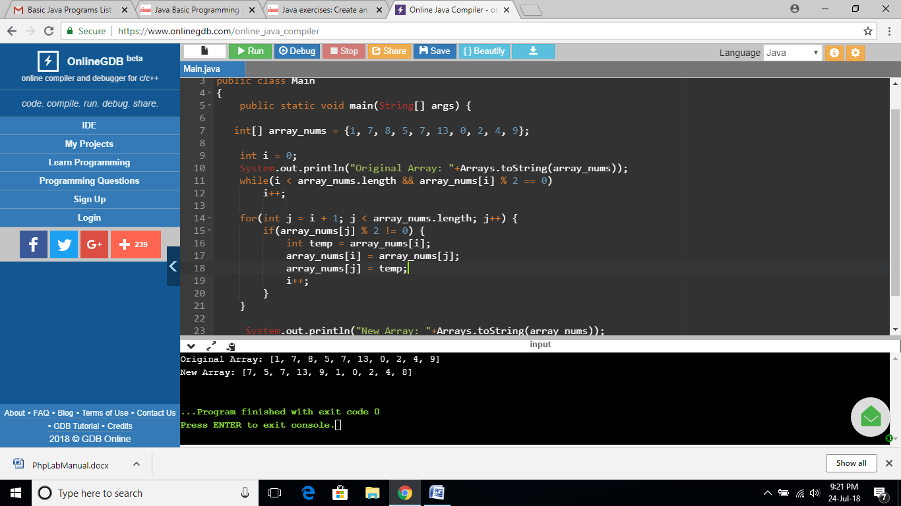

**EXERCISE 95:**

import java.util.*;

import java.io.*;

public class Main

{

public static void main(String[] args) {

int n= 5;

String[] arr_string = new String[n];

for(int i = 0; i < n; i++)

arr_string[i] = String.valueOf(i);

System.out.println("New Array: "+Arrays.toString(arr_string));

}

}

**OUTPUT:**

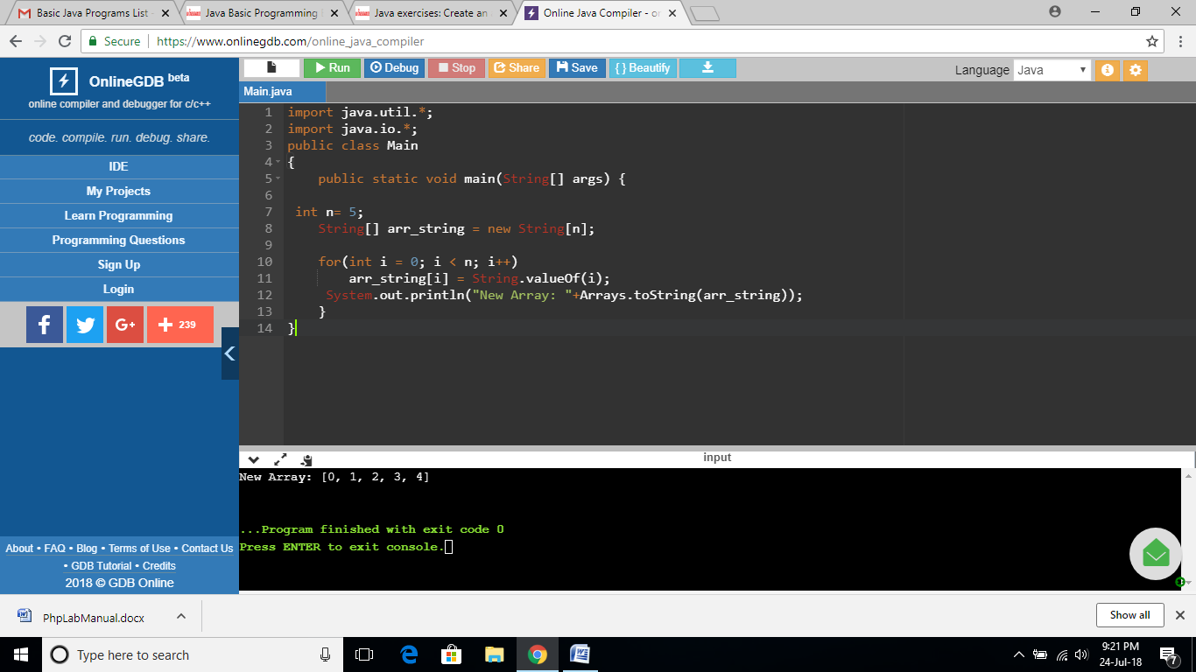

**EXERCISE 96:**

import java.util.*;

import java.io.*;

public class Main

{

public static void main(String[] args) {

int[] array_nums = {10, 70, 80, 50, 20, 13, 50};

boolean testd = false;

int result=0;

int x = 10;

int y = 20;

for(int i = 0; i < array_nums.length; i++) {

if(array_nums[i] == x)

testd = true;

if(testd && array_nums[i] == y)

{

System.out.printf( String.valueOf(true));

result = 1 ;

}

}

if (result==0)

{

System.out.printf( String.valueOf(false));

}

System.out.printf("\n");

}

}

**OUTPUT:**

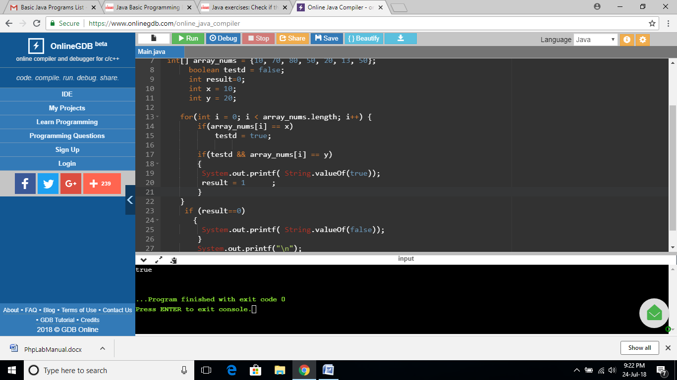

**EXERCISE 97:**

import java.util.*;

import java.io.*;

public class Main

{

public static void main(String[] args) {

int[] array_nums = {10, 20, 10, 50, 20, 13, 50};

//int[] array_nums = {10, 10, 50, 50, 20, 13, 50};

boolean testd = false;

int result=0;

int x = 10;

for(int i = 0; i < array_nums.length - 1; i++) {

if(array_nums[i] == x && array_nums[i+1] == x)

{

System.out.printf( String.valueOf(true));

result = 1 ;

}

if(i <= array_nums.length - 3 && array_nums[i] == x && array_nums[i+2] == x)

{

System.out.printf( String.valueOf(true));

result = 1 ;

}

}

if (result==0)

{

System.out.printf( String.valueOf(false));

}

System.out.printf("\n");

}

}

**OUTPUT:**

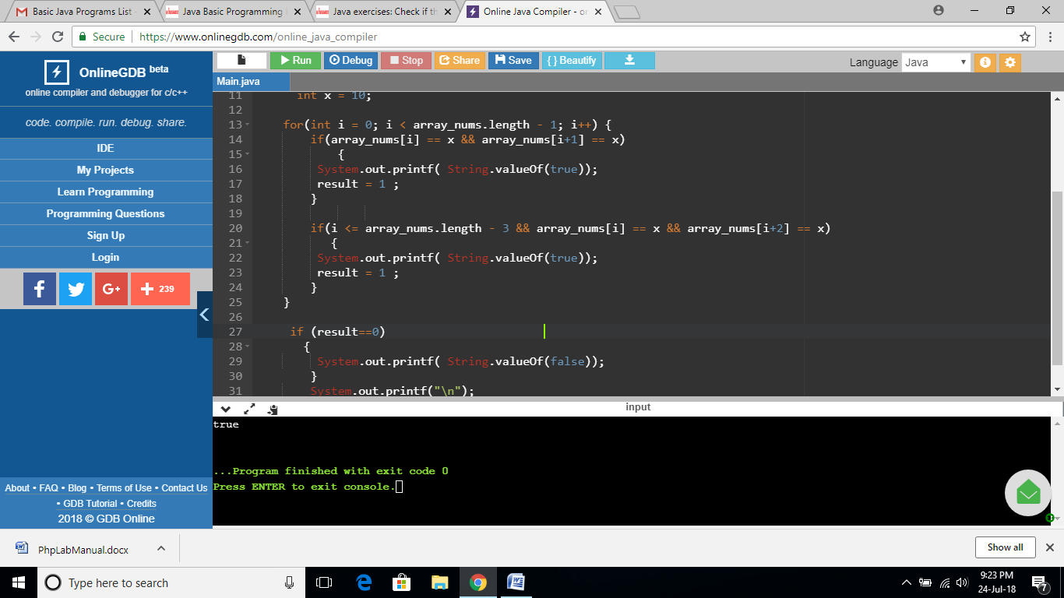

**EXERCISE 98:**

import java.util.*;

import java.io.*;

public class Main

{

public static void main(String[] args) {

int[] array_nums = {10, 20, 10, 20, 40, 13, 20};

int count = 0, result =0;

if(array_nums.length >= 1 && array_nums[0] == 20)

count++;

for(int i = 1; i < array_nums.length; i++) {

if(array_nums[i - 1] == 20 && array_nums[i] == 20)

{

System.out.printf( String.valueOf(false));

result = 1;

}

if(array_nums[i] == 20)

count++;

}

if (result==0)

{

System.out.printf( String.valueOf(count == 3));

}

System.out.printf("\n");

}

}

**OUTPUT:**

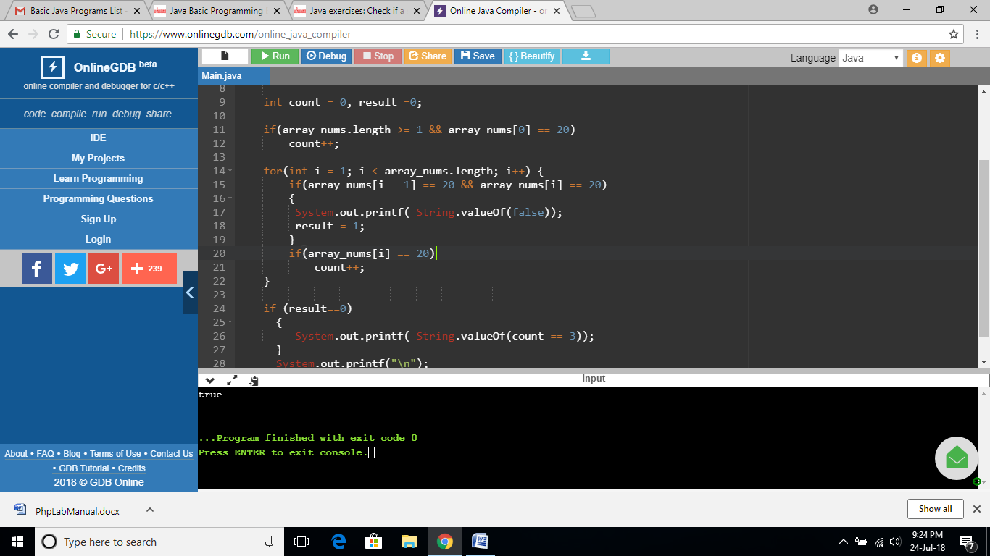

**EXERCISE 99:**

import java.util.*;

import java.io.*;

public class Main

{

public static void main(String[] args) {

int[] array_nums = {10, 20, 10, 20, 40, 20, 50};

int result = 0;

int x = 20;

for(int i = 0; i < array_nums.length - 1; i++) {

if(array_nums[i] != x && array_nums[i + 1] != x)

{

result = 1;

}

}

if (result==0)

{

System.out.printf( String.valueOf(true));

}

else

{

System.out.printf( String.valueOf(false));

}

}

}

**OUTPUT:**

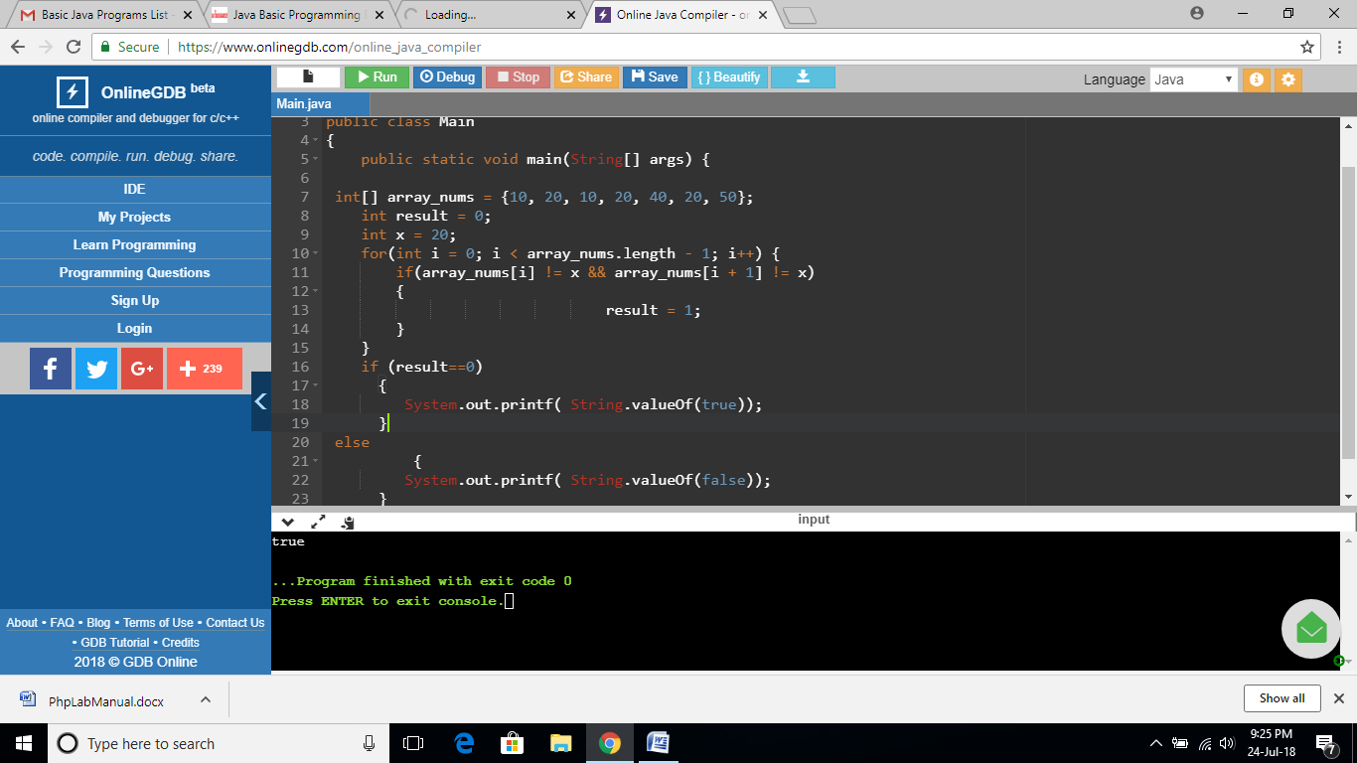

**EXERCISE 100:**

import java.util.*;

import java.io.*;

public class Main

{

public static void main(String[] args) {

int[] array_nums1 = {10, 11, 10, 20, 43, 20, 50};

int[] array_nums2 = {10, 13, 11, 20, 44, 30, 50};

System.out.println("Array1: "+Arrays.toString(array_nums1));

System.out.println("Array2: "+Arrays.toString(array_nums2));

int ctr = 0;

for(int i = 0; i < array_nums1.length; i++) {

if(Math.abs(array_nums1[i] - array_nums2[i]) <= 1 && array_nums1[i] != array_nums2[i])

ctr++;

}

System.out.printf("Number of elements: "+ctr);

System.out.printf("\n");

}

}

**OUTPUT:**

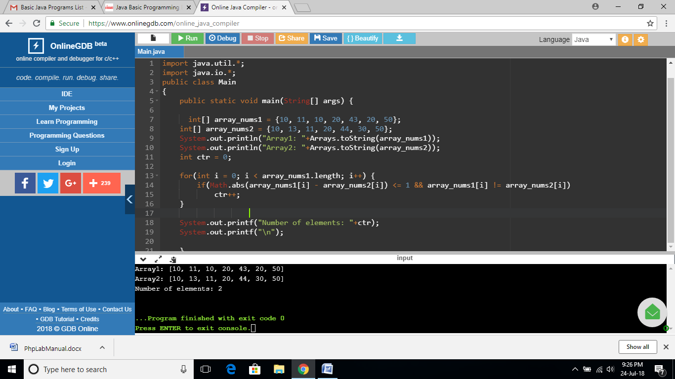

**EXERCISE 101:**

import java.util.*;

import java.io.*;

public class Main

{

public static void main(String[] args) {

int[] array_nums = {10, 11, 10, 30, 45, 20, 33, 53};

int result = 0;

System.out.println("Original Array: "+Arrays.toString(array_nums));

int ctr1 = 0;

int ctr2 = 0;

for(int i = 0; i < array_nums.length; i++) {

if(array_nums[i] == 10)

ctr1++;

if(array_nums[i] == 20)

ctr2++;

}

System.out.printf(String.valueOf(ctr1 > ctr2));

System.out.printf("\n");

}

}

**OUTPUT:**

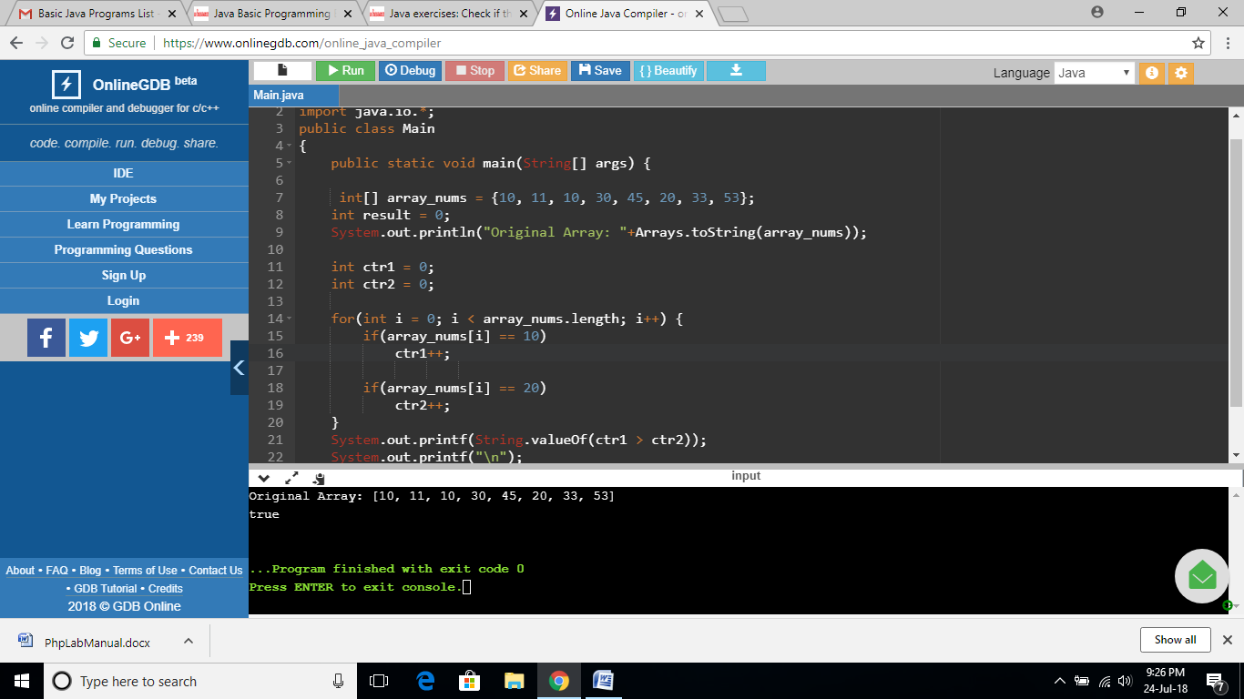

**EXERCISE 102:**

import java.util.*;

import java.io.*;

public class Main

{

public static void main(String[] args) {

int[] array_nums = {11, 11, 13, 31, 45, 20, 33, 53};

int result = 1;

System.out.println("Original Array: "+Arrays.toString(array_nums));

for(int i = 0; i < array_nums.length; i++)

{

if(array_nums[i] == 10 || array_nums[i] == 30)

{

result =0;

}

}

if (result==1)

System.out.printf( String.valueOf(false));

else

System.out.printf(String.valueOf(true));

}

}

**OUTPUT:**

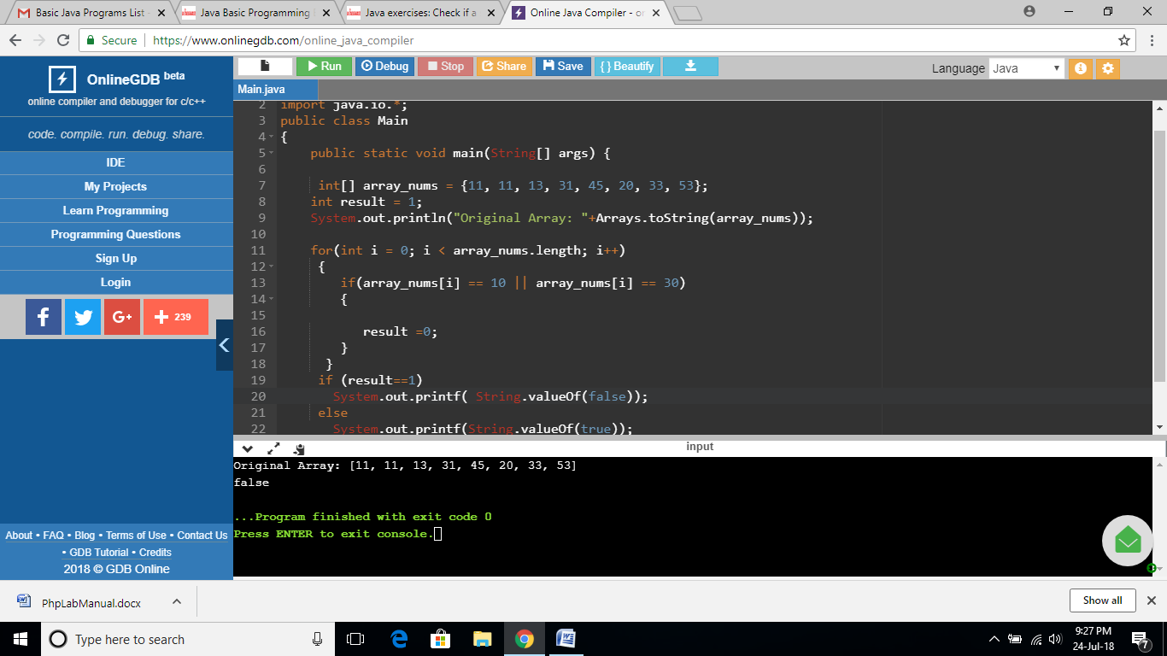

**EXERCISE 103:**

import java.util.*;

import java.io.*;

public class Main

{

public static void main(String[] args) {

int[] array_nums = {11, 10, 13, 10, 45, 20, 33, 53};

int result = 0;

System.out.println("Original Array: "+Arrays.toString(array_nums));

int l = array_nums.length - 1;

int[] new_array;

while(array_nums[l] != 10)

l--;

new_array = new int[array_nums.length - 1 - l];

for(int i = l + 1; i < array_nums.length; i++)

new_array[i - l - 1] = array_nums[i];

System.out.println("New Array: "+Arrays.toString(new_array));

}

}

**OUTPUT:**

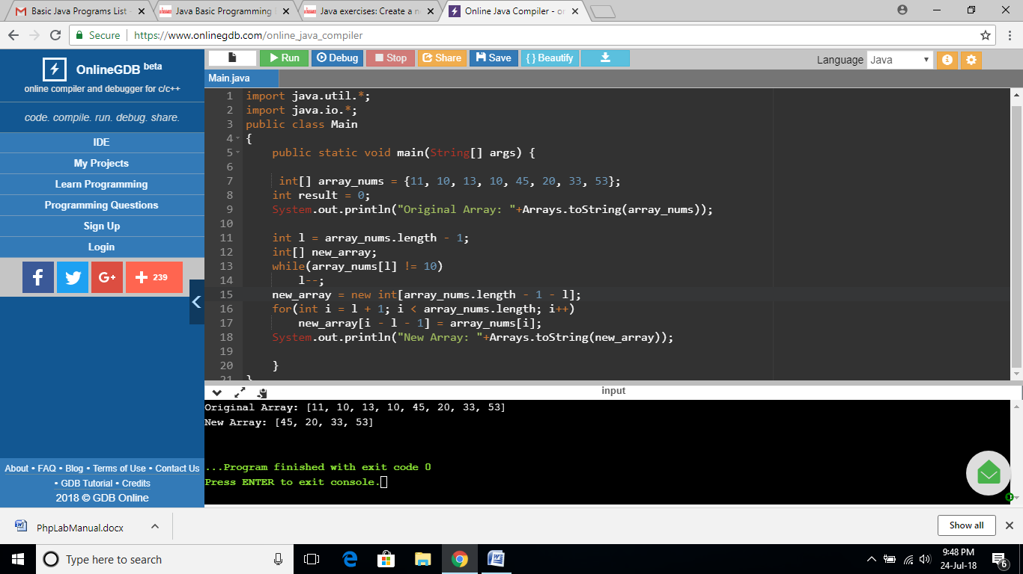

**EXERCISE 104:**

import java.util.*;

import java.io.*;

public class Main

{

public static void main(String[] args) {

int[] array_nums = {11, 15, 13, 10, 45, 20, 33, 53};

int result = 0;

System.out.println("Original Array: "+Arrays.toString(array_nums));

int l = 0;

int[] new_array;

while(array_nums[l] != 10)

l++;

new_array = new int[l];

for(int i = 0; i < l; i++)

new_array[i] = array_nums[i];

System.out.println("New Array: "+Arrays.toString(new_array));

}

}

**OUTPUT:**

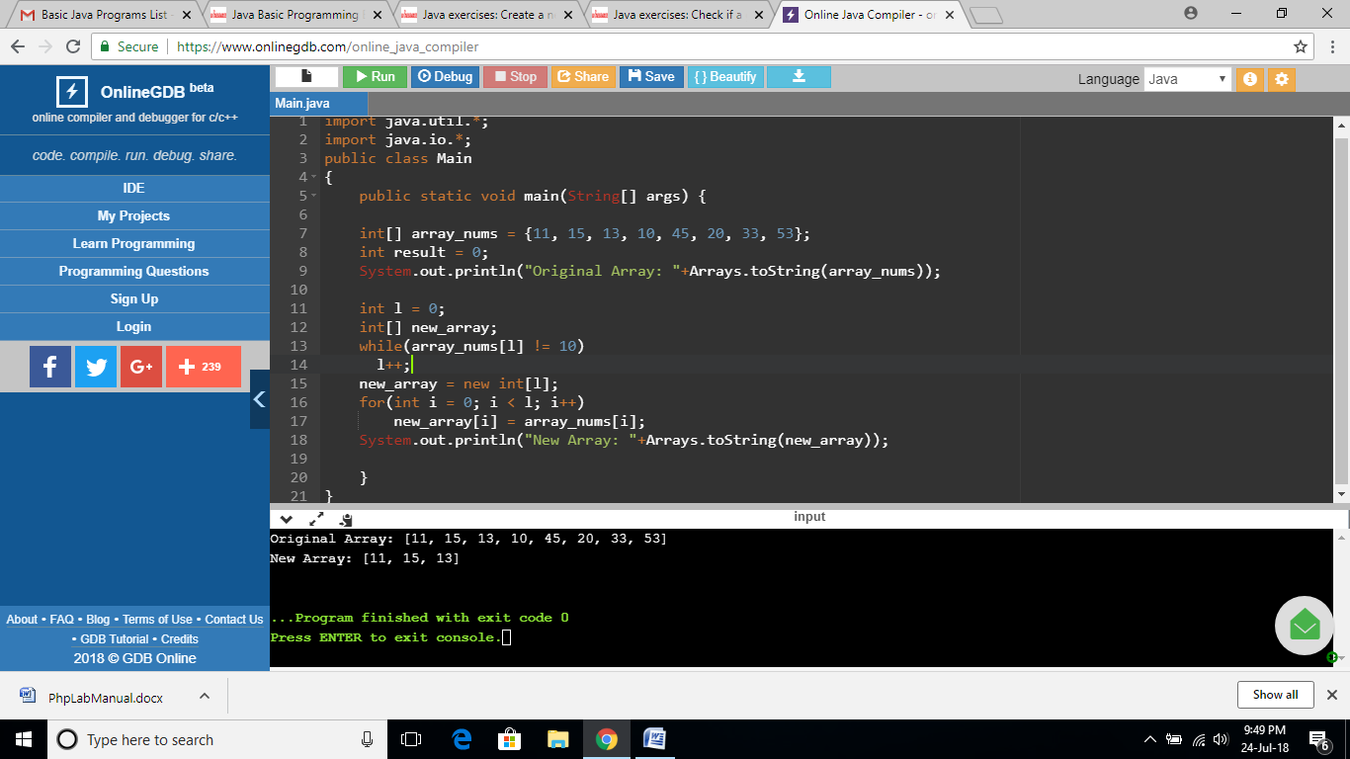

**EXERCISE 105:**

import java.util.*;

import java.io.*;

public class Main

{

public static void main(String[] args) {

int[] array_nums = {11, 15, 13, 10, 45, 20, 11, 15};

System.out.println("Original Array: "+Arrays.toString(array_nums));

int result = 0;

int l = 2;

int start = 0;

int end = array_nums.length-l;

for(; l > 0; l--)

{

if(array_nums[start] != array_nums[end])

result = 1;

else

{

start++;

end++;

}

}

if (result==1)

{

System.out.printf(String.valueOf(false));

}

else

{

System.out.printf(String.valueOf(true));

}

System.out.printf("\n");

}

}

**OUTPUT:**

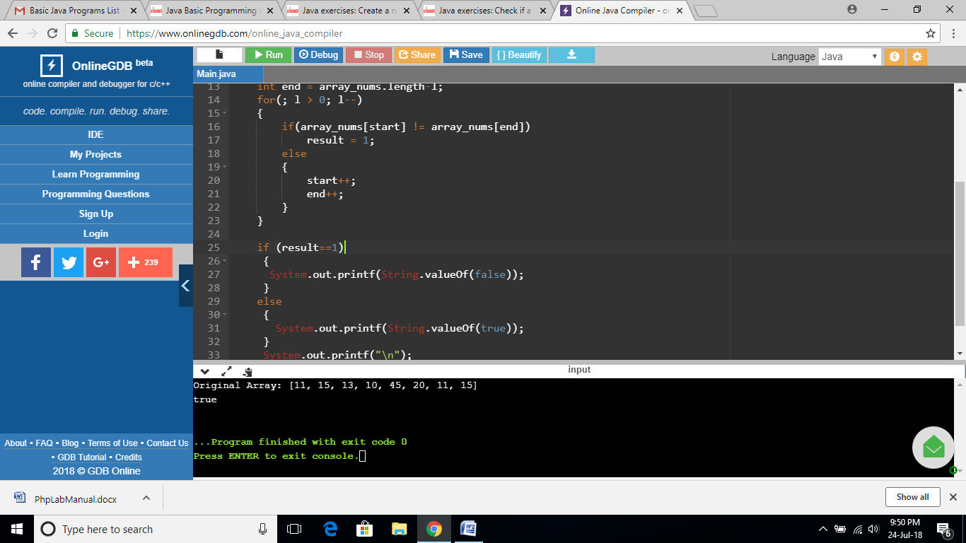

**EXERCISE 106:**

import java.util.*;

import java.io.*;

public class Main

{

public static void main(String[] args) {

int[] array_nums = {11, 15, 13, 10, 45, 20};

System.out.println("Original Array: "+Arrays.toString(array_nums));

if(array_nums.length >1)

{

int first = array_nums[0];

for(int i = 1; i < array_nums.length; i++)

array_nums[i - 1] = array_nums[i];

array_nums[array_nums.length - 1] = first;

System.out.println("New Array: "+Arrays.toString(array_nums));

}

}

}

**OUTPUT:**

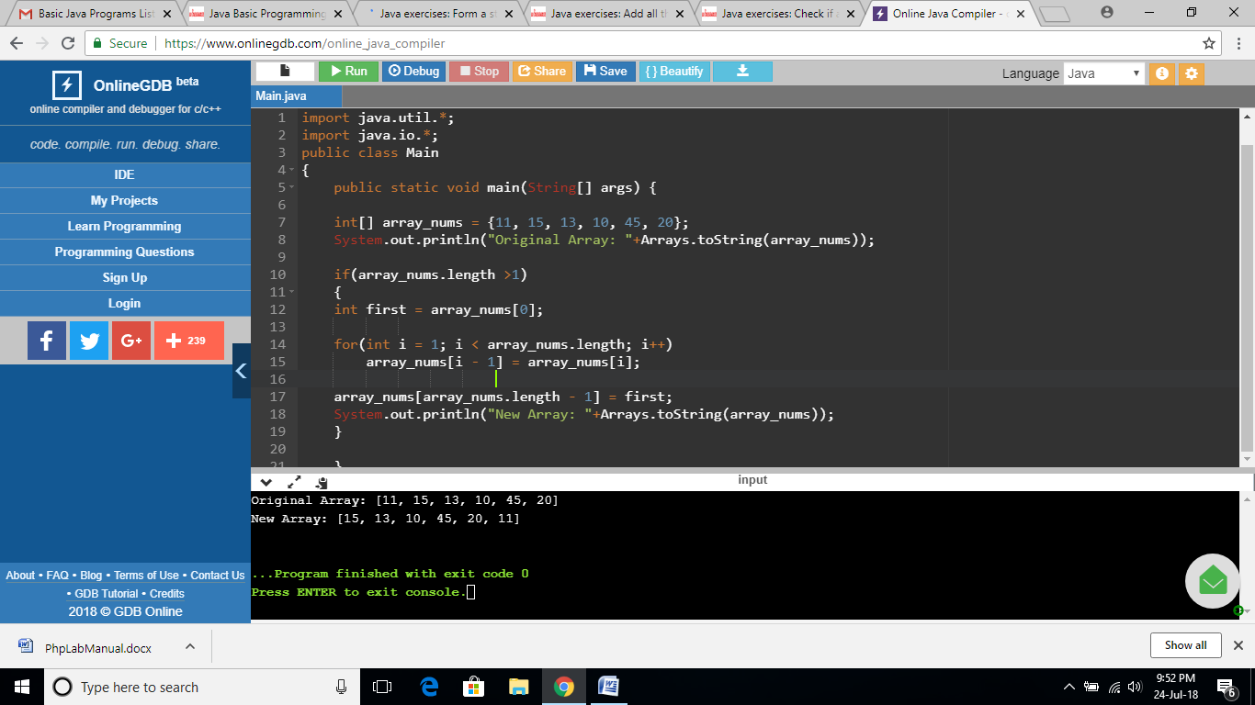

**EXERCISE 107:**

import java.util.*;

import java.io.*;

public class Main

{

public static void main(String[] args) {

int[] array_nums = {11, 12, 13, 14, 45, 20};

System.out.println("Original Array: "+Arrays.toString(array_nums));

int result =1;

for(int i = 0; i <= array_nums.length - 3; i++) {

if(array_nums[i] + 1 == array_nums[i+1] && array_nums[i+1] + 1 == array_nums[i+2])

result =0;

}

if (result==1)

{

System.out.printf(String.valueOf(false));

}

else

{

System.out.printf(String.valueOf(true));

}

System.out.printf("\n");

}

}

**OUTPUT:**

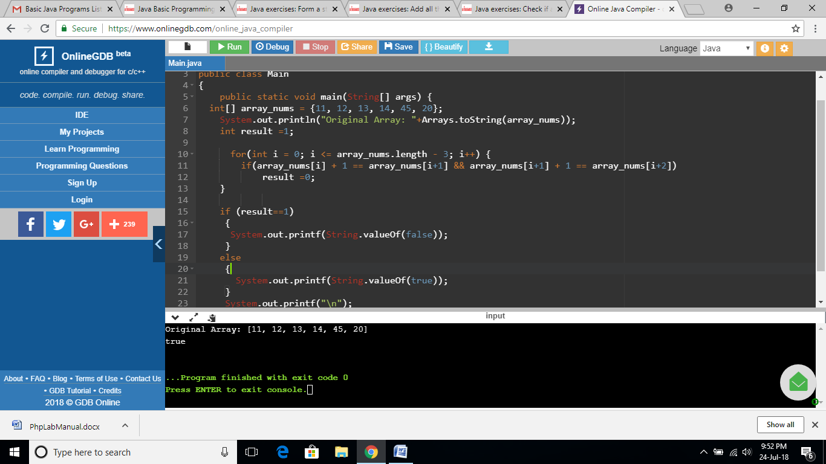

**EXERCISE 108:**

import java.util.*;

import java.io.*;

public class Main

{

public static void main(String[] args) {

Scanner in = new Scanner(System.in);

System.out.print("Input a positive integer: ");

int n = in.nextInt();

if (n>0)

{

System.out.print("The single digit number is: "+(n == 0 ? 0 : (n % 9 == 0 ? 9 : n % 9)));

}

System.out.println("\n");

}

}

**OUTPUT:**

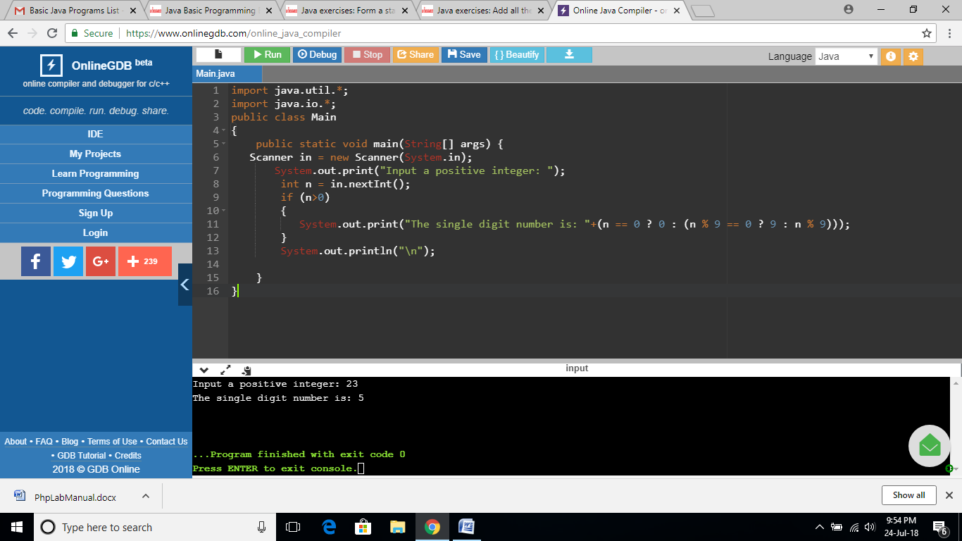

**EXERCISE 109:**

import java.util.*;

import java.io.*;

public class Main

{

public static void main(String[] args) {

Scanner in = new Scanner(System.in);

System.out.print("Input a positive integer: ");

int n = in.nextInt();

if (n>0)

{

System.out.println("Number of rows: "+((int)((Math.sqrt(8 * (long)n + 1) - 1) / 2)));

}

}

}

**OUTPUT:**

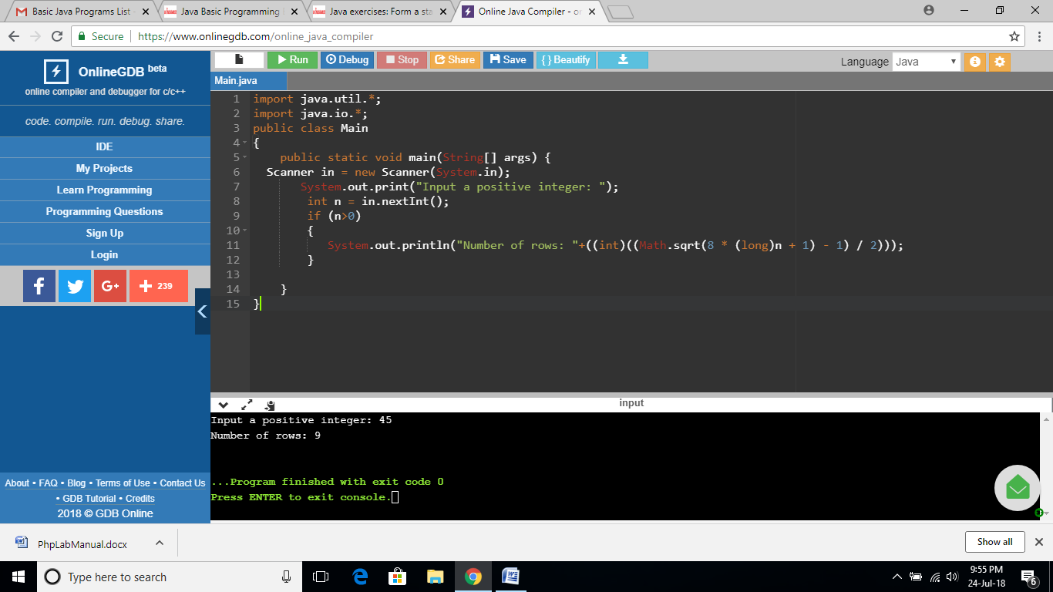

**EXERCISE 110:**

import java.util.*;

import java.io.*;

public class Main

{

public static void main(String[] args) {

int test = 0;

Scanner in = new Scanner(System.in);

System.out.print("Input a positive integer: ");

int n = in.nextInt();

if (n < 1) {

System.out.print(Boolean.toString(false));

test = 1;

}

if ((n & (n - 1)) != 0) {

System.out.print(Boolean.toString(false));

test = 1;

}

if (test==0)

{

System.out.print(Boolean.toString((n & 0x55555555) != 0));

}

System.out.print("\n");

}

}

**OUTPUT:**

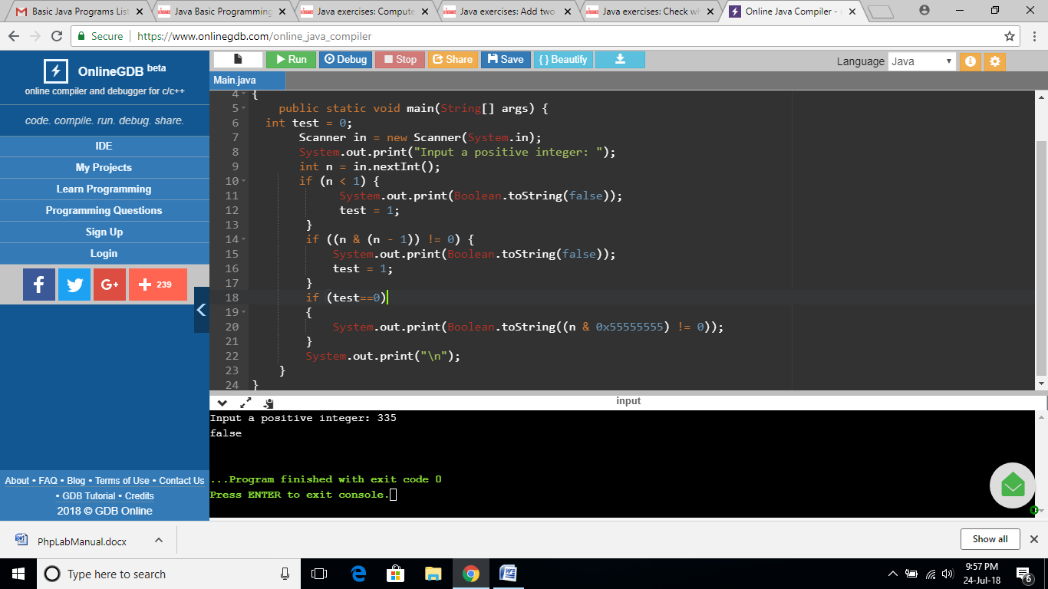

**EXERCISE 111:**

import java.util.*;

import java.io.*;

public class Main

{

public static void main(String[] args) {

int x, y ;

Scanner in = new Scanner(System.in);

System.out.print("Input first number: ");

x = in.nextInt();

System.out.print("Input second number: ");

y = in.nextInt();

while(y != 0){

int carry = x & y;

x = x ^ y;

y = carry << 1;

}

System.out.print("Sum: "+x);

System.out.print("\n");

}

}

**OUTPUT:**

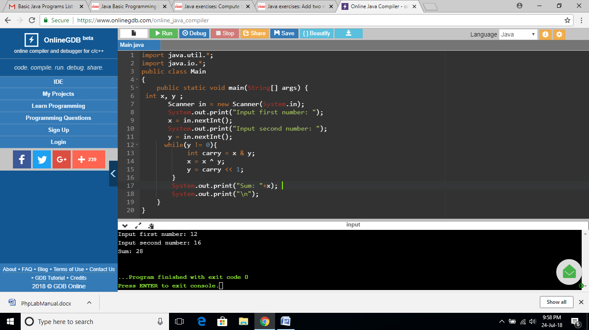

**EXERCISE 112:**

import java.util.*;

import java.io.*;

public class Main

{

public static void main(String[] args) {

Scanner in = new Scanner(System.in);

System.out.print("Input a number: ");

int n = in.nextInt();

int n1 = n;

long ctr = 0;

while (n != 0)

{

ctr += n / 5;

n /= 5;

}

System.out.printf("Number of trailing zeros of the factorial %d is %d ",n1,ctr);

System.out.printf("\n");

}

}

**OUTPUT:**

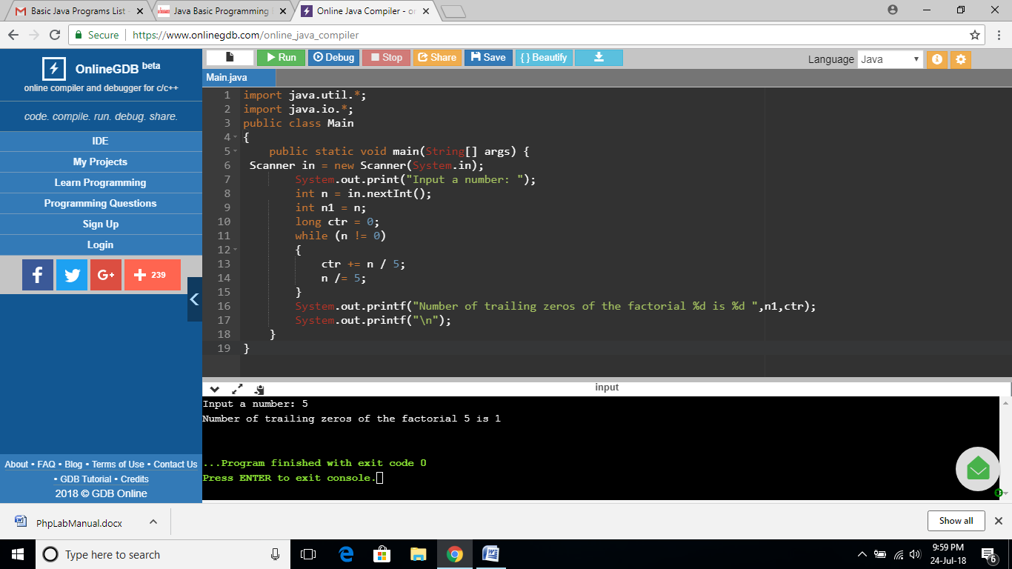

**EXERCISE 113:**

import java.util.*;

import java.io.*;

public class Main

{

public static void main(String[] args) {

// Sorted integer array array1 which has m elements,

// but size of array1 is m+n, sorted integer array array2 which has n elements

//declaration and instantiation.

int array1[]=new int[8];

//initialization.

array1[0]=1;

array1[1]=2;

array1[2]=3;

array1[3]=4;

int[] array2 = {2,5,7,8};

System.out.println("\nArray1: "+Arrays.toString(array1));

System.out.println("\nArray2: "+Arrays.toString(array2));

int m =4, n=4;

int i = m-1, j = n-1, index = m + n - 1;

while (i >= 0 && j >= 0) {

if (array1[i] > array2[j]) {

array1[index--] = array1[i--];

} else {

array1[index--] = array2[j--];

}

}

while (i >= 0) {

array1[index--] = array1[i--];

}

while (j >= 0) {

array1[index--] = array2[j--];

}

System.out.println("\nMerged array: "+Arrays.toString(array1));

}

}

**OUTPUT:**

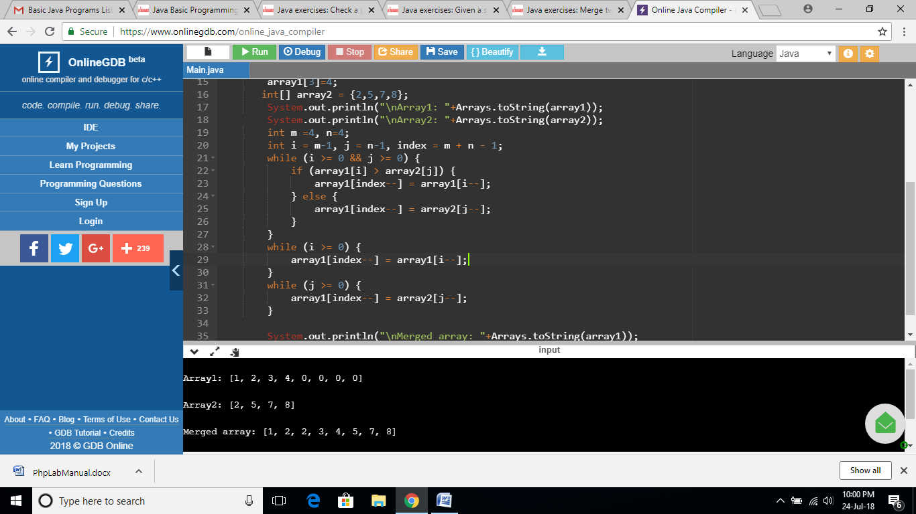

**EXERCISE 114:**

import java.util.*;

import java.io.*;

public class Main

{

public static void main(String[] args) {

String str = "abcdef";

char[] A = str.toCharArray();

int offset=3;

int len = A.length;

offset %= len;

reverse(A, 0, len - offset - 1);

reverse(A, len - offset, len - 1);

reverse(A, 0, len - 1);

System.out.println("\n"+Arrays.toString(A));

}

private static void reverse(char[] str, int start, int end) {

while (start < end) {

char temp = str[start];

str[start] = str[end];

str[end] = temp;

start++;

end--;

}

}

}

**OUTPUT:**

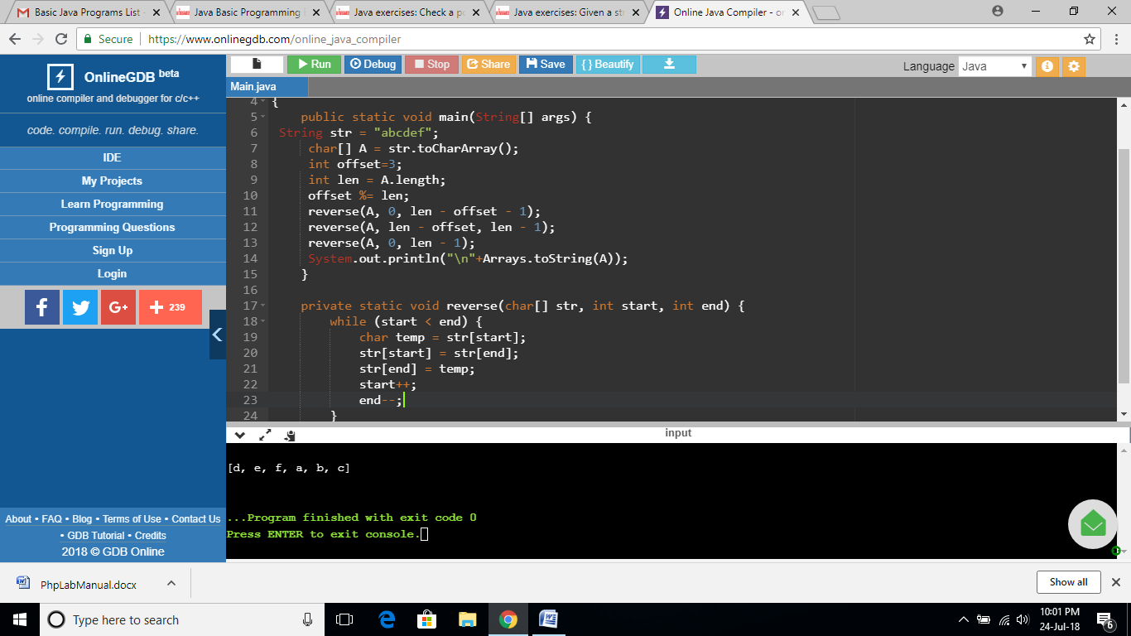

**EXERCISE 115:**

import java.util.*;

public class Main

{

public static void main(String[] args) {

int num;

Scanner in = new Scanner(System.in);

System.out.print("Input a positive integer: ");

int n = in.nextInt();

System.out.printf("Is %d is a palindrome number?\n",n);

System.out.println(palindrome(n));

}

private static boolean palindrome(int num) {

String str = String.valueOf(num);

int i = 0;

int j = str.length() - 1;

while (i < j) {

if (str.charAt(i++) != str.charAt(j--)) {

return false;

}

}

return true;

}

}

**OUTPUT:**

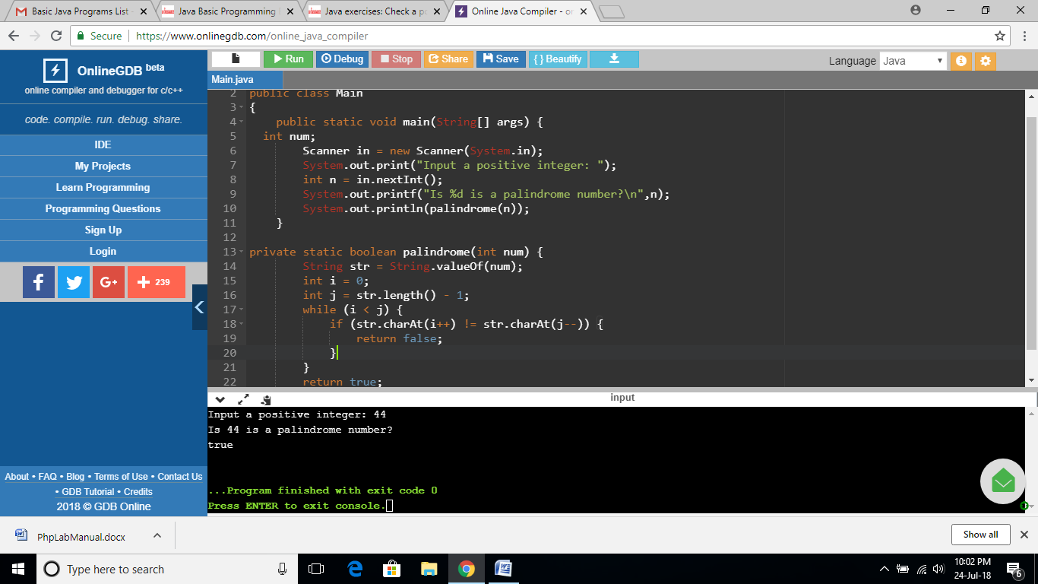

**EXERCISE 116:**

import java.util.*;

public class Main

{

public static void main(String[] args) {

for (int i = 1; i <= 100; i++) {

if (i % 3 == 0 && i % 5 == 0) {

System.out.printf("\n%d: fizz buzz",i);

} else if (i % 5 == 0) {

System.out.printf("\n%d: buzz",i);

} else if (i % 3 == 0) {

System.out.printf("\n%d: fizz",i);

}

}

System.out.printf("\n");

}

}

**OUTPUT:**

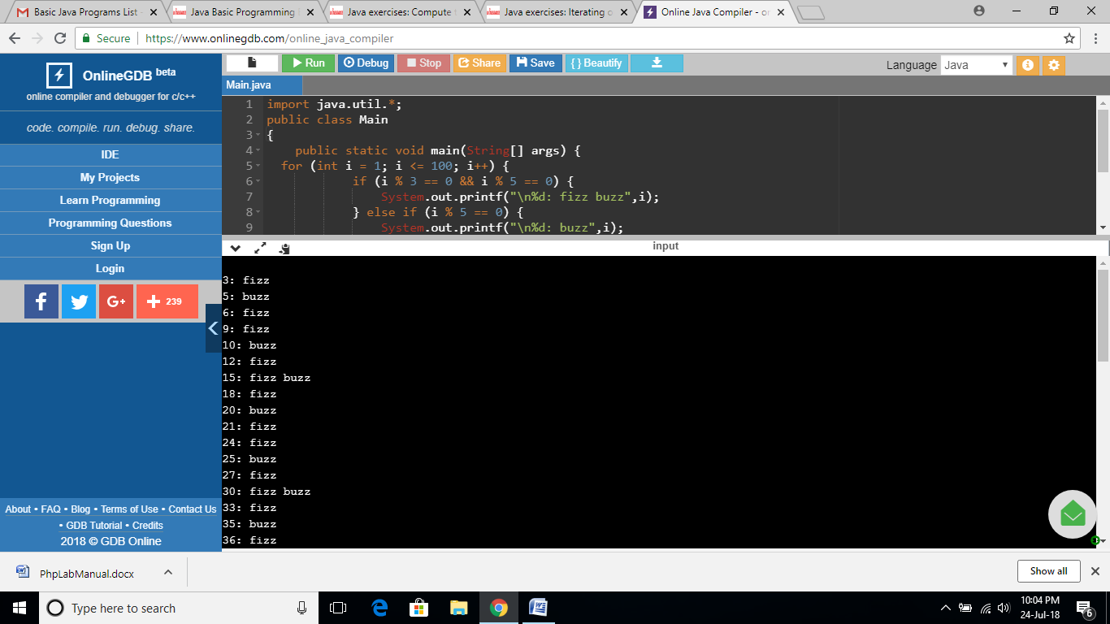

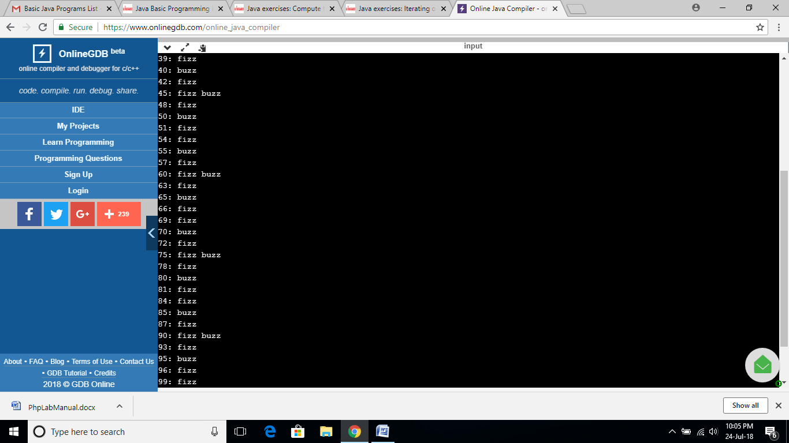

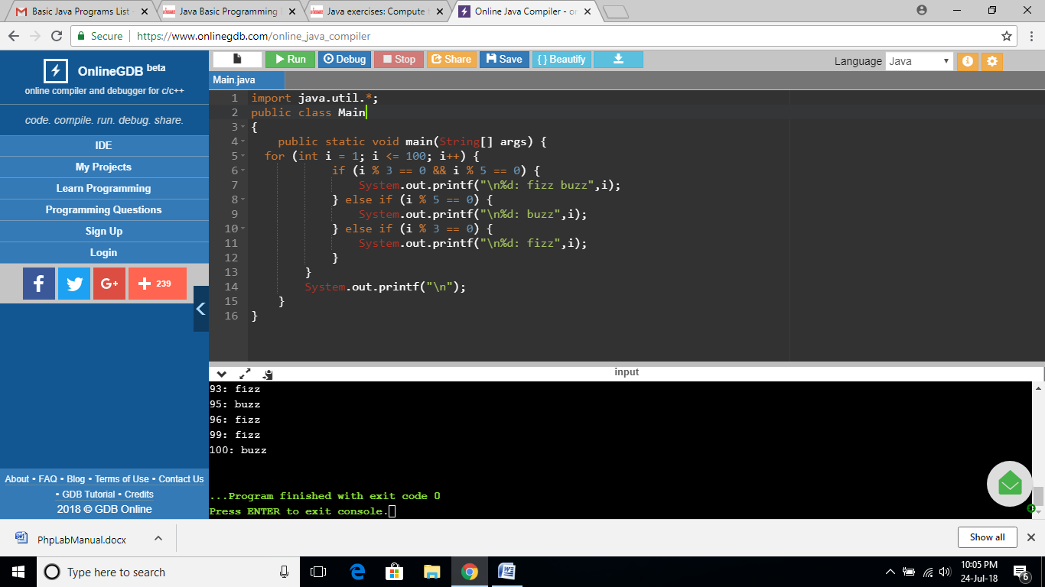

**EXERCISE 117:**

import java.util.*;

public class Main

{

public static void main(String[] args) {

int num;

Scanner in = new Scanner(System.in);

System.out.print("Input a positive integer: ");

int n = in.nextInt();

System.out.printf("Square root of %d is: ",n);

System.out.println(sqrt(n));

}

private static int sqrt(int num) {

if (num == 0 || num == 1) {

return num;

}

int a = 0;

int b = num;

while (a <= b) {

int mid = (a + b) >> 1;

if (num / mid < mid) {

b = mid - 1;

} else {

if (num / (mid + 1) <= mid) {

return mid;

}

a = mid + 1;

}

}

return a;

}

}

**OUTPUT:**

